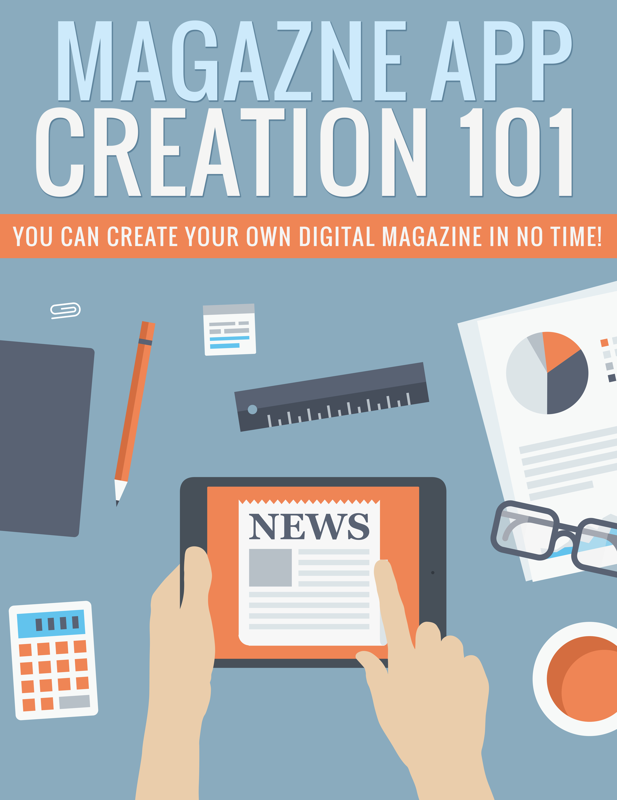

Legal

No part of this publication may be, including but not limited to, reproduced, in any form or medium, stored in a data retrieval system or transmitted by or through any means, without prior written permission from the publisher. The information contained herein has been obtained from sources believed to be reliable at the time of publication. The opinions expressed herein are subject to change without notice.
The publisher disclaims all warranties as to the accuracy, completeness, or adequacy of such information. The publisher assumes no liability for errors, omissions, or inadequacies in the information contained herein or from the interpretations thereof. The publisher specifically disclaims any liability from the use or application of the information contained herein or from the interpretations thereof.

Table of Contents

Legal 2
Table of Contents 3
Introduction 5
Identify Your Market 6
Develop Content 8
Monetization Methods 12
Subscriptions 12
Advertising 13
Brand Building 14
Creating Your App 15
TypeEngine 15
MagCast 16
Uploading Your App 18
Conclusion 19
Resources 20

Introduction

If you’re looking for a great way to get recurring monthly income that won’t cost a fortune in startup expenses, creating your own monthly magazine for the Apple App Store is a great option.

If you choose a great topic, create a quality product, and deliver new issues on time every month, having your own magazine can be a fantastic source of recurring monthly income that will grow over time.

In fact, 91% of all adults read magazines, and the top 25 magazines reach more people than the top 25 prime time television shows! This means there’s massive potential if you can find a hungry audience.

In this guide, you’re not only going to learn how to choose profitable markets, but also how to set up your magazine, create content, price for maximum profit, and more.

So let’s begin.

Identify Your Market

The first thing you want to do is identify a profitable market in which to create your magazine. If you’re trying to promote an existing business, you may already have your market in mind, but not every market will be profitable.

It’s important to keep in mind that when we discuss your market, we aren’t referring to your subject. Your subject (topic) would be something like golf or camping. Your market is made up of the people who would be interested in that topic.

The main reason for making the distinction is that you need to be sure your market is not only interested in your subject, but also:

- Is likely to own a tablet
- Is likely to have the disposable income to pay for the magazine
- Is interested in reading digital magazines
- Is willing to pay a monthly fee
- Has a passion or need you can fulfill

And here are the requirements for your market:

- Has products you can advertise
- Has existing competition (this is a good thing!)
- Has a passion or continual need you can fulfill
Remember that you’re going for a recurring monthly fee, which means you need to choose a market that not only has an interest in the subject, but one that is ongoing. For example, golf is a subject that its fans are very passionate about, whereas something like getting rid of fleas is a topic that someone is likely to want information about only once.

Believe it or not, you also want to see some competition. This means that not only is there definite interest in the topic, but also a proven willingness to buy magazines on the subject.

An easy way to find out the different magazines available and how well they sell is to check the various digital newsstands such as Amazon and Apple. This way you can see if there are already magazines on a particular subject, and get an idea if those magazines are selling well.

You can also take a look at the Texture (formerly called Next Issue) and Readly apps, which are apps that allow users to read an unlimited number of magazines for one monthly price.

Develop Content

Once you have an idea for the subject and market you’ll be addressing, it’s time to work on developing content. It’s a good idea to create at least three issues in advance so you don’t risk running into a situation where you don’t have time to finish an issue before it is due. It’s important to make sure your magazine is released on time every time or you will lose subscribers.

You should also ensure you’re developing content that is specifically geared toward your market. You may think that sounds silly and obvious, but too many beginners veer off their path. They might think that someone who’s into golf would enjoy an article about fine dining, but that isn’t always the case. Stay focused on your market.

There are three types of sections you will probably want to have in your magazine:

- Columns – Regular columns that feature messages from experts. You can either write these yourself, or hire an expert in the genre to write this each month. Sometimes this is in the form of a letter from the editor, kind of an introduction to the issue.
- Departments – These sections feature specific content each month. It might be something such as “Tip of the Month” or news.
- Features – These are the articles that are different in each issue and are usually in-depth articles on the subject.

You can write the content yourself, outsource it, or even curate other people’s content (with permission, of course.) Just be sure that all your content is top-notch and edited very well. It’s one thing to have typos or inaccuracies in a blog post, but in a monthly magazine people are paying for, it’s important to ensure it’s as close to perfection as possible.

One way to get extra content is to ask for content from your subscribers. This could be in the form of letters to the editor, where you publish your readers’ comments and questions. It could be an advice column where you give people help with problems they send in. Or you could just create an open call for submissions. Ask people to submit their articles in exchange for the potential of a small payment or perhaps just their byline.

It’s a great idea to create an editorial calendar that will let you map out what you’d like to feature for several months in advance. Many magazines create an editorial calendar 6-12 months in advance, of course leaving some space for articles that might be about breaking news topics.

Remember to think about the month you’ll be publishing content in, and create content that is appropriate for that month.

Let’s say it’s February, and you’re planning content for your golf magazine for June. You’ll want to specifically focus on Summer-related content, not Winter/Spring.

Curated content is a great way to get articles cheaply. You can just find content that’s already been created and ask the creator for permission to use it. If you find it difficult to locate content that people will give you permission to use, consider creating articles that are just quotes from articles.

For example:

5 Expert Tips for Improving Your Golf Swing

Then you’d find great tips on various expert blogs, one tip from each expert, and ask for permission to use their quote, along with a mention of their blog.

It could be formatted like this:

Martin Stevenson at GolfWebsite.com says, “The best way to improve your golf swing is to concentrate on…”

Or you could format it like this:

“The best way to improve your golf swing is to concentrate on…”

-- Mike Stevenson of GolfWebsite.com

Since most digital magazine apps make it easy to add working links, you can even link directly to the author’s website.
Curating content gives you the opportunity to get top-notch expert content without paying a fortune for it, and the owner/writer of the content gets credit in a publication. It’s a win-win situation.

Another good way to get content is to create contests. Each month, offer a prize for the top submitted article. You might even have consolation prizes for a few people who didn’t make the cut, or you could offer multiple prizes in exchange for publishing several articles each month.

Just be sure you don’t publish the content you don’t award prizes to. Some places put in their terms that they reserve the right to publish any content submitted, even for those who don’t win a prize, and that’s a good way to upset your readers. Even if it might technically be legal, although there’s a possibility it’s not, it’s not entirely ethical and it’s best to award prizes to anyone whose article you publish.

Monetization Methods

There are a few different ways to monetize a magazine. Subscriptions are the most obvious, as well as ad revenue, but there are other methods you can consider, too.

Subscriptions

Pricing is the first thing you need to think about with your magazine. Most digital magazine subscriptions cost between $0.99 and $4.99 per month. You may be tempted to go for the highest price to make the most revenue per subscriber, or the lowest to get the highest number of subscribers, but it’s not necessarily that simple.

For one thing, you need to be sure you’re competitive in your market. It’s not a good idea to charge a lot more or less than others in your market. If you’re a lot cheaper, people may think it’s because your magazine isn’t as good. If you’re a lot more expensive, people may choose other magazines because they are cheaper.

Also, remember that people are more likely to forget to cancel a subscription they’re not really reading if it costs very little. The higher the price, the more likely someone is to remember to cancel it. You can benefit from their procrastination by keeping the price lower.

Advertising

Most magazines are supported by advertisements, because the fees they get for their subscriptions isn’t enough to support the magazine entirely. If magazines depended solely on subscription revenue, there wouldn’t be very many magazines being published.

If your magazine is new and doesn’t have a large subscriber base, it’s not likely you’ll be able to charge much (if anything) for advertisements, but you can still have ads in your magazine that make you money.

How?

Affiliate offers, of course.

You may think you can’t have affiliate links in a magazine, because it’s too hard to type them in, but remember that you’re creating a digital magazine. You can easily create a link to your affiliate link within the app.

Also, you can pick up a domain just for advertising a particular product if you believe it will be lucrative. Let’s say you’re advertising a product called BoodleGlass and they have the website BoogleGlass.com. You could just use an affiliate link that might look like BoodleGlass.com/aff/70751345, but that doesn’t look very good in your graphics. Instead, you could get a domain like GetBoodleGlass.com and use that domain in your ads.

Since there are a whole lot of spaces for ads in your magazine, you have the potential to advertise a lot of products, but that might not be the best approach. It could spread potential revenue too thin. Instead, it might be best to focus on just a handful of the best products each month. This is a good way to see which products might outsell others, giving you the chance to promote those top sellers month after month.

Once your magazine has a good number of subscribers, you could choose to start accepting advertisers. You’ll probably want to create a PDF with advertising rates that you can put on your website for potential advertisers to download. Within that PDF, include prices, ad sizes available, locations, deadlines, and your most recent subscriber numbers. You can add a link to your page for advertisers in every issue.

Brand Building

Another source of revenue is simply building your brand. You may choose not to have as many ads in your magazine so that you can focus more on building your name as an expert in your field or traffic to your website.

Let’s say you own TopGolfHaven.com. You could brand the magazine with your website’s name, and include your URL on every page.

Creating Your App

Now it’s time to put all of your content and advertisements into your magazine. You may want to just hire someone to do this for you, but this can be fairly expensive because of the time and effort it takes to not only design the magazine pages themselves, but also the app.

There are many options available for creating magazines for the app store. Some are very expensive, and some are quite reasonable.

TypeEngine

>> http://typeengine.net/

TypeEngine is relatively easy to use, and the initial startup cost is free. You can create your magazine without paying anything, allowing you to see how you like the system and if you find it easy enough to use.

If you like their system, it costs $99 for the initial setup and just $25 per month plus $0.15 per download of each issue. You’ll only be charged when a subscriber first downloads an issue. If they delete it and download it again later, you won’t be charged a second time.

Unfortunately, there aren’t many built-in marketing methods available. You can use Apple’s built-in trial subscriptions, and offer an incentive to get people to opt-in to your email list. You can also sell individual issues if you want. That’s all they really offer in terms of marketing.

The system uses HTML/CSS to create issues, so it’s fairly easy to use, however this also means it’s potentially rather limited in what you can do with your magazine.

MagCast

>> http://www.magcast.co/

MagCast is a lot more expensive, coming in at $3,597 per year (and there is no monthly option). It’s an overwhelming cost for a startup. However, there are no additional monthly fees or download costs.

Magazines can be created with PowerPoint, Photoshop, InDesign, or just about anything else you can think of as long as you can export in PDF format.

Additionally, MagCast has great marketing options built in, such as:

- Push notifications to both subscribers and former subscribers
- Push notifications to ask subscribers to return
- Promo codes
- Social sharing integration
- Evernote integration
- Launch notifications
- Advertising banners
- Welcome letters
- Ad network integration (such as iAd, Chartboost, and others)
- Custom opt-in pages
- Many more

While it’s a prohibitively expensive platform, if you’re really serious about creating a magazine and making it successful, MagCast is by far the better option. There’s just nothing else that compares in terms of features.

Uploading Your App

Uploading your app to the app store isn’t all that difficult, but you’ll need to get an Apple Developer account before you do. This costs $99 per year.

You can enroll here:

>> https://developer.apple.com/programs/

One thing to keep in mind is that if you decide to sell your magazine later, you can NOT simply transfer the magazine itself. If you have recurring subscribers, you MUST transfer the ENTIRE account. For this reason, it’s probably a good idea to create a new developer account for each magazine you create so you have the ability to transfer the account later if you decide to sell the magazine.

Each specific magazine platform (TypeEngine, MagCast, etc.) will give you instructions for uploading the magazines you create to the app store. You can follow these instructions to get your first issue set up and uploaded to the store.

Be sure you create a compelling icon for your magazine, because this will grab people’s attention and remind them to read each month!

Conclusion

Creating a digital magazine can be quite lucrative, but the startup costs may be prohibitive for some. You have the expense of creating the content, creating the graphics/layout,

As long as you already have the skills to create great magazines, or the ability to outsource it, the process really doesn’t take a lot of effort.

Be sure you choose a topic that has the potential to be profitable, meaning there are already similar magazines existing and they have subscribers. This is the best way to measure your potential success.

It may take a little time and effort to learn all of the skills needed to create your first magazine, but once you clear that initial hurdle, it should get much easier for subsequent issues.

Outsourcing is another option. There are plenty of people who can help you create your magazine, and they probably cost a lot less than you think.

Best of luck with your digital magazine! I wish you the very best!

Resources

Here are quick links to the resources mentioned in the guide:

TypeEngine:

http://typeengine.net/

MagCast:

http://www.magcast.co/

Apple Developer:

https://developer.apple.com/programs/

