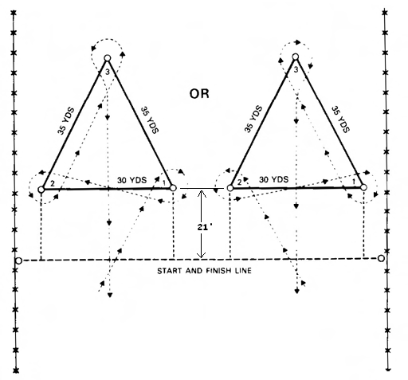
BARREL RACE
  - AQHA rules will apply except concerning wearing apparel of the riders.
  - Horses and rider may enter from either side as long as pattern is not broken and exit is made between two front barrels.
  - No barrel shall be placed closer than 15 feet from the fence.
  - Knocking over a barrel will result in disqualification.
  - Touching of the barrel by rider is permissible.
  - If a rider makes a qualified run in this event and the timer fails to work properly, the rider must make a bona fide attempt in the re-ride and will receive time even though a barrel is knocked down. NOTE: Deliberate and intentional knocking down of a barrel in order to receive a faster time will not be tolerated, and the decision of the judge will be final.
  - In the event of timer failure, a contestant may have his choice regarding time for his re-ride. He/She may run immediately, or the rider may run at the end of the event. If he/she should be the last rider in the event when the timer fails, he/she will be given five (5) minutes to rest his/her horse.
  - Pee Wee riders 10 and under who ride ponies will ride in Pony Barrels only,. Pee Wee riders 10 and under who ride horses over 52" will ride in Buckaroo Barrels only; but cannot ride in both.
BUCKAROO: 13 and under, any size horse
JUNIORS: 14 to 18, any size horse
SENIORS: 19 and over, any size horse

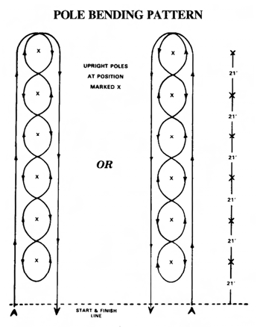

POLE BENDING
- AQHA rules will apply except concerning wearing apparel of the riders.
- The pole bending pattern is to be run around six (6) poles. Each pole is to be twenty-one (21) feet apart, and the first pole is to be at least twenty-one (21) feet from starting line with the last pole at least twenty (20) feet from the fence.
- Failure to follow the pattern shall cause disqualification. If pole is knocked over, rider will be disqualified,.
- Touching of pole by a rider is permissible and will not result in disqualification.
- If a rider makes a qualified run in this event and the timer fails to work properly, the rider must make a bona fide attempt in the re-ride and will still receive time even though a pole is knocked over. NOTE: Deliberate and intentional knocking over a pole in order to receive a faster time will not be tolerated, and the decision of the judge will be final.
- Re-ride time due to timer failure same as barrel race, rule number seven.
- Pee Wee riders 10 and under who ride ponies will ride in Pony Poles only. Pee Wee riders 10 and under who ride horses over 52" will ride in Buckaroo Poles only; but cannot ride both.
BUCKAROO: 13 and under, any size horse
JUNIORS: 14 to 18 any size horse
SENIORS: 19 and over, any size horse.

21’
30’
Timer Line

FLAG RACE
- Flags will be 18" long with 8x9"cloth flag. Soft wood of a one (1) inch dowel rod should be used. Flag may be used as a quirt. Flagstick shall be marked three (3) inches above the bottom. Flag will be sharpened.
- Buckets will be five (5) gallon size filled to within three (3) inches of top with masonry sand.
- Buckets shall be placed to the inside of barrel. The flag for pick up shall be placed in the center of the bucket.
- Upon completion of ride, barrels and buckets must be standing upright. Flag must be stuck inside bucket.
- If any barrel or bucket in knocked over, rider will be disqualified.
- If a rider makes a qualified run in this event and the timer fails to work properly, the rider must make a bona fide attempt in the re-ride and will still receive the time even though the rider fails to stick the flag. NOTE: Deliberate and intentional illegal procedures executed in order to receive a faster time will not be tolerated and the decision of the judge will be final.
- Re-ride time due to timer failure same as barrel race, rule number seven.
- End barrel must be set in same position as for barrel race.
- Barrels may be moved back or forward a certain distance to alleviate area around the barrels becoming dug out and dangerous.
- Judge will place flag in pickup bucket.
Juniors: 18 and under, any size horse.
Seniors: 19 and over, any size horse

SPEED RACE
- Rider will be disqualified if barrel is knocked over during run.
- If a rider makes a qualified run in this event and the timer fails to work properly, the rider must run again, making a bona fide attempt in the re-ride to receive a time. NOTE: Deliberate and intentional illegal procedures executed in order to receive a faster time will not be tolerated and the decision of the judge will be final.
- Re-ride time due to timer failure same as barrel race, rule number seven.
Juniors: 18 and under, any size horse.
Seniors: 19 and over, any size horse.

12’

5’ 10’

KEYHOLE RACE
- Keyhole shall consist of a 12-foot circle with a 10 foot long by 5-foot wide throat (10’x5’).
- Horse may enter pattern with flying start. This is a timed event. Keyhole used will be outlined in white lime. Horse will follow directions as indicated in pattern diagram.
- Horses must turn in circle not in throat or approach to circle.
- If a horse steps in or over the line, it will be disqualified and no time will be given on the rider.
- Judge must stand behind the keyhole or to the side at a safe distance.
- If a rider makes a qualified run in this event and the timer fails to work properly, the rider must run again, making a bona fide attempt in the re-ride to receive a time. NOTE: Deliberate and intentional illegal procedures executed in order to receive a faster time will not be tolerated and the decision of the judge will be final.
- Re-ride time due to timer failure same as barrel race, rule number seven.
- Open to all ages, any size horse.

BARREL PICK UP
- A contestant may enter only one time in this class, either as a rider or as a jumper, but not as both.
- This race is to be run with a barrel at the opposite end of the arena. The barrel must be a least 20 feet from the fence, and the rider may ride to the right of left, circling the barrel.
- For safety of riders in this class, the barrel is moved ten feet if necessary and is to be left to the discretion of the show manager.
- The starting line should be at least 20 feet inside the arena.
- The jumper must mount from the barrel and must be astride of the horse at the finish line.
- Person being picked up must mount unassisted. Use of rider’s hands at any time during the ride is not allowed and will result in disqualification.
- If jumper touches the ground, it will be a disqualification and jumper must exit arena on foot.
- Judge is to be on the ground back of the barrel so as to have a better view.
- If a rider makes a qualified run in this event and timer fails to work properly, the rider must run again, making a bona fide attempt in a re-ride to receive a time. NOTE: Deliberate and intentional illegal procedures executed in order to receive a faster time will not be tolerated and the decision of the judge will final.
- Re-ride time due to timer failure same as barrel race, rule number seven.
- Open to all ages, any size horse.

