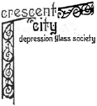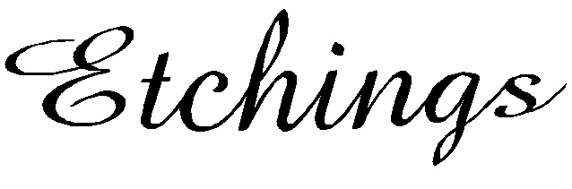

Meeting Reminder

~~<>~~

Wednesday

April 13, 2016

Meeting Begins 7:30pm

Doors Open 7:00pm

**April, 2016**

2015-16 Society Officers

President – Donna Terrio Vice President – Joy Boudreaux Treasurer – Glenn Plauche Recording Secretary - Cynthia Brignac

Corresponding Secretary – Jane Grace Stacy

Program:

**April program is Antique Lamps**

Refreshment Volunteers:

**Drinks**

Brenda Reilly

Betty Kehm

**Appetizers**

Lee Vinson

Astrid Mussiett

Glenn Plauche

Charlenne Adolph

**Desserts**

Carole Martinez

Ellen Cook

Lou Reed

Show ‘n Tell:

**Best Buy of the Show**

CCDGS Website

[www.crescentcityglass.org](http://www.crescentcityglass.org)

Check it out for meeting and event information.

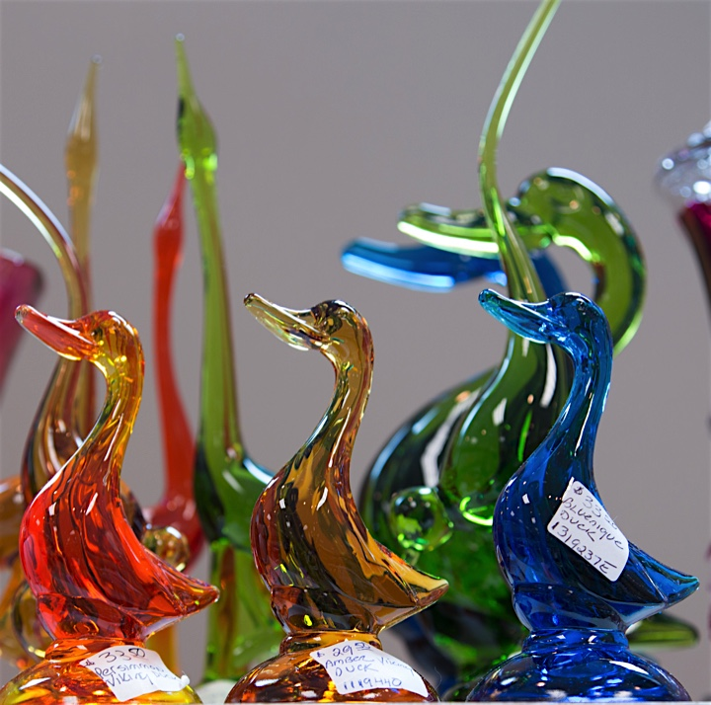

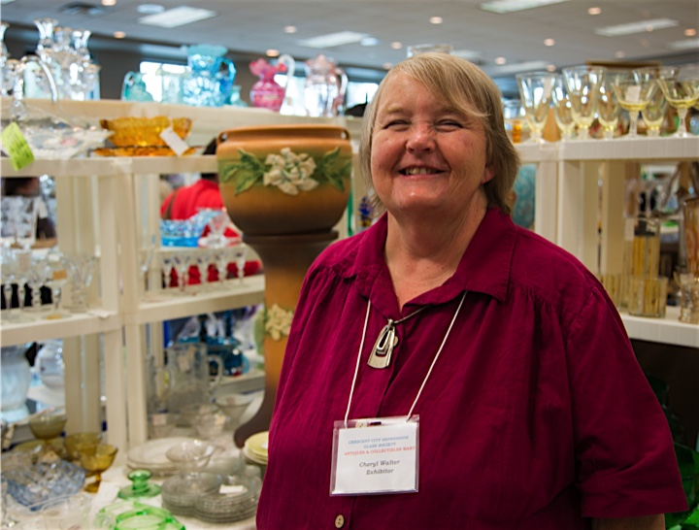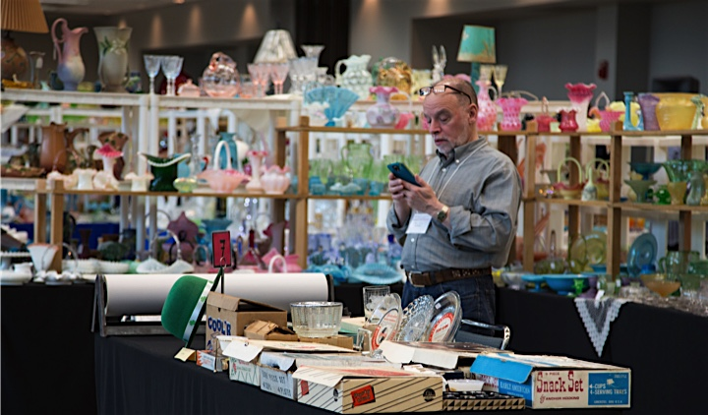

Glimpses of the March Antiques and Collectibles Show

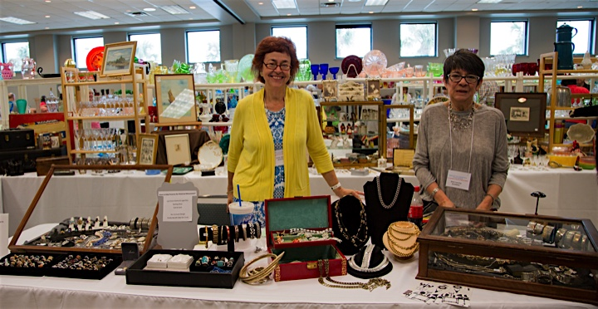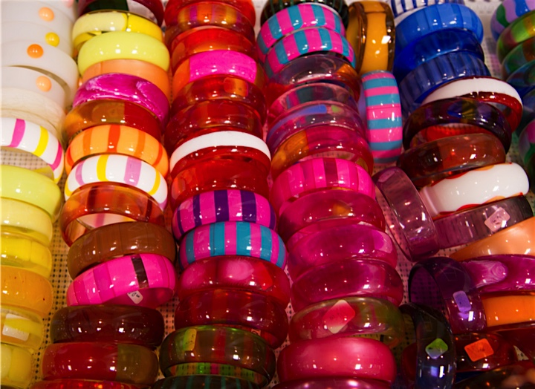

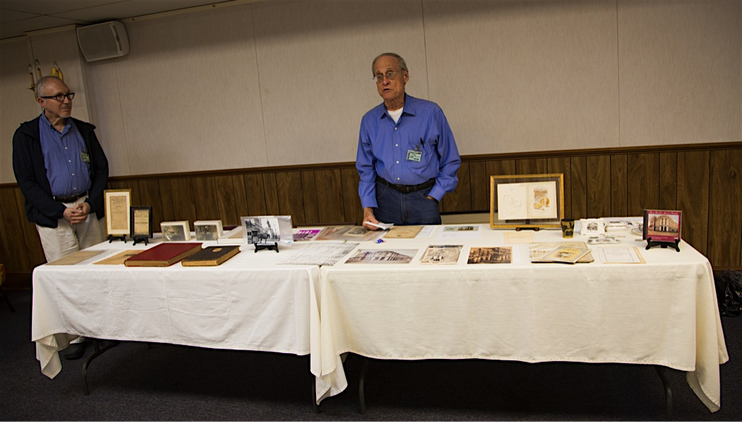

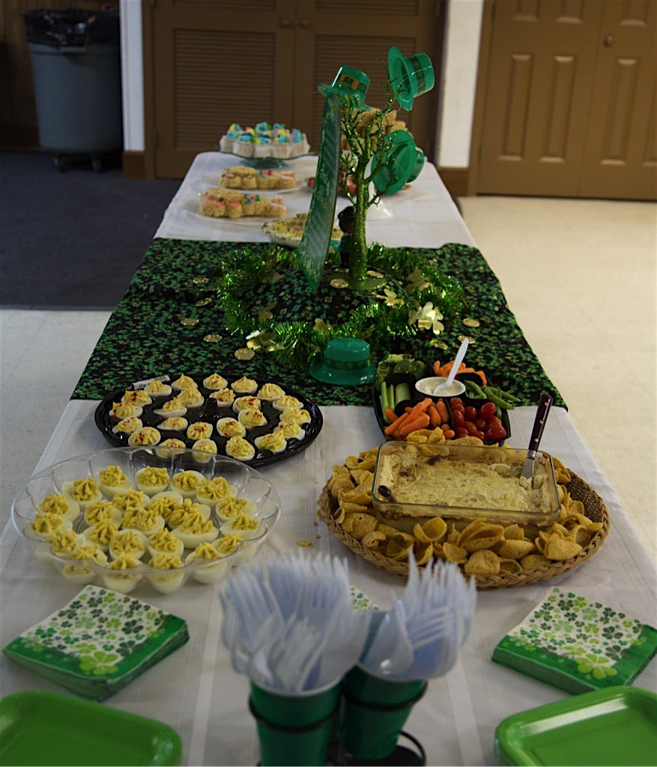





**Sandra Carter – April 2**

**Byron Jacob – April 3**

**Ethel Kidd – April 21**

**Janel Mumme – April 2**

**Gloria Tamplain – April 19**

**ThE Gallery**

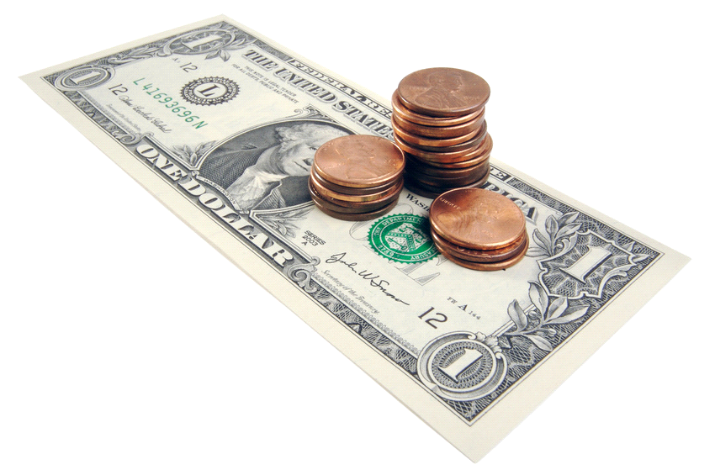

Monthly Program

**March Meeting Highlights**

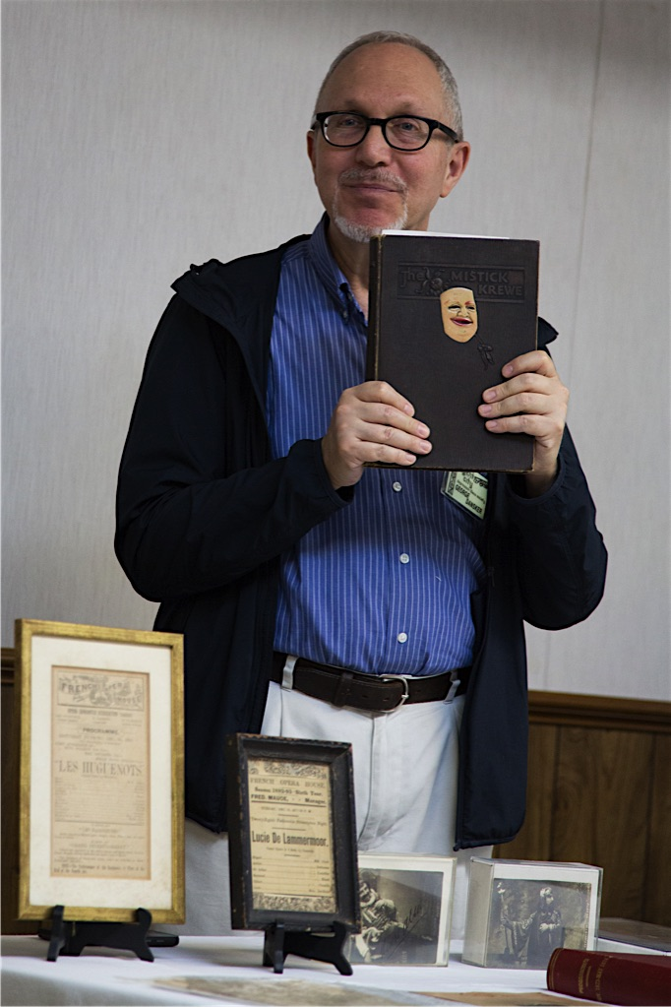

**The Gallery, continued**

Upcoming Glass Events!

### July 25-27, 2015

National Fenton Glass Society Convention  
Quality Inn  
700 Pike Street  
**Marietta, OH 45750**  
740-374-3345  
[http://www.nfgs.org](http://www.nfgs.org/)  
[office@nfgs.org](mailto:office@nfgs.org?Subject=NDGA%20show%20calendar%20question)

Glimpses of the Meeting