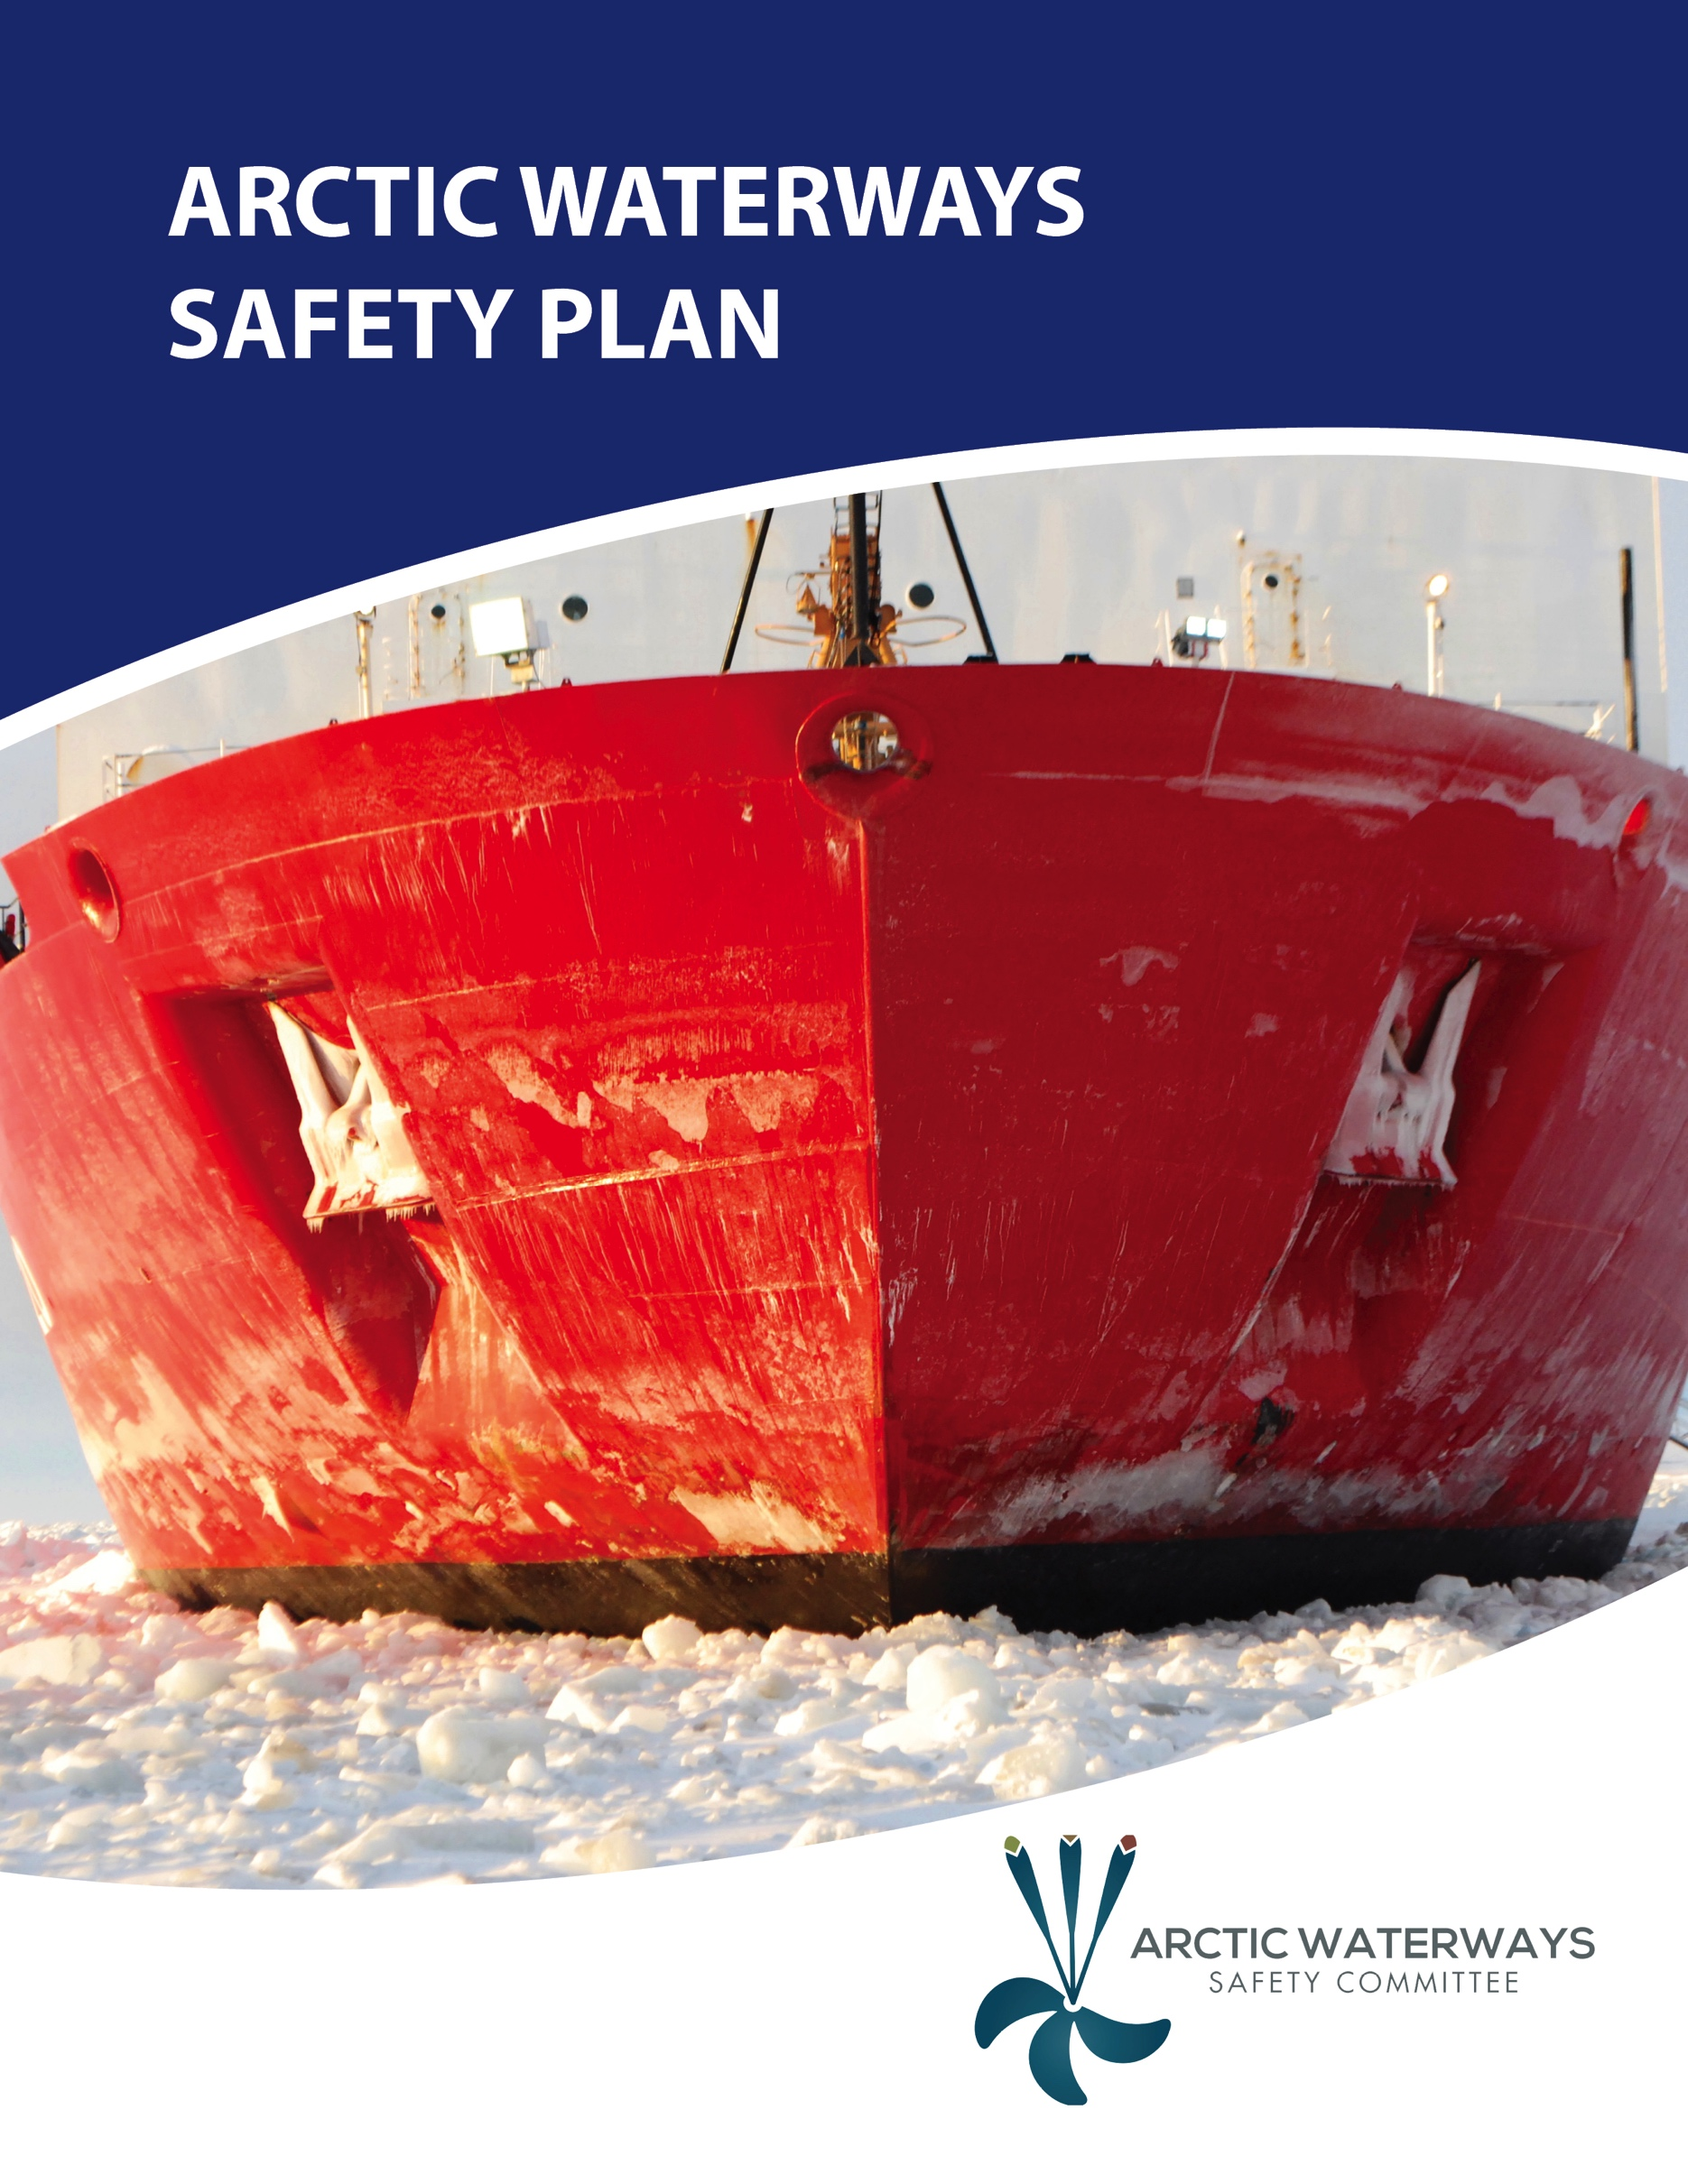
April 2016

[Forthcoming: Letter of Support from USCG for the Arctic Waterways Safety Plan]

Letter of Promulgation

Welcome to the Arctic Waterways Safety Plan. The goal of the Arctic Waterways Safety Plan (AWSP) is to enhance marine safety, Indigenous Peoples’ food security, and environmental stewardship via risk based decision-making. First published and distributed in 2016, the plan is intended to provide information, guidelines, and Standards of Care for marine operations in the United States (Alaskan) Arctic. This version of the plan, as with all subsequent versions, will be the product of a collaboration of the organizations and entities represented on the Arctic Waterways Safety Committee, and others in our maritime community, who shared their time and expertise to develop this plan.
The first section of the plan is administrative, and introduces the reader to the Waterways Safety Committee and its work. The second section is primarily informative in nature, and provides important information for professional mariners transiting the United States Arctic waterways. The third section includes Standards of Care developed by the Waterways Safety Committee that formalize and document certain “good marine practices” especially important to operations in the United States’ Arctic waterways.
The Arctic Waterways Safety Committee is committed to maintaining and updating this plan as new information and changing technologies warrant.
The Arctic Waterways Safety Committee has a web site at arcticwaterways.org where further details regarding the activities of the Committee can be found. Comments and suggestions regarding the plan may be forwarded to the Committee through this web site. Comments may also be submitted to the Committee via mail at the below address.
Coast Guard Captain of the Port: The Coast Guard is the primary advisor, an active participant and major contributor to the Arctic Waterways Safety Committee and this Plan. This Plan is strongly endorsed by the Captain of the Port.

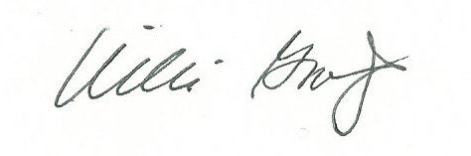

Willie Goodwin
Chair, Arctic Waterways Safety Committee
P.O. Box 92326
Anchorage, AK 99509

Acknowledgements

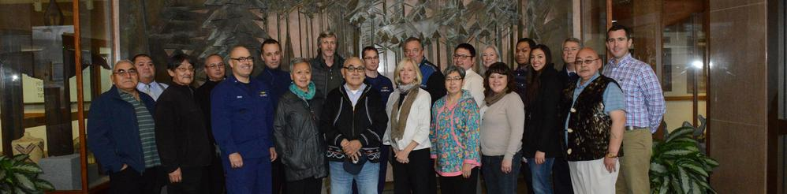
Numerous parties contributed to the initial Arctic Waterways Safety plan, but particular credit is given to the Indigenous waterways users who came together as the Arctic Marine Mammal Coalition (AMMC) in 2012 to work with U.S. Coast Guard’s District 17 to address growing concerns about the threats of increased maritime traffic to long-standing subsistence practices. Oak Foundation financially supported these efforts and was joined by Pew Charitable Trusts and the National Fish and Wildlife Foundation, who supported writing of the first Arctic Waterways Safety Plan.

TABLE OF CONTENTS

Letter of U.S. Coast Guard Support (forthcoming) ii
Letter of Promulgation iii
Acknowledgements iv
Table of Contents v

Section A – Introduction
Statement of Purpose 2
Arctic Waterways Safety Committee Members 4
Geographic Plan Applicability and Information 5
Indigenous Food Security 8

Section B – General Information
Principle Regulations
Principle Routing Considerations
- Port Access Routing
- Current Protected Areas
- Ports and Refuges
- Sea Ice and Ice Breaking
Communication Systems and Protocols
- Local Notices to Mariners
- Aids to Navigation (virtual and real)
- Automatic Identification System
- Charts
- Coastal Pilot
- Weather Services
Accident Prevention and Response
- Oil Spill Response Organizations (OSROs) and Strategies
- Transboundary Response and Coordination
- Alternative Planning Criteria
Coastal Access (e.g., military and Native allotments; St. Lawrence Island)
Areas of Mandatory Pilotage (Alaska Marine Pilots)
Specific Waterways User Considerations
- Seasonal Subsistence and Fishing
- Fishing Areas
- Naval Vessels
Environmentally Sensitive Areas
- Marine Mammal Aggregations
- Seabird Aggregations
Notification of Unusual Sightings
- Floating Debris (NOAA)
- Floating Oil
- Stranded Animals

Section C – Standards of Care (SOCs)
Maritime Research [in development]
Tourism [in development]
Springtime icebreaking [for development]
Offshore mining [for development]
Lightering [for development]

Appendix 1 – Glossary of Terms
Appendix 2 – List of Acronyms
Appendix 3 – Maps

SECTION A
INTRODUCTION

Statement of Purpose
Arctic Waterways Safety Committee Members
Geographic Plan Applicability and Information
Indigenous Food Security

PURPOSE OF THE
ARCTIC WATERWAYS SAFETY PLAN
The mission of the Arctic Waterways Safety Committee is to provide a proactive forum for identifying, assessing, planning, communicating, and implementing operational and environmental measures beyond statutory and regulatory requirements that promote safe, secure, and efficient use of the Arctic Waterways. The committee is made up of delegates appointed by broadly based organizations representing a span of interests focused on the Arctic Waterways. Additionally, various governmental agencies, academic institutions, and Non-Governmental Organizations support the work of Arctic Waterways Safety Committee in advisory roles.
Reflecting the purpose of the Arctic Waterways Safety Plan, the Mission of the Arctic Waterways Safety Committee, as stated in their By-Laws is to:
- Provide a proactive forum for identifying, assessing, planning, communicating, and implementing those operational and environmental best practices that promote the safe and efficient use of Arctic waters from St. Lawrence Island/Norton Sound north through the Alaskan Chukchi and Beaufort Seas;
- Ensure the long-term health of the Arctic ecosystem and marine mammals;
- Ensure the continued health, vitality, and safety of Alaska Native maritime subsistence hunters and the long-term food security of Alaskan Arctic communities;
- Ensure the continued health, vitality, and safety of the full diversity of maritime users and local residents;
- Facilitate the continued safe and efficient economic development, commerce, and subsistence practices that are vital to local economies;
- Act as an educational and resource network through which ideas, materials, and procedures can be provided to persons interested in Arctic marine safety and operations;
- Act as a resource at the request of governmental bodies and individual legislators regarding issues related to marine operational and environmental safety;
  - INUIT CIRCUMPOLAR COUNCIL (ICC) - ALASKA PROPOSED FOOTNOTE/CAVEAT: AWSC does not act as a body for or take the place of regional or tribal consultation.
    - Should this be adopted? If so, should it be included in the AWSC bylaws, as a clarifying note in this section of the AWSP, or both?
- Ensure that marine safety and environmental measures are coordinated with security initiatives.
With its regular meetings and broad stakeholder group participation, the Arctic Waterways Safety Committee offers an agile and vibrant forum to lead the stakeholder community in identifying and resolving conflicts or concerns, existing and potential, in the commercial, subsistence, and recreational use of the Arctic Waterways.
Consistent with the U.S. Coast Guard’s Navigation and Vessel Inspection Circular #1-00, the responsibilities of the Arctic Waterways Safety Committee include recommending actions to improve the safety, security, mobility, and environmental and cultural protection of the Arctic waterways. The Arctic Waterways Safety Committee, in collaboration with the U.S. Coast Guard, takes responsibility for capturing existing standards and protocols as well as developing new standards and protocols that address those environmental and operational elements of maritime operations that are somewhat unique and especially significant to the Arctic Waterways.
The Arctic Waterways Safety Plan is to document the Standards of Care that local users regard as appropriate for the Arctic Waterways. The Standards of Care are the result of local marine interests in the Alaskan Arctic coming together in a single forum – the Arctic Waterways Safety Committee – and acting collectively on behalf of those interests to develop best practices to ensure a safe, efficient, and predictable operating environment for all current and future users of the waterways. The Arctic Waterways Safety Plan is intended to complement and supplement existing federal, state, and tribal laws and regulations, with advice to mariners regarding unique conditions and requirements that may be encountered in the Arctic Waterways and adjacent waters.
The Arctic Waterways Safety Committee should be viewed as the multi-stakeholder agent of choice by government, industry, Indigenous interests, and environmentalists to present and discuss information on user-conflicts, including desired new practices, new safety initiatives, and measures to reduce natural resource conflicts.
The Arctic Waterways Safety Committee can also support and expand upon the work of other Arctic focused organizations, such as the U.S. Coast Guard District 17, Alaska Department of Environmental Conservation, 11th Rescue Coordination Center, Northwest Arctic Sub-Area Committee, and others.
Action Items: Especially important action items for vessel masters will be highlighted throughout the plan in special “action items boxes like this one.
Procedures
“Focus teams,” which are subcommittees of the Arctic Waterways Safety Committee, develop the elements of the Arctic Waterways Safety Plan. To assure the broadest perspectives on measures considered, focus teams are expected to include interested parties from within the Arctic Waterways Safety Committee and to reach beyond the Committee for membership, participation and advice.
As possible additions and/or corrections to the Waterways Safety Plan are identified, the Chair will appoint one or more Arctic Waterways Safety Committee members to lead a focus group to consider the issues and bring recommendations to the full Arctic Waterways Safety Committee.

Guidelines
Standards and protocols included in the Arctic Waterways Safety Plan address operational and environmental issues unique to the Arctic Waterways. The Arctic Waterways Safety Plan is not intended to supplant or otherwise conflict with federal, state, tribal, or other regulations developed under legal authorities. Nor is the Arctic Waterways Safety Plan intended to replace the good judgment of a ship’s master in the safe operation of his/her vessel. The Arctic Waterways Safety Plan is intended to complement existing regulations by advising the mariner of unique conditions and requirements that may be encountered in the Arctic Waterways and adjacent waters and the standards and protocols developed by local experts for ensuring greater safety in light of those conditions and requirements.
The intent of the Arctic Waterways Safety Committee is to maintain the relevance of Arctic Waterways Safety Plan to contemporary conditions and activities through annual review and updates.

ARCTIC WATERWAYS SAFETY COMMITTEE MEMBERS
List of Members
The Arctic Waterways Safety Committee is a multi-stakeholder organization. A broad based association representing the interests of each stakeholder group is invited to nominate a representative as a lead and as an alternate for voicing perspectives and concerns of that group during meetings. The Arctic Waterways Safety Committee includes the following user groups, of which five representatives from each make up the voting members: a) Alaska Native Marine Mammal Organizations, b) Industry, and c) Other.
THE TERM “ALASKA NATIVE MARINE MAMMAL ORGANIZATIONS HAS REPLACED THE VARIOUS OTHER TERMS USED TO DESCRIBE THESE ORGANIZATIONS (EX. HUNTER GROUPS, SUBSISTENCE HUNTERS) THROUGHOUT THIS AND OTHER AWSC DOCUMENTS TO PROVIDE CONSISTENCY IN TERMINOLOGY AND MORE SPECIFICITY. IF THERE IS ANOTHER TERM THE COMMITTEE FEELS IS MORE APPROPRIATE THIS CAN BE CHANGED.
Committee membership shall not, by itself, be construed to in any way limit the legal rights, obligations, or authorities of an individual representative or the groups or agencies, which they represent.
ICC PROPSED CAVEAT/FOOTNOTE CAN POSSIBLY BE ADDED HERE

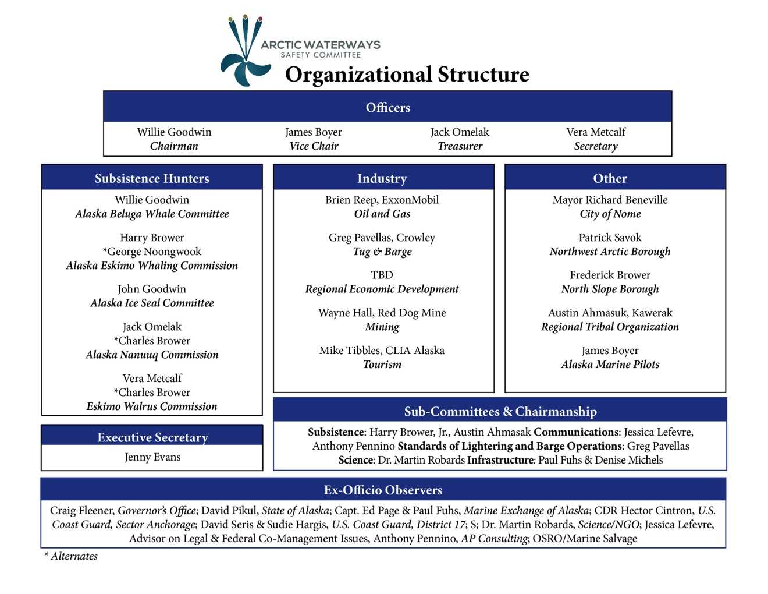
Sub-Committees
The Chair of the Arctic Waterways Safety Committee appoints the chairs of the various subcommittees.

GEOGRAPHIC PLAN
APPLICABILITY AND INFORMATION
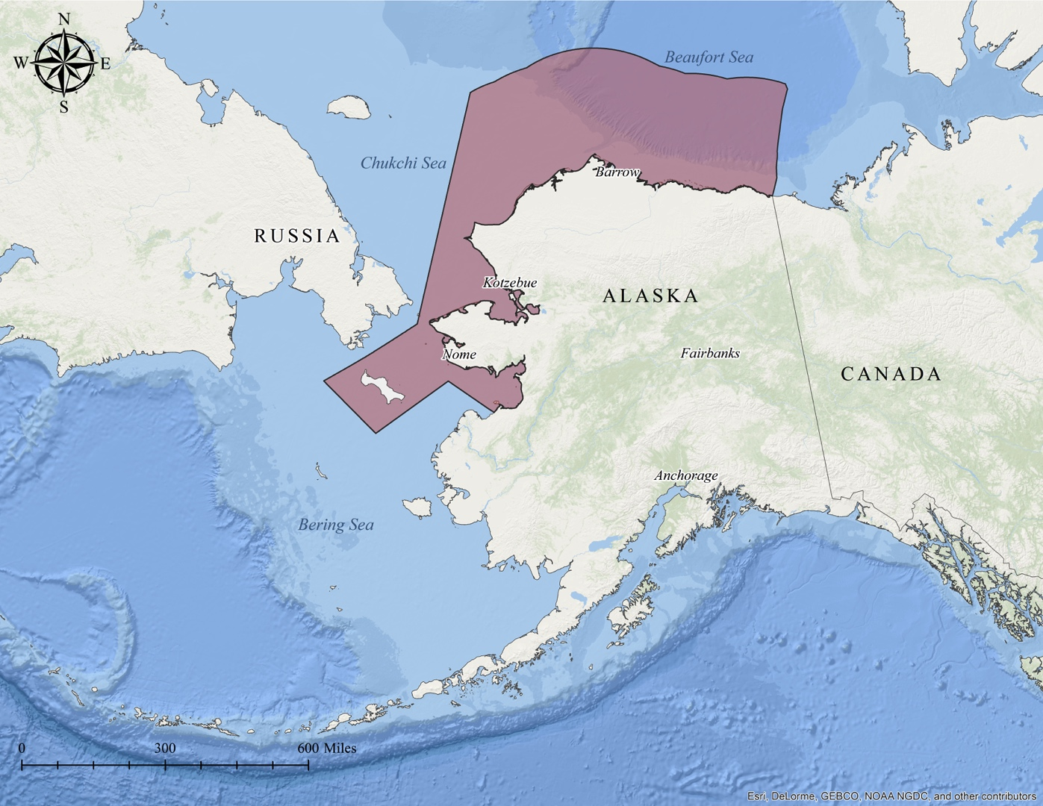
Geographic Boundaries
The Arctic Waterways Safety Plan encompasses United States territorial waters of the Beaufort Sea, bordered on the east by Canada; the Chukchi Sea, bordered on the west by the Russian Federation; and the northern Bering Sea. The ANSCA Bering Straits region, encompassing St. Lawrence Island, demarcates the boundary to the south.

U.S. Coast Guard Captain of the Port (COTP) Zone
For all Coast Guard mission areas including waterways management, marine safety, search and rescue, law enforcement, border security, port security and environmental issues in the Arctic Waterways, the Captain of the Port, Sector Anchorage (part of District 17) is the primary Coast Guard authority. The legal boundaries for the Captain of the Port, Sector Anchorage are set forth in 33 Code of Federal Regulations 3.65-10. The Captain of the Port has varying levels of jurisdiction extending to the outer limit (200 nautical miles) of the Exclusive Economic Zone (EEZ) for foreign and domestic vessels.

Unified Plan and Sub-Area Contingency Planning Areas
Subarea Contingency Plans are supplements to the Alaska Federal/State Preparedness Plan for Response to Oil & Hazardous Substance Discharges/Releases (commonly referred to as the Unified Plan). The Unified and the Subarea Contingency Plans represent a coordinated and cooperative effort by government agencies and were written jointly by the U.S. Coast Guard, the U.S. Environmental Protection Agency, and the Alaska Department of Environmental Conservation. The Oil Pollution Act of 1990 (OPA 90) requires the U.S. Coast Guard and the U.S. Environmental Protection Agency to prepare oil spill response plans for the State of Alaska, which is designated as an entire planning region under Federal guidelines. Alaska statute requires the Alaska Department of Environmental Conservation to prepare a statewide master plan addressing oil and hazardous substance discharges. The Unified Plan meets these Federal (NCP and OPA 90) requirements for regional and area planning, as well as State planning requirements.
For the Arctic waterways, the Northwest Arctic Sub-Area Committee and the North Slope Sub-Area Committee are the venues in which their respective subarea contingency plans are developed, which are updated on a five-year basis unless critical updates require more timely, out-of-cycle changes (http://dec.alaska.gov/spar/PPR/plan.htm). The state’s jurisdiction extends to activities occurring in the coastal waters within the U.S. territorial seas, and state interests may even extend beyond those limits to the extent the event would likely impact state waters and resources.
Chadux is the primary oil spill response organization (OSRO) for the Northwest Arctic Area, and Alaska Clean Seas is the primary OSRO in the Beaufort Sea. The remote nature of the Arctic Waterways has also prompted inclusion of an Alternative Planning Criteria for ensuring safe vessel passage (See Section 2).

Regional (Municipal) Government
Local government within the Arctic Waterways Safety Committee’s region is comprised of the North Slope Borough (http://www.north-slope.org) and Northwest Arctic Borough (http://www.nwabor.org). Kawerak, Inc (http://www.kawerak.org) represents tribes in the southern part of the Arctic Waterways Safety Committee area, but is not a municipality or borough, but rather a tribal consortium.
Services in the region are provided by local non-profit and corporate organizations, including Bering Straits Native Corporation (http://beringstraits.com), Kawerak, Inc (http://www.kawerak.org), NANA Regional Corporation (http://www.nana.com), and Maniilaq Association (http://www.maniilaq.org) in Northwest Alaska; and Arctic Slope Regional Corporation (http://www.asrc.com), Inupiat Community of the Arctic Slope (http://www.inupiatgov.com), and Ukpeaġvik Iñupiat Corporation (http://www.uicalaska.com) on the North Slope.
Coastal land ownership is a complex mix of Federal, State, Alaska Native, and privately owned lands. Vessel operators are advised that landowners may require permission and sometimes payments for access. Vessel owners must accept responsibility for knowing land ownership, and should not access shore areas unless they have permission.
Cooperative Agreements and Co-Management of Marine Mammals
The federal government may enter into Cooperative Agreements with Alaska Native organizations to cooperatively manage (and sometimes co-manage) marine mammals. Alaska Native marine mammal organizations, formed for the cooperative management or co-management of specific marine mammal species, are tribally authorized organizations with representation from tribal membership throughout their respective regions. The Alaska Native marine mammal organizations within the AWSC are the Ice Seal Committee, Alaska Beluga Whale Committee, Alaska Eskimo Whaling Commission, Alaska Nanuuq Commission, and the Eskimo Walrus Commission. The agencies that currently hold agreements with these Alaska Native organizations are the National Marine Fisheries Service and the National Oceanic and Atmospheric Association (for ice seals, beluga, and bowhead whales), and the U.S. Fish and Wildlife Service (for polar bears and walrus). Contact details for these organizations are provided in the Appendices and distribution of Alaska Native marine mammal organizations provided in the figure below.
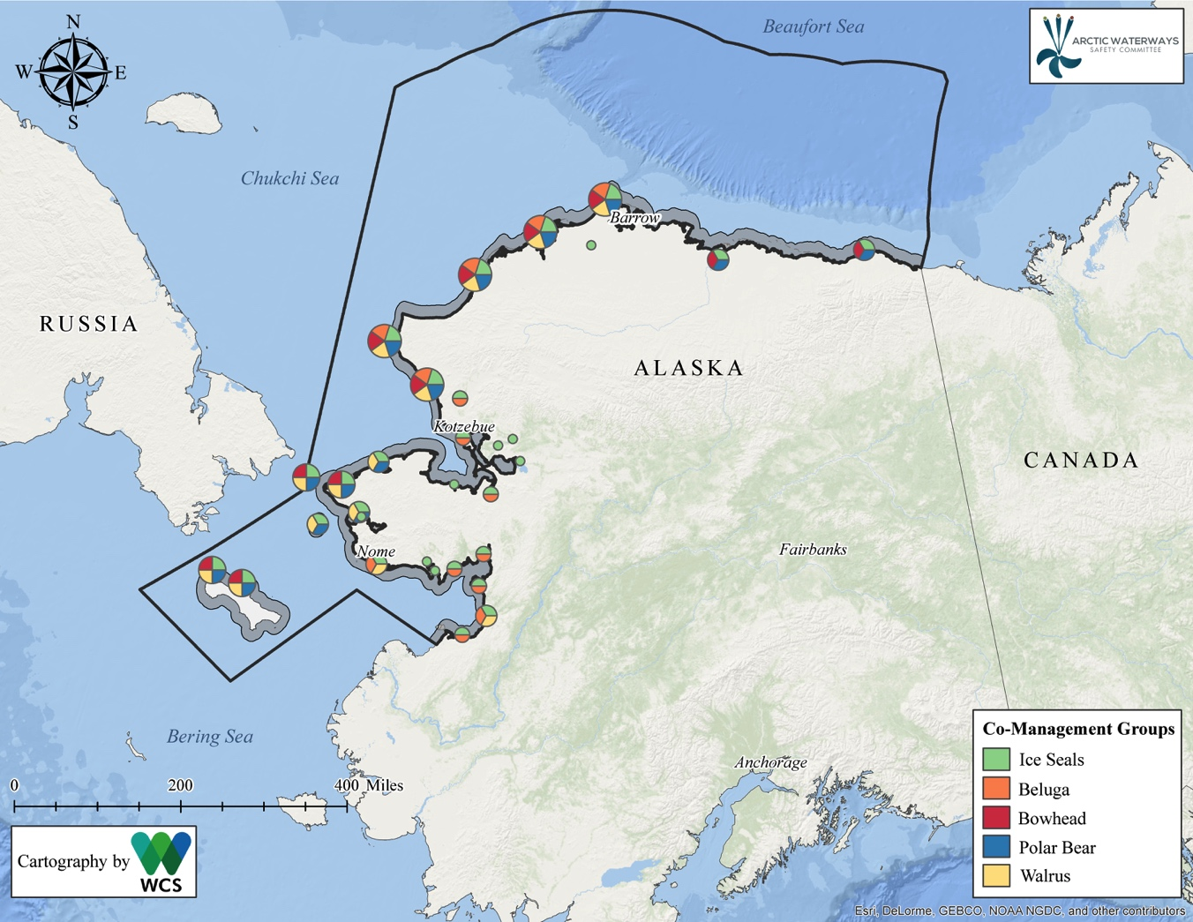
Co-management representation at the different coastal villages within the Arctic Waterways Safety Committee’s area. A 12 nautical mile buffer is shown along the coast for scale.
INDIGENOUS FOOD SECURITY
The Arctic waterways are unique in United States waters for their long-time role in Indigenous food security, particularly with respect to marine mammals. Food security has been variously defined, so we consistently use the definition provided by the Inuit Circumpolar Council-Alaska within the Arctic Waterways Safety Plan.
Alaskan Inuit food security is the natural right of all Inuit to be part of the ecosystem, to access food and to care-take, protect and respect all of life, land, water and air. It allows for all Inuit to obtain, process, store and consume sufficient amounts of healthy and nutritious preferred food – foods physically and spiritually craved and needed from the land, air and water, which provide for families and future generations through the practice of Inuit customs and spirituality, languages, knowledge, policies, management practices and self-governance. It includes the responsibility and ability to pass on knowledge to younger generations, the taste of traditional foods rooted in place and season, knowledge of how to safely obtain and prepare traditional foods for medicinal use, clothing, housing, nutrients and, overall, how to be within one’s environment. Understanding that food is a lifeline and a connection between the past and today’s self and cultural identity. Inuit food security is characterized by environmental health and is made up of six interconnecting dimensions: Availability, Inuit Culture, Decision-Making Power and Management, Health and Wellness, Stability and Accessibility. This definition holds the understanding that without food sovereignty, food security will not exist.

Cultural is added to the verbatim USCG text in the context of the Arctic Waterway’s Safety Committee’s objectives.

