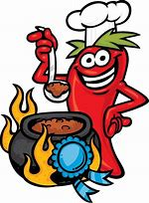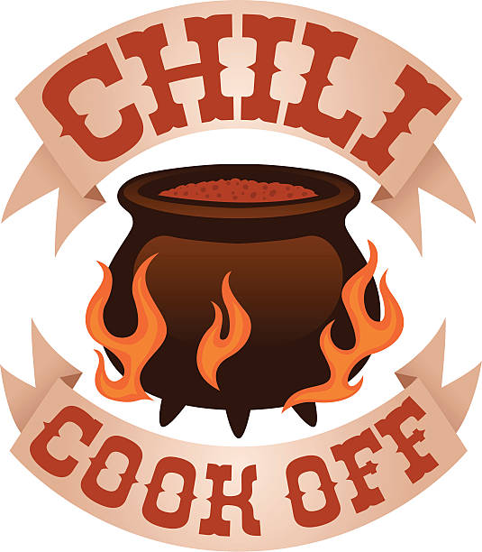Winners

1st Place – Tailgate Chili

Barb Blohowiak

2nd Place – A Little on the Mild Side

Diana Schaiberger

3rd Place – 3 winners tied

Midwestern Chili – Lara Loewenheim

Meatsa Meatsa – Ivan Pelaez

Vegetable Chili – Barbara Otwell

Honorable Mention – Notsa Normal Chili

Sandra & Bob Wooley

Thank you for all who participated in entering and judging the contest!!!

It was fun!!!

