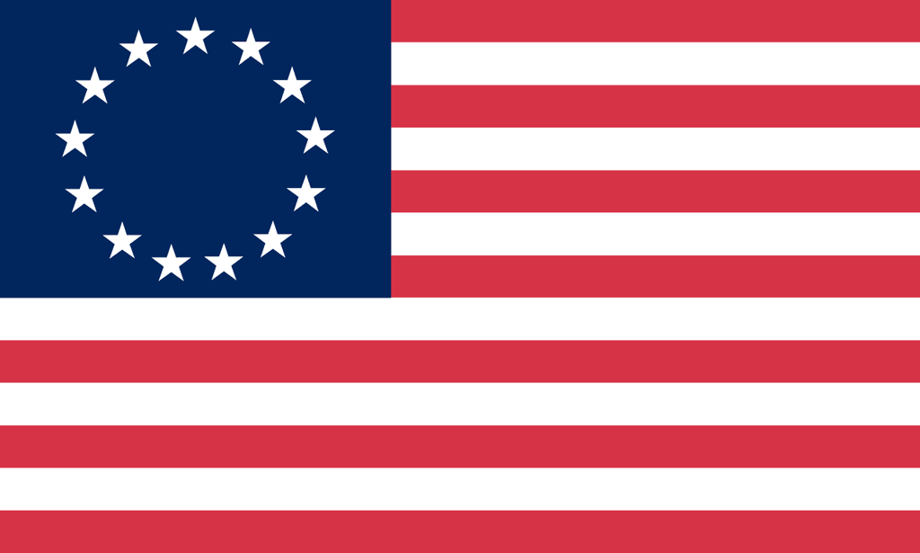U.S. History with Mr. Brown Name _______________________________ Period _____
European Exploration Vocab Quiz

Directions: Match the definition on the right with the correct vocabulary term on the left.

1) _____ Iroquois League  2) _____ Christopher Columbus  3) _____ Slavery  4) _____ Domestication  5) _____ Civilization | A: An alliance amongst several native tribes  B: Breeding plants or animals to meet the needs of humans  C: A culture defined by it economics, government, religion, record keeping , and tools  D: an Italian Sailor who thought he knew a faster way to reach Asia  E: Holding a person in bondage for labor
6) _____Conquistadors  7) _____ Plantations  8) _____ Middle Passage  9) _____ Columbian Exchange  10) _____ African Diaspora | A: A large farm worked by slaves that produces cash crops  B: Middle leg of the Triangular Trade that brought slaves over from Africa to the New World  C: Spanish explorer soldiers  D: The exchange of plants animals and diseases between the old and the new world  E: The forced removal of Africans from their home lands to serve as slave labor

