REGULAR MEETING
DECEMBER 17, 2014

A Regular Meeting of the Town Board of the Town of Hampton, County of Washington and the State of New York was held at the Town Hall, 2629 State Route 22A, Hampton, New York on the 17th day of December, 2014.

PRESENT: David K. O’Brien----------Supervisor
Tamme Taran---------------Councilwoman
David Jensen----------------Councilman
Donald Sady----------------Councilman
Andrea Sweeney-----------Councilwoman
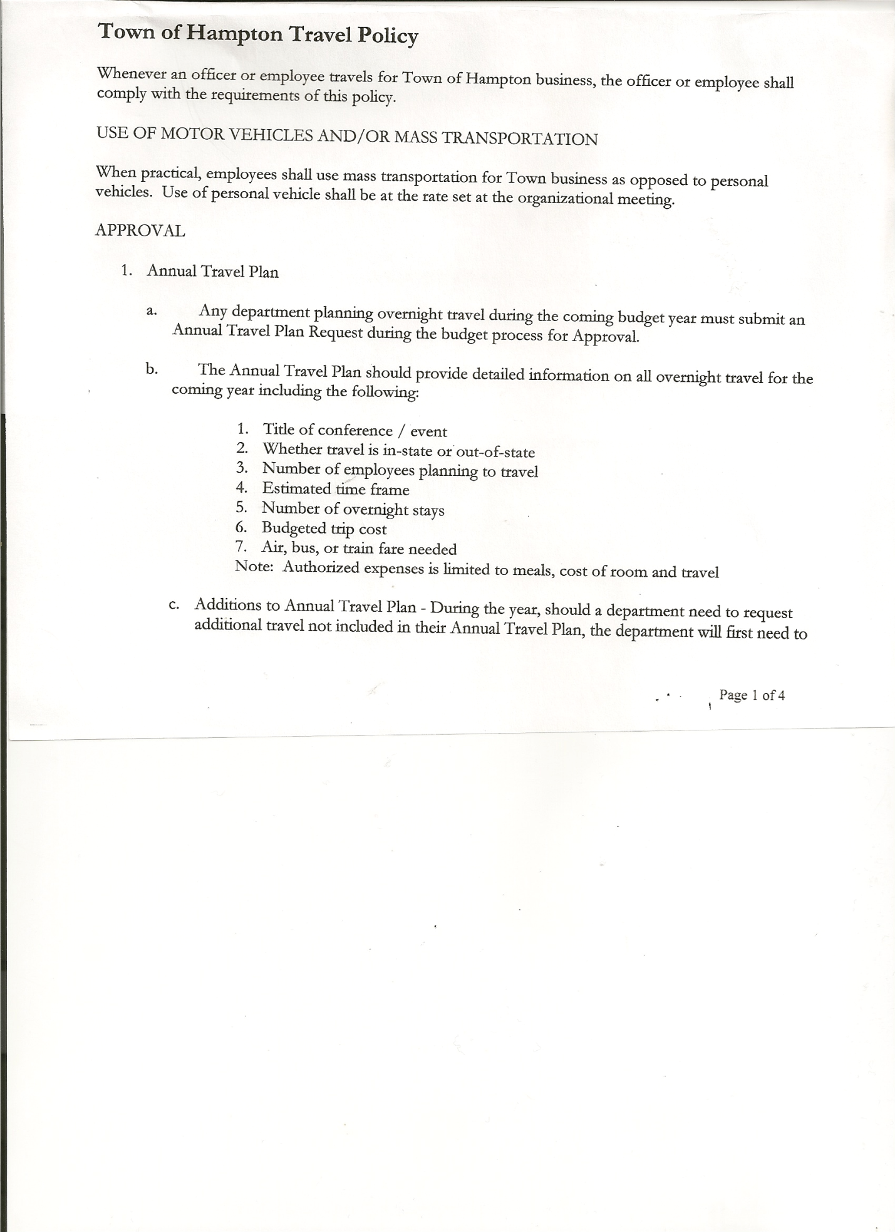
Rebecca Jones--------------Town Clerk
Camilla Shaw---------------Tax Collector/Deputy Town Clerk
Herbert Sady, Jr.------------Highway Superintendent

Planning Board Member(s): Bonnie Hawley, Chair

Also present: See attached list

The meeting was called to order by Supervisor O’Brien at 7:30pm followed by the Pledge of Allegiance. Location of Fire Exits were given.

Supervisor O’Brien asked for a moment of silence in memory of Elaine Johnson, Cty Route 21.

RESOLUTION NO. 100-2014
APPROVAL OF THE MINUTES
On a motion of Councilwoman Taran, seconded by Councilman Sady, the following resolution was
ADOPTED: Ayes 5 O’Brien, Taran, Jensen, Sady, Sweeney
Nays 0
RESOLVED that the Regular Town Board Minutes for November 19th, 2014 are approved.

Supervisor O’Brien presented Joseph Panoushek with a Proclamation in recognition of his dedicated service to the Planning Board of the Town of Hampton. He also read a Proclamation for Heather Spaulding-Gale for her service to the Planning Board. (Copy of each is attached)

Planning Board Report…Bonnie Hawley, Chair
- Planning Board may not have a meeting for December
- Robert Johnson of County Route 21 is interested in serving on the Planning Board

Larry Carman, Dog Control Officer – no report submitted

Camilla Shaw, Tax Collector….no activity, zero balance. County/Town Tax bills will be mailed out the end of December.

Tax Rate Comparison Sheet for the last four years (2012-2015) was handed out to board members (copy is attached)

TOWN BOARD MEETING
DECEMBER 17, 2014 PAGE 2

Herbert Sady, Jr., Highway Superintendent gave his report: (a copy is attached)
- Tyler McClure started work for the Highway Department on December 1st.
- 2000 International….Sander switch needs to be replaced.
- Both Highway Employees have been drug tested and had physicals at Glens Falls Hospital….Random tests will be done at the Whitehall Family Health Center.

COUNTY UPDATES/SUPERVISOR’S REPORT /COMMUNICATIONS:
- Supervisor O’Brien reported that the County Administrator, Kevin Hayes and County Clerk, Dona Crandall would both be retiring at the end of 2015.
- Washington County via the Consolidated Funding Program received a grant for over three (3) million dollars for Economic Development
- At Friday’s County Board of Supervisors Meeting there will be a discussion on whether or not to allow the arming of Probation Officers
- Information sheet handed out on incentives that are available for Advanced Cordwood Boiler heating systems

RESOLUTION NO. 101-2014
APPROVAL OF SUPERVISOR’S MONTHLY REPORT
On a motion of Councilman Sady, seconded by Councilman Jensen, the following resolution was ADOPTED Ayes 5 O’Brien, Taran, Jensen, Sady, Sweeney
Nays 0
RESOLVED that the Supervisor’s Monthly report be accepted as submitted for NOVEMBER 2014.
10/30/14 11/30/14
ACCOUNT BALANCE RECEIPTS DISBURSEMENTS BALANCE
General Fund $ 62034.12 $ 2006.16 $ 14218.27 $ 49822.01
Highway Fund $ 68689.23 $ 389.34 $ 13384.13 $ 55694.44
Equipment Reserve $ 85138.32 $ 7.00 $ 0.00 $ 85145.32
Fire #1 $ 15996.04 $ 1.51 $ 0.00 $ 15997.55
Fire #2 $ 2362.00 $ 0.00 $ 0.00 $ 2362.00
Totals $ 234219.71 $ 2404.01 $ 27602.40 $209021.32

All Board Members present signed Supervisor’s Report.

Town of Hampton, Washington County, Drug and Alcohol Testing Policy 2014…Supervisor O’Brien went over said Policy, which was copied from Washington County’s Drug/Alcohol Testing Policy….

RESOLUTION NO. 102-2014
DRUG AND ALCOHOL TESTING POLICY
On a motion of Councilwoman Taran, seconded by Councilwoman Sweeney, the following resolution was ADOPTED Ayes 5 O’Brien, Taran, Jensen, Sady, Sweeney
Nays 0
RESOLVED to adopt the Town of Hampton, Washington County, Drug and Alcohol Testing Policy 2014, with the additional information completed on page nine (9).
A copy of the Policy is attached.
TOWN BOARD MEETING
DECEMBER 17, 2014 PAGE 3

Employee Handbook…. Councilman Jensen went over Employee Handbook, a few minor corrections need to be made before adopting.

RESOLUTION NO. 103-2014
AMEND TOWN HIGHWAY EMPLOYEE PER HOUR RATE
On a motion of Councilwoman Taran, seconded by Councilman Sady, the following resolution was ADOPTED Ayes 5 O’Brien, Taran, Jensen, Sady, Sweene
Nays 0
RESOLVED to amend the hourly rate of pay set at the 2014 Organizational Meeting for Town Highway Employee from $13.75 to $14.00.

SPECIAL MEETINGS SET
December 29th, 2014 at 7:00pm to Close the Books for 2014 and
January 1st, 2015 at 6:00pm for the Organizational Meeting for 2015

The Town Clerk’s report for November 2014 was submitted to the Board. The Town Clerk had Board Members review and sign bank reconciliation statements for the Town Clerk Account and Special Town Clerk Account dated November 30th, 2014.

RESOLUTION NO. 104 -2014

AUDIT OF CLAIMS
On a motion of Councilman Sady, seconded by Councilwoman Taran the following resolution was ADOPTED Ayes 5 O’Brien, Taran, Jensen, Sady, Sweeney
Nays 0
RESOLVED that the bills have been reviewed by the Town Board and are authorized for payment in the following amounts.
General Fund No. 163 through No. 185 $ 24555.78
Highway Fund No. 133 through No. 145 $ 17117.24
Total both funds $ 41673.02

RESOLUTION NO. 105-2014
AUTHORIZE PAYMENT OF CDPHP BILL
On a motion of Councilman Sady, seconded by Councilwoman Taran the following resolution was ADOPTED Ayes 5 O’Brien, Taran, Jensen, Sady, Sweeney
Nays 0
RESOLVED, to pay the CDPHP bill (medical insurance) for George Palmer, new Town Highway Employee.

On a motion of Councilman Sady, seconded by Councilwoman Taran , the meeting adjourned at 9:02pm. All in favor Aye.

Respectfully submitted,

Rebecca S. Jones, RMC
Town Clerk

