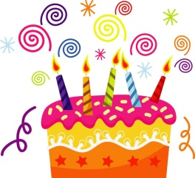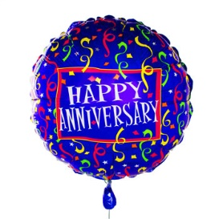
Call it a birthday, call it an anniversary.
Whatever you call it, come CELEBRATE.
When: Sunday, September 12, 2021
Where: Fellowship Hall following the 11 am service.
What: Lunch, cake, fellowship
135 years since the founding of our church.

