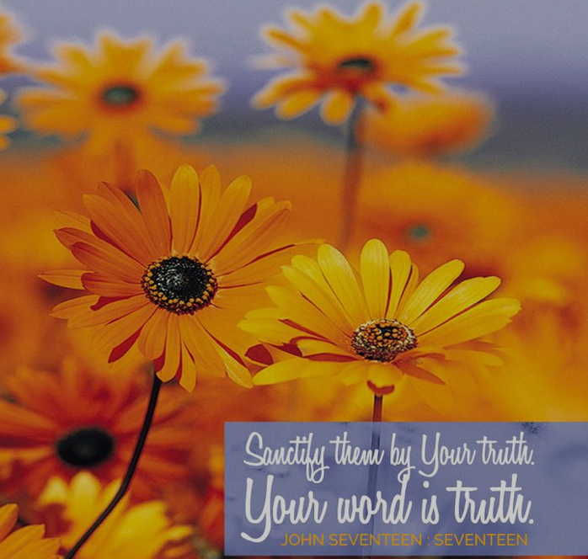

September 18, 2022

15th Sunday after Pentecost

Carson City United Methodist Church

10:30 am

Greeting/Announcements

Call to Worship
L: Because of the Lord’s great love we are not condemned,
for his compassion never fails.

P: Gods compassion is new morning, great is Gods faithfulness.

L: Let us say to ourselves, “The Lord is my salvation,
therefore, we will wait for him.”

P: The Lord is gracious to those whose hope is in him,
to those who seek him.

L: It is good to wait patiently for the salvation of the Lord.

P: It is good to be still and look and see God’s presence all around us every day.

*Hymn: Jesus Loves Me UMH 181

Opening Prayer:
May the strength of God guide us. May the power of God preserve us. May the wisdom of God instruct us. May the hand of God protect us. May the ways of God direct us. May the shield of God defend us. May the ghost of God guard us against the snares of evil and the temptations of the world. May Christ be with us, Christ before us, Christ in us, Christ over us. May your salvation O Lord, be always ours this day and forevermore. AMEN.

Contemporary Song: Amazing Love (News Boys)

Offering

Doxology UMH 95

Offertory Prayer

Sharing of our Joys and Concerns

Call to Prayer: Turn Your Eyes Upon Jesus UMH 349

Pastoral Prayer

Gospel Reading: JOHN 17:14-15

Old Testament: JEREMIAH 29:7

Epistle Lesson: 1 PETER 2:22-25

Contemporary Song: One Way Jesus (Philips, Craig & Dean)

MESSAGE

*Hymn: Savior Like a Shepherd Lead Us UMH 381

Benediction

CCUMC – Announcements & Upcoming Events:

As a courtesy to others please silence or shut off cellphones

==================================================
St. Mary Parish Craft Show: Sat, Sep 24th, 9:00 am to 3:00 pm. Located at St. Mary Hall, Carson City.
==================================================
Hall Rental: Sat, Sep 24th, all day.
==================================================
Town Hall Meeting: Tue, Sep 27th @ 7:00 pm in the Sanctuary. Topic is discussing the disaffiliation from The United Methodist Church as well as our options. Andy Croel will be the speaker.
==================================================
Ad Board/Finance Meeting: Wed, Sep 28th @ 6:30 pm.
==================================================
Michigan Conference Mission U: Is held at Gaylord UMC October 17-18. Walthagaye is attending both so if you need a ride, please get in touch with her. The flyer is on the What’s Happening bulletin board with registrations on the shelf under it.
==================================================
Craft & Vendor Show: CCUMC will be hosting a Craft Show on Sat, Nov 5th, 9:00 am thru 2:00 pm. If you are a Vendor interested in reserving a spot, please contact Dawn Wager @ 989-285-2518.
==================================================

Serving & Supporting Sunday Worship
Audio/Video: Pat Monroe

Joys, Concerns & Prayer Request
For those battling cancers:
Jim Dunlap, Carolyn Nykerk, Dillan Abell,
Amorena Newman-Wojciakowski

For those who need support, guidance or have health concerns: Mindy Dennis, Heather Kile

Weekly Giving
9/4 $1307.97 9/11 $3537.97

Nursery Schedule
9/18 Molly Fitzpatrick 9/25 Maryann Severson

Lighting of Candles

Passing of Collections Plate

Our Church in Ministry This Week

Sun: Women’s Group 6:30-8:00 pm
Mon: P.T. Class 6:30-8:00 pm
Tue & Thu: COA Meal 10 am – 2 pm
Wed: A.R.K. 6:30-8:00 pm

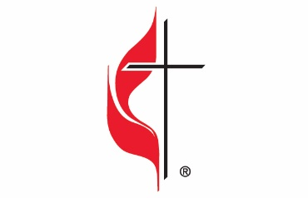

Carson City United Methodist Church
Location: 119 East Elm St., Carson City, MI
Mail: PO Box 298, Carson City, MI 48811
Phone: 989-584-3797 Email: carsoncityumc@gmail.com
Website: carsoncityumc.com
Sunday Worship Service: 10:30 am
Office Hours: Monday-Thursday, 9:00 am-12:00 pm
After hours by appointment
Pastor: Ian McDonald 906-322-5318
Secretary: Bonnie Seaman 989-763-1674

Weekly Sunday Bulletin now available on our website
@ www.carsoncityumc.com

“Glorious God, help me to grow in Your wisdom”

