Grant opportunities:
https://www.schooltheatre.org/programs/ags/grants

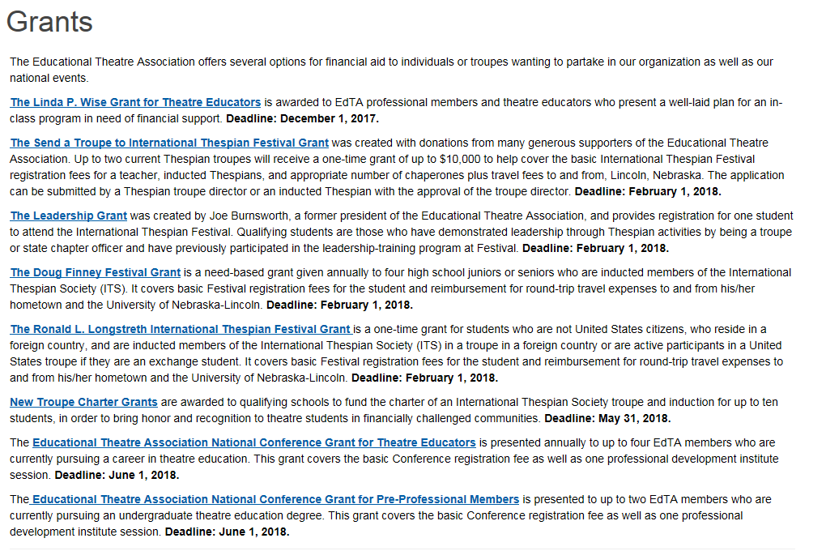

National Scholarships:
https://www.schooltheatre.org/programs/ags/scholarships
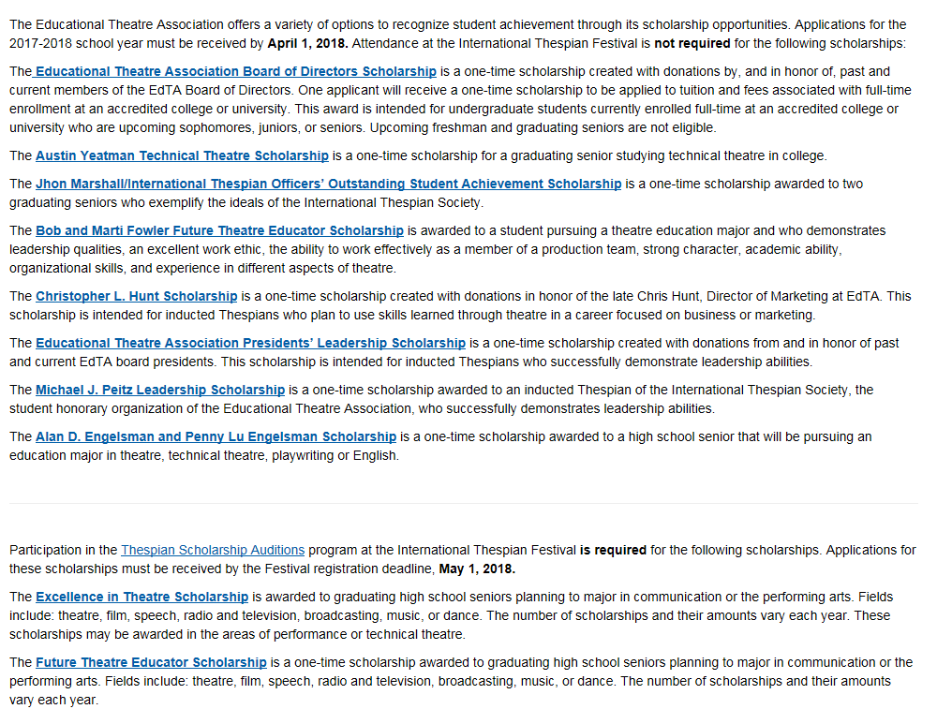

Awards:
https://www.schooltheatre.org/programs/ags/awards
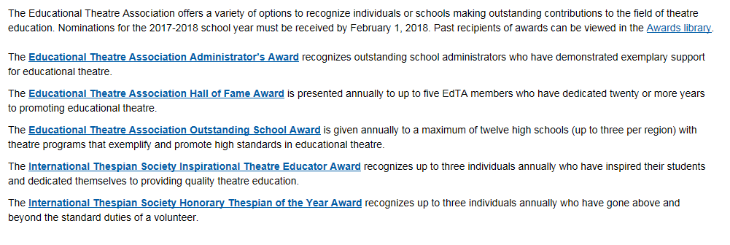

COLLEGE AUDITIONS & THESPIAN SCHOLARSHIPS
If you are going to state, here is the link and information to audition for college and thespian scholarships.
https://sites.google.com/site/indianathespians/state-conference/Scholarship-Auditions

