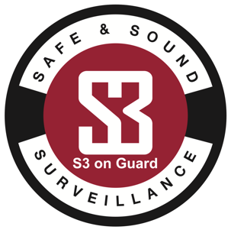
ACKNOWLEDGEMENT OF CRIMINAL HISTORY BACKGROUND CHECK

As an applicant for a non-gaming position at Safe and Sound Surveillance – S3 on Guard, I hereby acknowledge that I have completed the Safe and Sound Surveillance – S3 on Guard Employment Application truthfully. In completing the “Criminal History Background Addendum” section of this application I hereby agree that I fully understand each and every question or statement contained in this addendum and acknowledge that I must disclose each and every criminal conviction and pending criminal charges that I have ever had no matter how old that event might be. Furthermore, I acknowledge that failure, on my part, to disclose any information in this addendum will be grounds for denial of my application or termination of my employment.

As an applicant, I understand that if I have been convicted of any crime, which is a felony in Mississippi, of moral turpitude, embezzlement, or larceny, I may not eligible for employment at Safe and Sound Surveillance – S3 on Guard.

As an applicant, I understand that if I have been convicted of misdemeanor theft, or misdemeanor conviction for crimes of violence, including simple assault or domestic violence during the past three years I may not be eligible at Safe and Sound Surveillance – S3 on Guard.

As an applicant, I further understand that if employed, I must report any arrest or conviction to the Safe and Sound Surveillance – S3 on Guard Human Resources Department.

I hereby agree that I have read and understand this document. My signature below authorizes Safe and Sound Surveillance – S3 on Guard to conduct a confidential background check to verify all information I have provided.

Signature of Applicant  PRINTING YOUR NAME HERE GIVES YOUR ELECTRONIC SIGNATURE | SSN | Date

Human Resources Representative Signature Date

CRIMINAL HISTORY ADDENDUM

Please read the form completely and fill in ALL blank spaces:

ITEM |  | YES | NO
A. | Have you ever been convicted of any crime, which is a felony, of moral turpitude, embezzlement, or larceny?
B. | Have you been convicted of misdemeanor theft, or misdemeanor conviction for crimes of violence, including simple assault, or domestic violence within the past three years?
C. | Do you currently have any criminal charges pending against you?

If you answered yes to any of the above questions, you must complete the following section (Use additional sheets if necessary).

Date | Charge | Arresting Agency | City | State | Disposition

I, the undersigned applicant, certify that the foregoing information is true and correct. I further acknowledge that failure to make full and true disclosure of all information on the application is cause for denial or revocation of my application or employment at Safe and Sound Surveillance – S3 on Guard.

Signature of Applicant  PRINTING YOUR NAME HERE GIVES YOUR ELECTRONIC SIGNATURE | Date

Human Resources Representative Signature Date

