PUBLIC HEALTH  St. Clair County Health Center  530 Arduser  Osceola, Missouri 64776  Phone: (417) 646-8332  Fax: (417) 646-8159 | 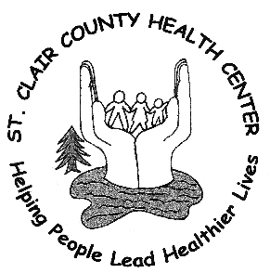

Nancy Stephan
CFO / Administrator

April 8, 2020

St. Clair County Health Center Reports First Case of COVID-19

St. Clair County Health Department is announcing its first positive case of novel coronavirus (COVID-19). The cases are not travel-related outside of the country and the patients are Male 78 years old, and Female 76years old. They have been put in quarantine.

Health Department staff are working in coordination with the Missouri Department of Health and Senior Services (DHSS) to determine any close contacts of that individual who were possibly exposed. If there were any, health officials will provide guidance to these individuals and monitor them closely for the development of symptoms.

The health department urges the public to take appropriate precautions including good hygiene, social distancing and limiting in-person interactions. If you are sick, particularly with a fever and a cough, or shortness of breath, stay home and contact your health care provider or urgent care center for guidance regarding symptoms and next steps.

“The best tips for prevention are still social distancing and proper handwashing,” said Nancy Stephan, Administrator of St. Clair County Health Center. “Staying home if you are sick and avoiding close contact with others will help us limit any spread.”

For more information, visit the DHSS website at www.health.mo.gov/coronavirus or the CDC website at www.cdc.gov/coronavirus or St. Clair County Health Center website at www.scchcmo.net under COVID-19. A statewide COVID-19 hotline also operates 24 hours a day, 7 days a week at 877-435-8411. For further questions you may contact Jeanne Beas, Epidemiology Investigator, at 660-890-5044 cell or Jeanne.beas@lpha.mo.gov .

