Hilliard Family PODIATRY, LLC.

PATIENT FULL NAME: DATE OF BIRTH: GENDER: FEMALE MALE
SOC SEC # MARITAL STATUS: MARRIED SINGLE PARTNERED DIVORCED WIDOWED

.

.

RACE WHITE PACIFIC ISLANDER OTHER ETHNICITY: LANGUAGE:
.
.
.
AMERICAN INDIAN ASIAN BLACK/AFRICAN AMERICAN HISPANIC NON-HISPANIC
.
.
.
.
.
ADDRESS: CITY: STATE: ZIP:

PRIMARY PHONE: TYPE: H/W/C SECONDARY PHONE: TYPE: H/W/C OKAY TO LEAVE MESSAGE: YES NO

OKAY TO TEXT: YES NO

E-MAIL ADDRESS:

EMPLOYER: PHONE: OCCUPATION:

RESPONSIBLE PARTY: SELF SPOUSE PARENT OTHER ____________________

ADDRESS: CITY: STATE: ZIP:

DOB: SOC SEC #: PRIMARY PHONE #:

EMERGENCY CONTACT: RELATIONSHIP: PHONE #:

INSURANCE INFORMATION
Primary Insurance: SUBSCRIBER: DOB:
Secondary Insurance: SUBSCRIBER: DOB:

CONTINUITY OF CARE
PRIMARY CARE PHYSICIAN: PHONE: DATE LAST SEEN:

PHARMACY: PHONE: ZIP:

SOCIAL HISTORY
DO YOU SMOKE? NO PAST USE YES HOW MANY PACKS PER DAY? ____ FOR HOW LONG? ____

DO YOU USE DRUGS? NO YES PAST USER

DO YOU DRINK ALCOHOL? NO YES ( 1-2 DRINKS/MONTH 1-2 DRINKS/WEEK 2-3 DRINKS/WEEK 3+/WEEK)

EXERCISE? NEVER OCCASIONALLY WEEKLY DAILY

HEIGHT | WEIGHT | SHOE SIZE
DIABETES
DO YOU HAVE DIABETES: YES NO HOW LONG?

HOW DO YOU CONTROL YOUR DIABETES? DIET INSULIN OTHER MEDICATION

WHAT WAS YOUR LAST BLOOD SUGAR LEVEL OR A1C?

MEDICAL HISTORY
AIDS/HIV | SELF FAMILY | HIGH CHOLESTEROL | SELF FAMILY
ANEMIA | SELF FAMILY | HYPERTENSION | SELF FAMILY
ANXIETY | SELF FAMILY | KIDNEY PROBLEMS / DISEASE | SELF FAMILY
ARTHRITIS (GENERAL) | SELF FAMILY | MENTAL DISORDER | SELF FAMILY
ASTHMA | SELF FAMILY | OPEN SORES | SELF FAMILY
BACK PAIN | SELF FAMILY | OSTEOPOROSIS | SELF FAMILY
BLEEDING DISORDER | SELF FAMILY | POOR CIRCULATION | SELF FAMILY
BLOOD CLOTS | SELF FAMILY | RHEUMATOID ARTHRITIS | SELF FAMILY
CANCER | SELF FAMILY | SLEEP APNEA | SELF FAMILY
DEPRESSION | SELF FAMILY | STD / STI | SELF FAMILY
EPILEPSY / SEIZURES | SELF FAMILY | STOMACH ULCERS | SELF FAMILY
FIBROMYALGIA | SELF FAMILY | STROKE | SELF FAMILY
GOUT | SELF FAMILY | THYROID / HIGH / LOW | SELF FAMILY
HEADACHES | SELF FAMILY | TUBERCULOSIS ACTIVE / NON | SELF FAMILY
HEARING PROBLEMS | SELF FAMILY | VEIN DISORDER | SELF FAMILY
HEART DISEASE | SELF FAMILY | VISION PROBLEMS | SELF FAMILY
HEPATITIS ( A / B / C ) | SELF FAMILY
PLEASE LIST OTHERS:
HAVE YOU HAD ANY OF THE FOLLOWING: CHICKEN POX MEASLES MUMPS POLIO

ALLERGIES NO KNOWN DRUG ALLERGIES

NAME | REACTION | NAME | REACTION | NAME | REACTION
___ASPIRIN |  | ___NSAIDS |  | ___PENICILLIN
___CODEINE |  | ___DEMEROL |  | ___ANESTHETICS
___CORTISONE |  | ___SULFA |  | ___LATEX
___IODINE/  SHELLFISH |  | ___TAPE/  ADHESIVES |  | ___IV CONTRAST  (DYE)
LIST ANY OTHERS:
ENVIRONMENTAL / FOOD:

MEDICATION LIST: Do we have permission to electronically obtain your medication list? ___ Yes ___ NO
NAME OF MEDICATION | REASON FOR MEDICATION
PAST DIAGNOSTIC TESTING
(MRI / X-RAY / CT) OF FOOT/ANKLE | DATE | WHERE WAS THE TEST PERFORMED

HISTORY OF ANY NON-FOOT RELATED SURGERIES: DATE/YEAR:
HISTORY OF ANY FOOT SURGERIES: DATE/YEAR:

REASON FOR VISIT: ______________________________________________________________________________________________________________________________________________________________________________
LENGTH OF CONDITION: _________ DAYS / WEEKS / MONTHS / YEARS
LOCATION: _______________________________________________________________________________________________
CHARACTERISTICS OF PAIN: ACHING NUMB BURNING DULL SHOOTING SHARP STABBING ITCHING DEEP SUPERFICIAL
PAIN LEVEL: 0 1 2 3 4 5 6 7 8 9 10
PAST TREATMENTS: _____________________________________________________________________________________________________________________________________________________________________________________________________________________________________________________________________
PREVIOUS DOCTORS SEEN FOR THIS CONDITION:
WHAT HAS HELPED SYMPTOMS: _______________________________________________________________________________________
WHAT MAKES SYMPTOMS WORSE:
_______________________________________________________________________________________
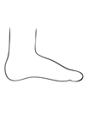
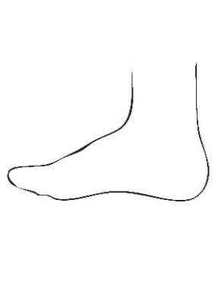
CIRCLE PROBLEMATIC AREAS
LEFT FOOT RIGHT FOOT
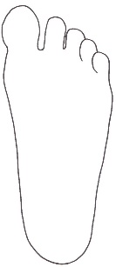
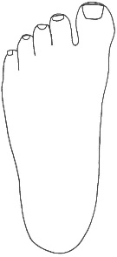
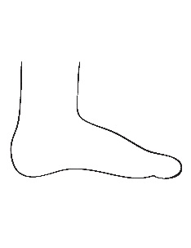
TOP BOTTOM BOTTOM TOP

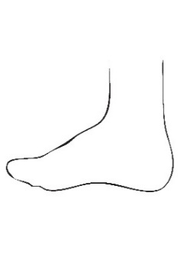
INSIDE INSIDE

OUTSIDE OUTSIDE

I hereby give permission for Hilliard Family Podiatry to render the proposed podiatric examination and treatment. I authorize the release of any information to my insurance company and any medical information necessary to process any claim and I request payment of insurance benefit due to Hilliard Family Podiatry to be paid directly to Hilliard Family Podiatry. I hereby give my permission for Hilliard Family Podiatry to forward any pertinent medical information to my primary of referring physicians for continuity of care. I permit a copy of this authorization to be used in place of the original. This authorization may be revoked at any time by either me or my insurance company in writing. The above information is true and I will notify Hilliard Family Podiatry of any changed.

Signature: _________________________________________ Printed name: ____________________________ Date: __________

