**Diffusion and Osmosis Lab**

**Objectives:**

1. To review the parts of a solution (solvent, solute) and the meaning of concentration.
2. To understand the process of diffusion and how Brownian movement contributes to diffusion.
3. To understand the concept of concentration gradients.
4. To understand selective permeability of membranes.
5. To understand how osmosis and dialysis occur.
6. To understand the relative tonicity of solutions and the effect of tonicity on cells.

A solution is a mixture of a **solvent** and a **solute** dissolved in the solvent. The **concentration** of a solution is the amount of solute dissolved in a given amount of solution. In the example below, solution A is more concentrated than solutions B or C. You can confirm this by comparing the relative number of solute particles, represented by black dots, in each container in the figure below.

**Solution B**

**Solution C**

**Solution A**

More concentrated

Less concentrated

If you have been in mountainous terrain you have probably seen signs warning truck drivers of the steep grade they face as they drive down a mountainside. Because the road slopes away from away from the mountaintop, gravity will quickly pull a vehicle down the highway. The difference in height between the top and the bottom of the mountain creates a steep *elevation gradient*/grade on the highway. The steeper the gradient, the faster the truck will run down the mountain. In some situations, certain solutes may not be uniformly distributed in a solvent. There may be an area where the solute concentration is high and another area where the solute concentration is low. We call this difference a **concentration gradient**. The bigger the difference in concentration, the faster the molecules will move from areas of higher to lower concentration.

For example, in today’s lab, such a gradient will be formed when crystals of KMnO4 are placed in a beaker containing water. As those crystals dissolve, purple MnO4- ions will move into the surrounding water. The water nearest the crystals will contain more purple ions than the water farther from the crystals. Like the truck rolling down the slope, purple ions will move outward from the area of highest concentration (immediately surrounding the crystals) to areas of lower concentration (the rest of the water) by a process known as **diffusion**. The ions are said to move *down their concentration gradient*, or with the gradient (from high to low concentration). In the figure below, solvent (H2O) is present throughout the container. The visible solute (black dots) is more concentrated in one part of the container than in others.

High solute concentration Low solute concentration



Low water concentration High water concentration

There are, in essence, two concentration gradients in this figure. There is a gradient of solute concentration (higher on the left than on the right). Conversely, a solvent concentration gradient is oriented in the opposite direction. Where no solute appears, on the right, the concentration of water is 100%. On the left, where solute is present, the concentration of water is less than 100%.

All particles undergoing diffusion move from an area where their concentration is high, to an area where their concentration is low. This means, they always move down their concentration gradients. Those particles will continue to move in that direction until the concentration gradient is gone. This happens when the concentration in any part of the solution is the same as it is in other parts of the solution. This condition is called **dynamic equilibrium**. Particles are still in motion but there is no net movement of particles in either direction.

# Movement of substances across membranes

In biological systems, solutions are often separated by membranes. For example, substances dissolved in the fluid surrounding the cells may be at a different concentration than the concentration of that solution in the cytoplasm of the cell. If two solutions are separated by a selectively permeable membrane, there are two factors to consider before predicting whether diffusion or osmosis will occur:

1) Is there a concentration gradient? Remember there can be a gradient of either solute or solvent. Without such a gradient there will be no net movement of molecules from one compartment to the other.

2) Is the membrane **permeable** to solvent or solute molecules? Will the membrane allow passage of those molecules?  
If the membrane is permeable to solute and solvent, diffusion will drive the solute from the compartment on the left to the one on the right. Diffusion of soluble substances (solutes) through a selectively permeable membrane is called **dialysis**. Water will also cross the membrane. **Osmosis**, the process that moves the water **solvent** through selectively permeable membranes, will drive water from the compartment on the right to the one on the left. These processes will continue until the concentrations are the same on each side of the membrane.

**Exercise 1:   
Osmosis along a concentration gradient/creating artificial “cells”**

Osmosis is the diffusion of water across a selectively permeable membrane that is impermeable to the solute. The diffusion rate or speed at which a substance moves from one area to another depends on the nature of the concentration gradient between those areas. If concentrations differ greatly, then the gradient is steep and diffusion rate is more rapid. Diffusion rate decreases as the concentration gradient flattens out.

The relative concentration of two solutions can be described in terms of tonicity.   
  
 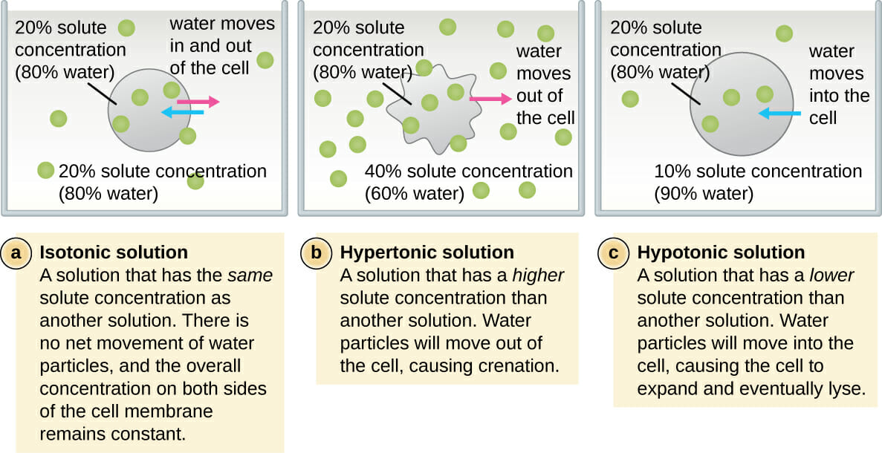

**Remember…**osmosis is the movement of *water* across the membrane *not the solutes.***You’ll be testing your hypothesis which answers the question…***Which of the following systems will experience the greatest osmotic change over time*

*and which will experience the least osmotic change over time?***This question can be answered by considering how concentration gradients affect the rate of osmosis.**Here are the systems:  
a. distilled water placed in a 25% sucrose environment  
b. distilled water placed in a 50% sucrose environment  
c. 25% sucrose placed in a distilled water environment  
d. 50% sucrose placed in a distilled water environment  
e. 25% sucrose placed in a 50% sucrose environment  
f. 50% sucrose placed in a 25% sucrose environment  
  
I will set up a system that will function as your control:   
25% sucrose in a 25% sucrose environment  
  
You will be working in groups as part of a collective research team (your class).

Each of the six groups will be assigned one of the six systems listed. The data collected by each group will be shared with the rest of the team in order to determine the validity of your hypothesis. **However, everyone’s hypothesis is their own…you do not need to agree with your group or other members of the research team.   
   
  
All of the materials you need will be on the supply bench and in the supply cabinets.  
To test your hypothesis,** you’ll perform an experiment using the instructions provided in class.   
Your data will consist of 7 weight measurements… your initial weight and 6 others.  
Using these data:  
you’ll determine how much your cell has changed in weight.  
you’ll calculate the % weight change by dividing your change in weight by your starting weight.  
you’ll plot your 7 weight changes for your group on the graph paper provided making sure that your X/Y axis designation accurately represents your results.   
You’ll add your data to the data for the entire team written up front on the board.   
  
Your conclusion will be based on the data from the entire team and include:  
Which cell had the largest net gain in water weight over time? Why?  
Which cell served as your class’s control? Why?  
Which cell had the smallest net loss in water weight over time? Why? **Your lab report will be based on the data collected by your entire   
 research team = your class.**You were given the question.  
You created your hypothesis.  
You accessed specific materials.  
You completed a step by step procedure.  
You have your group’s data and the data for each of the sections of your   
 research team.  
You can present this data so that it is understandable via charts, graphs   
 and any calculations.  
You can draw your conclusions based on this data…was your hypothesis   
 correct?  
You can discuss your conclusions and the validity of your hypothesis,  
 suggesting further research and any possible future alterations  
 in your procedure.   
  
**Hard copies of your lab reports will be submitted Wednesday, October 25th.**

Each student is to write their own report. Collaboration is encouraged but outright copying another student’s work is considered plagiarism.

**Exercise 2:   
 Osmosis in living plant cells**

To demonstrate that osmosis occurs across cell membranes in living systems, we will study the effects of various salt solutions on *Elodea* cells.  
 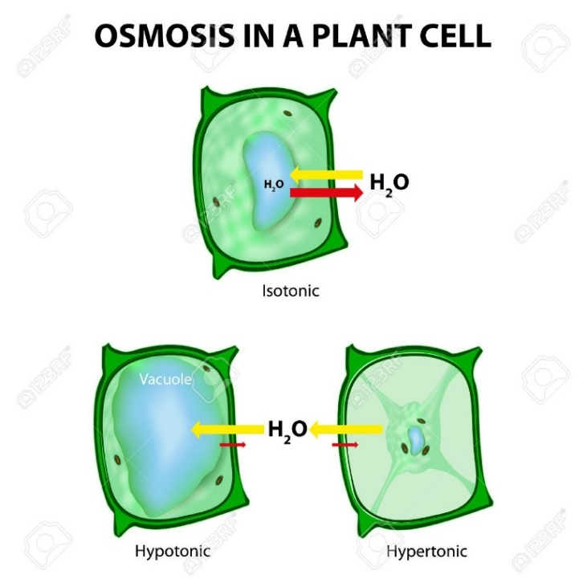  
**Obtain the following materials from the supply bench:**3 slides  
3 coverslips  
Distilled water  
3 *Elodea* leaves  
1% NaCl solution  
20% NaCl solution

**Procedure:**

1. Label three slides 0, 1%, and 20% using a wax pencil.

2. Remove three healthy *Elodea* leaves and place each on a separate slide. Add a few drops of distilled water to the slide labeled “0.” Add the appropriate salt solutions to the other slides. Place a cover slip over each leaf.

3. After 5 minutes, examine the cells under 40X magnification. (Remember to focus first at 4X, then 10X, then 40X.) Pay particular attention to the placement or movement of the chloroplasts in each cell.

4. Draw cells of each slide, and identify each extracellular solution as isotonic,   
 hypotonic, or hypertonic relative to the cytoplasm. Explain what happened in each.  
  
 **Exercise 3  
 Brownian movement (demo)**

Brownian movement is the random movement of small particles resulting from collisions with other moving molecules in a fluid medium (liquid or air). You cannot see the movement of individual molecules, but you can witness the effect of all of this molecular movement on other larger particles. India ink is a liquid suspension of very small pieces of black pigment. The pigment particles vibrate when water molecules (surrounding the particles of pigment) bump into them, forcing them to bounce around. It is the force of Brownian movement that drives diffusion in solutions – the bouncing around eventually produces an even distribution of particles.

**Procedure:**1. Place a small drop of India ink on a microscope slide and cover it with a coverslip.

2. This is a difficult slide to focus on, but you must focus on (4X) and (10X) before going any higher. The presence of a small air bubble may help by giving you a structure to focus on. At (40X) you should see thousands of particles vibrating rapidly. Lower the light with the iris diaphragm lever to improve the appearance.   
 **Exercise 4:   
 Simple diffusion**

**Obtain the following materials from the supply bench:**distilled water and a bottle potassium permanganate (KMnO4) crystals

**Procedure:**

1. Fill a small beaker with distilled water and place it on a bench top in an out-of-the-way place. Drop a small crystal of potassium permanganate into the water. Do not shake the beaker.

2. Observe the changes in the beaker from time to time and record your observations in the space provided below.   
  
 **Exercise 5:  
Diffusion across a selectively permeable membrane/dialysis**

The size of a molecule (molecular weight) is an important factor determining whether a membrane is permeable to that molecule. In this experiment we can demonstrate membrane selectivity for molecular size by using a bag made from dialysis tubing to model a selectively permeable membrane, such as the cell membrane found in living cells. Dialysis membranes are very good models for selectively permeable membranes because they have small pores that allow small molecules such as water to pass but block larger molecules such as sucrose and starch. Dialysis is the movement of dissolved substances (solute) across a membrane from higher concentration to lower concentration until dynamic equilibrium is reached.

**All materials are available on the supply bench. Glassware is in the cabinets.**

Dialysis tubing 20cm long iodine-potassium iodide (I-KI) 1% starch solution  
 distilled water 1 M NaOH solution phenolphthalein

**Procedure:**

1. Soak two pieces dialysis tubing in distilled water. Make a leak proof knot at one end of each tube.

2. Fill the open end of one tube with 10 mL of distilled water and 3 drops of phenolphthalein. **Phenolphthalein is a pH indicator that turns red in a basic solution.**Seal off the bag tightly with a knot. Rinse the outside with tap water. Place the bag in a 250 mL beaker containing 200 mL of tap water and 8 drops of NaOH.

3. Fill the other tube with 10 mL of starch solution. Tie off the bag. Rinse excess starch off the outside. Place this bag in a 250 mL beaker containing 200 mL of tap water and 10 drops of iodine (I-KI). **Iodine is a starch indicator turning dark blue in the presence of starch**.

4. Set the 2 beakers aside for 1 hour and observe changes; record in table below.

5. **E**xplain which molecules moved in which direction and why.

|  |  |  |
| --- | --- | --- |
| **Starch + Iodine** | Initial | Final |
| Color of contents of tube |  |  |
| Contents of tube |  |  |
| Color of contents of beaker |  |  |
| Contents of beaker |  |  |

|  |  |  |
| --- | --- | --- |
| **Phenolphthalein + NaOH** | Initial | Final |
| Color of contents of tube |  |  |
| Contents of tube |  |  |
| Color of contents of beaker |  |  |
| Contents of beaker |  |  |

**Questions:**

1. Define solution, solute, solvent, and concentration.

2. Describe a concentration gradient.

3. Define Brownian movement. How can you speed up the movement?

4. What is the difference between diffusion and osmosis?

5. In Exercise 3, has starch moved out of the second tube? How can you tell?

6. In Exercise 3, has phenolphthalein left the tube? How can you tell?

7. Which molecules or ions passed through the selectively permeable bags in exercise 3?

8. What happens to the *Elodea* cells when placed in distilled water? Why do they not burst?

What happens to the *Elodea* cells when placed in 20% NaCl solution?

9. In exercise 4, which solutions (in the beakers outside of bags) were isotonic, hypertonic, or hypotonic to the contents of the bags? Which bags gained, lost or remained the same in weight?

10. Define hypertonic, hypotonic and isotonic solutions.

11. If you place red blood cells in distilled water, what would you expect to happen? Why?

12. How does the concentration gradient of water affect the rate of osmosis in the bags? Which bags had the steepest concentration gradient?