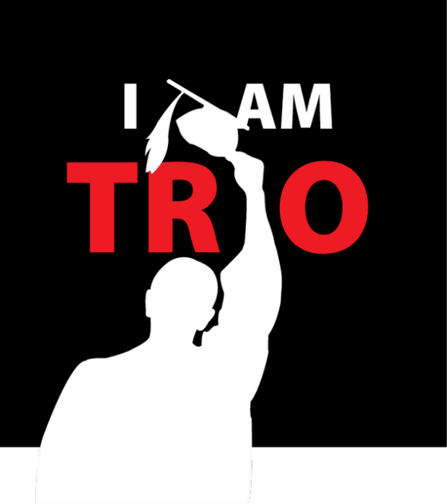
CENCAL WESTOP
TRIO DAY Tentative Agenda
Fresno City College
Saturday, February 23rd, 2019

9-10 am Alumni Breakfast (RCC)
930-1045 FCC Tours for students who show up early (Ben)
10-1045 Registration/Change into shirts/Fill up Auditorium

11 am Start Program
Welcome FCC/SCCCD
History of TRIO & Advocacy
Congressman #1
Proclamations SSS programs
Congressman #2
Proclamations Talent Searches

12 pm Lunch
1245 pm Finish Lunch
1 pm – 145 Workshop Strand #1
22 Workshops 15 High School / 7 College Aged

2 pm – 245 Workshop Strand #2

3 pm – 330 pm Philanthropic Effort / Proclamations/ Presentation of Letters Closing

