Friday Pizza Program
Sign Up Form

Session 2 runs from January 21 to April 8, 2022
Make checks payable to Sunrise Montessori School

If your full day student is interested in participating in the optional pizza program,
please complete this form and send a check in the amount of $50.00, payable to
Sunrise Montessori School. Be sure to write your child's name on the memo line of the check.

On the Fridays listed below, cheese pizzas are ordered for lunch from 360 Pizzeria & Kitchen
in Franklin. In addition to pizza, the children will enjoy a special story time!
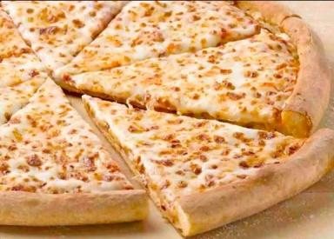

Student’s Name: __________________________________

Please detach the bottom of this page and save as a reference.
Please return this form no later than Friday, December 17, 2021.

If your child does not plan to participate in the pizza program, please be sure to pack a
peanut free lunch.

The 10 Friday Pizza dates for Session 2 are:
- January 21 and 28 (no pizza on January 14 due to the Professional Development Day)
January 7 was a snow day – the session has been extended to April 8
- February 4, 11 and 18 (no pizza on February 25 due to Vacation Break)
- March 4, 11 and 25 (no pizza on March 18 due to the Professional Development Day)
- April 1, 8

