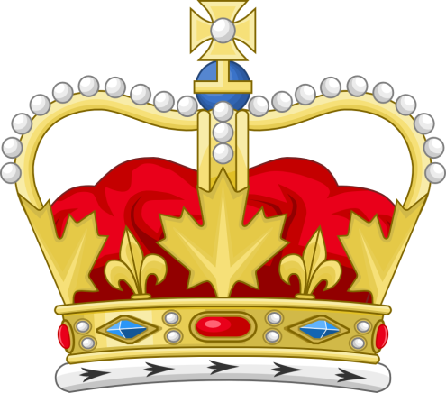
Applications are now OPEN
for the
2023-24 CY Young Days
Princess & Little Slugger!!
Qualifications:
- Must be a Newcomerstown resident.
- Must be going into grades K, 1, or 2 for the 2023-24 academic school year.
- Must be a male/female as assigned at time of birth on birth certificate per guidelines set by Miss USA & Miss America.
- Must be able to represent their title and behave in a positive and polite manner, as well as, be able to communicate on stage and with the general public.
- Must be able to take part in ALL Cy Young Days Festival activities as assigned by the Queen Coordinator, as well as, participate in other various activities/festivals throughout the year with the rest of the Cy Young Court.
- Parent must be willing to sign a member contract and pay a $10 application fee.

Applications are Available at: Newcomerstown Library,
www.cyyoungdaysfestival.com
CY YOUNG ROYALTY - FACEBOOK

Mail applications & a $10 application fee (non-refundable) to:

Jennifer Lindig
Cy Young Queen Coordinator
234 N 8th Street
Coshocton, OH 43812

VERY IMPORTANT!!!!! VERY IMPORTANT!!!!! VERY IMPORTANT!!!!!

APPLICATIONS/FEES MUST BE RECEIVED BY WEDNESDAY, MAY 24, 2023. In addition, there will be a MANDATORY MEETING on Wednesday, May 31, at 6 p.m., at the Cy Young Park Pavilion by the pool to go over contest information and answer any questions. YOU MUST ATTEND THIS MEETING TO PARTICIPATE IN THE CONTEST. In the event of an emergency, call 740-610-7866.

Princess & Little Slugger
(CIRCE APPROPRIATE TITLE ABOVE)

I wish to make application to be a contestant in the Cy Young Days Festival Princess & Little Slugger Contest on Thursday, June 22, 2023.

Name of Applicant: _________________________________________________________________
Applicant’s Address: _____________________________________________________________
Applicant’s Phone: ____________________ AGE: ________ GRADE: ____________
All about Me
Favorite Game: ______________________________ Movie: _____________________________
Color: ____________ School Subject: ____________________ Food: ____________________
What is your most prized possession? _________________________________________________
What do you like about being you? ____________________________________________________
What do you think you might want to be when you grow up? _______________________________
What is something you would like others to know about you? ______________________________
__________________________________________________________________________________
All About My Family
Do you have any sisters, brothers, or pets? What are their names? _________________________
__________________________________________________________________________________
__________________________________________________________________________________
What kind of things do you like to do as a family? _______________________________________
Do you have a favorite family member? Who? What do you like about them? ________________
__________________________________________________________________________________
All About My School (If already in school)
What school do you attend? _________________________________________________________
Who is your favorite teacher & why is he/she your favorite? _______________________________
__________________________________________________________________________________
What school activities do you like to do? _______________________________________________
__________________________________________________________________________________
Why do you want to be the Cy Young Days Festival Princess or Little Slugger?
______________________________________________________________________________________________________________________________________________________________________________________________________________________________________________________

____________________________________________
Parent Signature/Date

