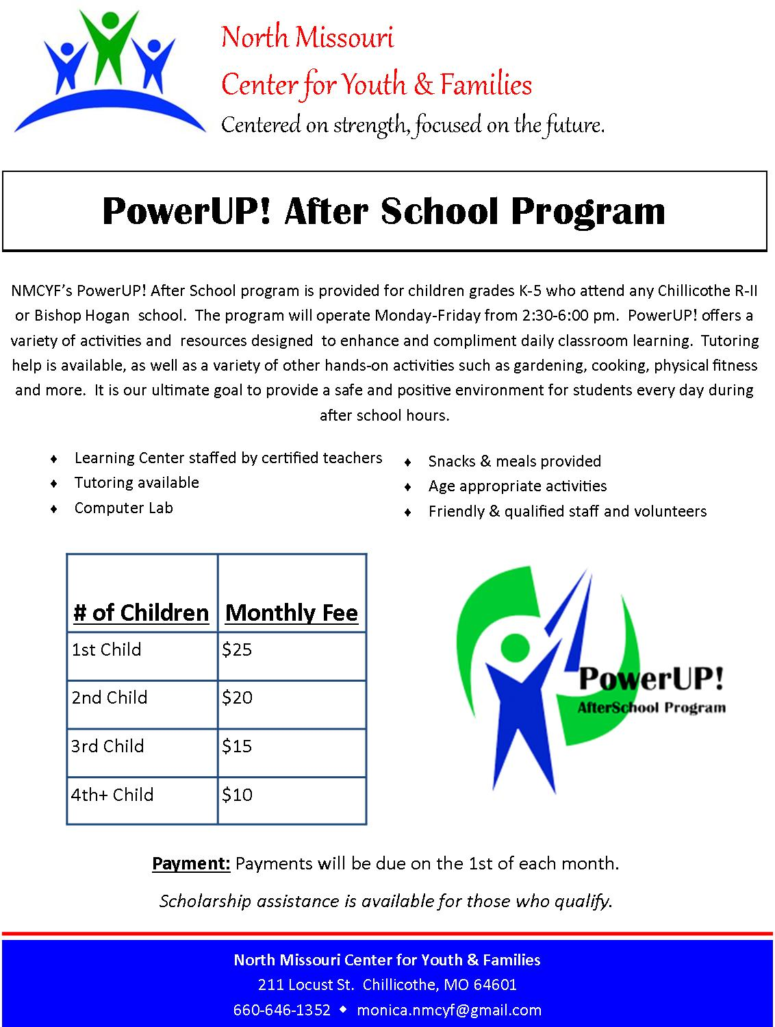

PowerUP! After School registration form

student Information
Full Name:
Date of birth: | Gender: |  |  |  |  |  | Grade:
School: (Please Circle) Dewey Field Central Bishop Hogan

Parent/guardian Information
Parent/Guardian Name(s):
Address:
City: | State: |  |  |  |  |  | Zip Code:
Home Phone: | Cell Phone: |  |  |  |  |  | Work Phone:
Email: |  |  |  | Relationship to Student:

Emergency Contact information
Emergency Contact Name: |  |  |  |  | Relationship:
Home Phone: |  |  |  |  | Work/Cell Phone:
Emergency Contact Name: |  |  |  |  | Relationship:
Home Phone: |  |  |  |  | Work/Cell Phone:

Student medical information
Primary Care Physician: |  |  |  |  |  | Phone:
Medical Care Facility/Hospital: |  |  |  |  |  | Phone:
Medications: |  |  | Allergies:
Please list any additional medical information (diet, ADD/ADHD, asthma, etc.):

Student transportation information
Please indicate how your child will get home from the After School Program:
□ My child will walk/ride bike home
□ My child will be picked up

Persons Authorized to Pick UP Student
Name: |  | Relationship:
Name: |  | Relationship:
Name: |  | Relationship:

media/photo release
□ I give permission for my child to be photographed or videotaped as part of his/her involvement in the NMCYF PowerUP! After School Program. I also give permission for his/her photo and/or image to be used in publications and/or promotional material associated with the after school program.

□ I do NOT give permission for my child to be photographed or videotaped as part of his/her involvement in the NMCYF PowerUP! After School Program. I also do NOT give permission for his/her photo and/or image to be used in publications and/or promotional material associated with the after school program.
Signature of Parent/Guardian: |  |  |  |  |  |  | Date:

PowerUP! After School registration form

parent responsibility contract
Parent/Guardian Initials
 | I, the undersigned, certify that my child, ______________________, has my permission to take part in the program conducted by NMCYF. In consideration of the acceptance and enrollment of my child in the program, I do hereby expressly waive any claim for injuries sustained by said child participating in the program.
 | I understand that this is a well-child program. I will not send my child to the program if they are ill. My child is not eligible to attend the program if they did not attend school that day.
 | I understand that the PowerUP! After School Program promotes healthy lifestyles. I will not send my child to the program with clothing or gear reflecting inappropriate messages regarding smoking, drinking, sexuality, etc.
 | I understand that this program follows the Chillicothe R-2 School District calendars.
 | I will take all steps necessary to ensure that any/all individuals authorized to pick up my child will be drug/alcohol free and will conduct themselves in a courteous/respectful manner when they arrive on site.
I realize that picking up my child by 6:00 pm is an important responsibility on my part and that failing to do so will result in the following procedures:
-A $5.00 fee per child will be assessed for every 15 minutes a child remains at the program past 6:00 pm (ex. 6:01-6:15 pm=$5.00 per child, 6:16-6:30 pm=$10.00 per child).
-The first and second time this occurs, I will be informed that failing to pick up my child on time may result in my child’s loss of program services.
-The third time this occurs, I will receive written notification that my child will no longer be able to participate in the program.

Program payment agreement policy
 | Payments are due on or before the 1st of the month preceding services.
 | Any payments received after the 1st of the month will incur a $15 late charge.
 | If payment due remains unpaid by the last day of the month in which it is due, parent/guardian agrees to withdraw the child from the program as of the first day of the following month.
A child who is withdrawn from the program for non-payment can re-register for services (if space is available) by paying:
- An additional $15 registration fee;
- Payment for all days of service to be used within that month prior to the first day of attendance and
- Payment of any/all outstanding balances due or previous service.

refund policy
No refunds will be given for program(s).
I, the undersigned, have read, understand and accept the conditions by which I must abide and which are contained in the Parental Responsibility Contract. Failure to comply may result in loss of program privileges.
Signature of Parent/Guardian: |  | Date:

MEDICAL RELEASE FORM

Does your child take any medications that will need to be administered during program hours?
If yes, please list medication, dosage and time to be given ______________________________
______________________________________________________________________________

I, _________________________(Parent/Guardian Name), hereby give permission for any and all medical attention to be administered to my child ___________________________ (Child’s Name) in the event of accident, injury, sickness, etc., under the direction of the person(s) listed below, until such time as I may be contacted. If necessary, I approve of officials taking my child to the nearest doctor or hospital. If I cannot be reached by phone, such medical treatment, including surgery, as deemed necessary by competent medical personnel, would be rendered. I also assume the responsibility for the payment of any such treatment. This release is effective for the period of one year from the date given below.

ADDRESS:

INSURANCE COMPANY:

POLICY NUMBER:

In case I cannot be reached, any of the following persons is designated to act on my behalf:

___________________________________________________________________
___________________________________________________________________
___________________________________________________________________

Parent/Guardian Signature _________________________________

Date ______________________

Please attach a copy of your child’s current immunization records.

