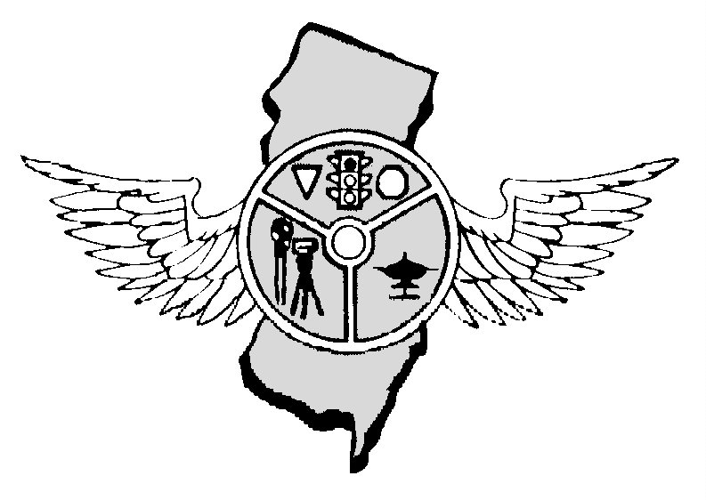

JANUARY 2018 NEWSLETTER OUR 43rd YEAR

Nicolas Schock, President Tony Parenti, Executive Director, Editor First Vice-President, Frank Fiore Mark Wilson, Operations Secretary
NJPTOA - P.0. Box 664, Voorhees, NJ 08043 - 856-220-1433 – njptoa@hotmail.com. Website – njptoa.org

REGULAR BUSINESS MEETING: January 3, 2018 – 10:00 AM at AAA Building, Hamilton, NJ. On behalf the Board of Directors we wish you and yours a Very Happy Christmas and all you expect with the New Year.
PRESIDENT’S MESSAGE: I’d like to wish everyone and their families a safe and joyous holiday season.
I look forward to serving as your President in the upcoming years and continuing the proud traditions of this association. I’d like to thank our outgoing President, Tim Franco, for his 6 years of service as President,
and for all he has done for the association and the traffic safety community. The executive board will be
working on some new initiatives and programs in the coming months. If anyone has a suggestion for the betterment of the association, please reach out to either myself or any executive board member.
Any new ideas are welcome. As always, stay safe; see you in the new year. Nick
DROWSY DRIVERS:: Federal statistics show more people are killed by drivers asleep at the wheel than by those exceeding the speed limit or running a red light. Motorists are more likely to be killed by a drowsy driver than a red light runner. According to data released last month by the National Highway Traffic Safety Administration (NHTSA), drivers who failed to get enough sleep caused an average of 824 fatalities each year -- 2.5 percent of the nationwide road toll. By comparison, the latest NHTSA data show an average of 708 red light running fatalities annually. Less attention is paid to the issue of drowsy driving because there is no automatic way to detect it and issue a citation. NHTSA's data are compiled from the reports made by the officers at the scene of the accident assigning blame on a standardized crash form to drivers who were extremely fatigued or even asleep just before an accident occurred. Drowsy driving is listed a cause in minor fender benders far less often. NHTSA researchers stressed the limitations of relying on police reports for this assessment. "Underreporting of the occurrence of drowsy driving is most likely due to lack of firm evidence of such involvement since investigation is done after the crash; drivers unaware of the role that drowsiness played in the crash; drivers reluctant to disclose that they fell asleep or were tired; and fatality of the involved driver," the report acknowledged. "Previous reports cite data limitations that include over reporting due to greater social acceptance of fatigue over alcohol use, speeding, or inattention, or underreporting from crashes involving 'drift out of lane' that could actually be drowsy driving." Earlier this year, another NHTSA report suggested drowsy driving was responsible for 16.5 percent of all fatal crashes, far more than the 7 percent attributed to drivers exceeding the posted speed limit. Technology may provide a partial solution to the drowsy driving problem. Automobile manufacturers are increasingly offering systems that automatically apply the brakes if the car detects the potential for a crash. The insurance industry's Highway Loss Data Institute reports fewer insurance claims from automobiles equipped with these technologies. Lane departure warning systems that vibrate the wheel or sound an alarm if the driver starts drifting have not proved as effective. "Unfortunately, the same analyses show some tradeoff in an increased number of side-swipe crashes with injuries," the NHTSA report issued in March noted.
DWI STOPPED IN IT’S TRACKS: Two good Samaritans used their cars to stop a suspected drunken driver swerving all over a highway. Two witnesses in Butler County, Pennsylvania saw a motorists nearly hit a concrete barrier. They use their vehicles to box him in and bring him safely to stop on the shoulder. They called the police and the driver was arrested for suspicion of DWI.
NHTSA SAYS “STOP DRUNKEN DRIVING: Every day, almost 29 people in the United States die in alcohol-impaired vehicle crashes—that's one person every 50 minutes in 2016. Drunk-driving fatalities have fallen by a third in the last three decades; however, drunk-driving crashes claim more than 10,000 lives per year. In 2010, the most recent year for which cost data is available, these deaths and damages contributed to a cost of $44B per year.

As of December 18, 2017 there were 607 traffic fatalities in NJ compared to 462 during the same period in 2016. AN INCREASE OF 145 DEATHS
.
COUNTY | 2017 | 2016 | CHANGE | COUNTY | 2017 | 2016 | CHANGE
AtlantiAtlantic | 32 | 37 | -05 | Bergen | 28 | 32 | -04
BurlinBurlington | 44 | 45 | -01 | Camden | 43 | 28 | +15
Cape Cape May | 15 | 11 | +04 | Cumberland | 26 | 28 | -02
Essex Essex | 40 | 41 | -01 | Gloucester | 43 | 24 | +19
Hudso Hudson | 25 | 25 | -00 | Hunterdon | 07 | 10 | -03
Mercer Mercer | 24 | 16 | +08 | Middlesex | 45 | 42 | +03
Monm Monmouth | 44 | 48 | -04 | Morris | 30 | 17 | +13
Ocean Ocean | 51 | 36 | +15 | Passaic | 18 | 19 | -01
Salem Salem | 17 | 14 | +03 | Somerset | 23 | 16 | +07
Susse Warren | 10 | 12 | -02 | Union | 35 | 24 | +11
Warre Sussex | 07 | 12 | -05
Deaths: Driver 332; Passenger 80; Pedalcyclist 16; Pedestrian 179. Crashes 578 TRAFFIC SIGNALS: Motorists who find themselves stopped at an intersection will arrive at their destination faster if traffic signals give motorists notice before the light changes to green. A team from Belgian Hasselt University presented their findings on the "starting yellow" idea to the Transportation Research Board in Washington, DC earlier this year. Germany and the UK already use the system, which flashes the traffic signal's yellow light one or two seconds before the green light illuminates. The idea is to give motorists a chance to prepare to get moving by placing their cars in gear, or putting down their mobile phones. As in the United States, Belgium does not permit the use of starting yellow lights. So the researchers used a driving simulator to investigate the effects of the idea on traffic flow and safety. Motorists can take as much as three or four seconds to get moving after a light turns green. This is because it takes time for a driver to notice the change in the traffic signal and respond by pressing the accelerator. It then takes even more time for the car to get up to speed, particularly for slower and heavier vehicles. Forty-four test subjects of various ages used the driving simulator to explore a number of scenarios by traveling through intersections with and without the two-second starting yellow system. The evaluation looked for potential conflicts with pedestrians and other vehicles. The testing revealed that drivers took an average of 3.5 seconds to get moving, a time that dropped to 2.4 seconds when the starting yellow was displayed. No safety problems were found, since Belgium uses a two-second all-red phase to prevent traffic conflicts. After trying out the system, thirty-nine of the participants agreed that it would be worth implementing, while one participant found the system confusing. The researchers concluded that a longer-term study under real-life conditions would produce more accurate results.
THANKSGIVING STATISTICS: 2016 – 7:: Winslow Township, Passenger Car Driver Passenger Car Passenger. Hackensack City, Passenger Car Passenger. Teaneck Township, Passenger Car Drive. Hillsborough Township, Passenger Car Driver. Camden City, Pedestrian. Ringwood Boro, Passenger Car Driver. 2017:-6: Warren County, Passenger Car Driver. Camden City, Passenger Car Driver. Roselle Boro, Pedestrian. Hillsborough Township, Pedestrian. Maurice River Township 2 Passenger Car Drivers. Washington Township (Warren) Passenger Car Driver. Camden City, Passenger Car Driver. Roselle Boro, Pedestrian. Hillsborough Township, Pedestrian. Maurice River Township, 2 Passenger Car Drivers SLEEPY DRIVERS KILL: Motorists are more likely to be killed by a drowsy driver than a red light runner. Drivers who failed to get enough sleep caused an average of 824 fatalities each year -- 2.5 percent of the nationwide road toll. By comparison, the latest NHTSA data show an average of 708 red light running fatalities annually. Less attention is paid to the issue of drowsy driving because there is no automatic way to detect it and issue a citation. NHTSA's data are compiled from the reports made by the officers at the scene of the accident assigning blame on a standardized crash form to drivers who were extremely fatigued or even asleep just before an accident occurred. Drowsy driving is listed a cause in minor fender benders far less often.
NEXT MEETING: January 3, 2018 – AAA Building, Hamilton, NJ.
.
ALWAYS WEAR YOUR SAFETY BELTS AND BULLET PROOF VEST WHILE ON DUTY

Top of Form

NJ Police Traffic Officers Association
PO Box 664
Voorhees, NJ 008043
856-220-1433
E-MAIL: njptoa@hotmail.com

2018 INVOICE

DATE | ITEM | AMOUNT
1/1/2018 | Annual Membership Dues for Police Department | $50.00
 | TOTAL: | $50.00

DATE: 1/1/2018 SIGNED: Nickolas Schock, President.
Our Tax ID number is 22-2344113
Copies of purchase orders can be faxed to 856-783-0012 or scanned for an e-mail and sent to NJPTOA@Hotmail.com.

Note: If you would like to receive the newsletter by e-mail instead of by postal mail, please send your request to njptoa.tparenti@gmail.com

(Please check mailing label. Correct if necessary by phone call, text, or e-mail)

,.,,

