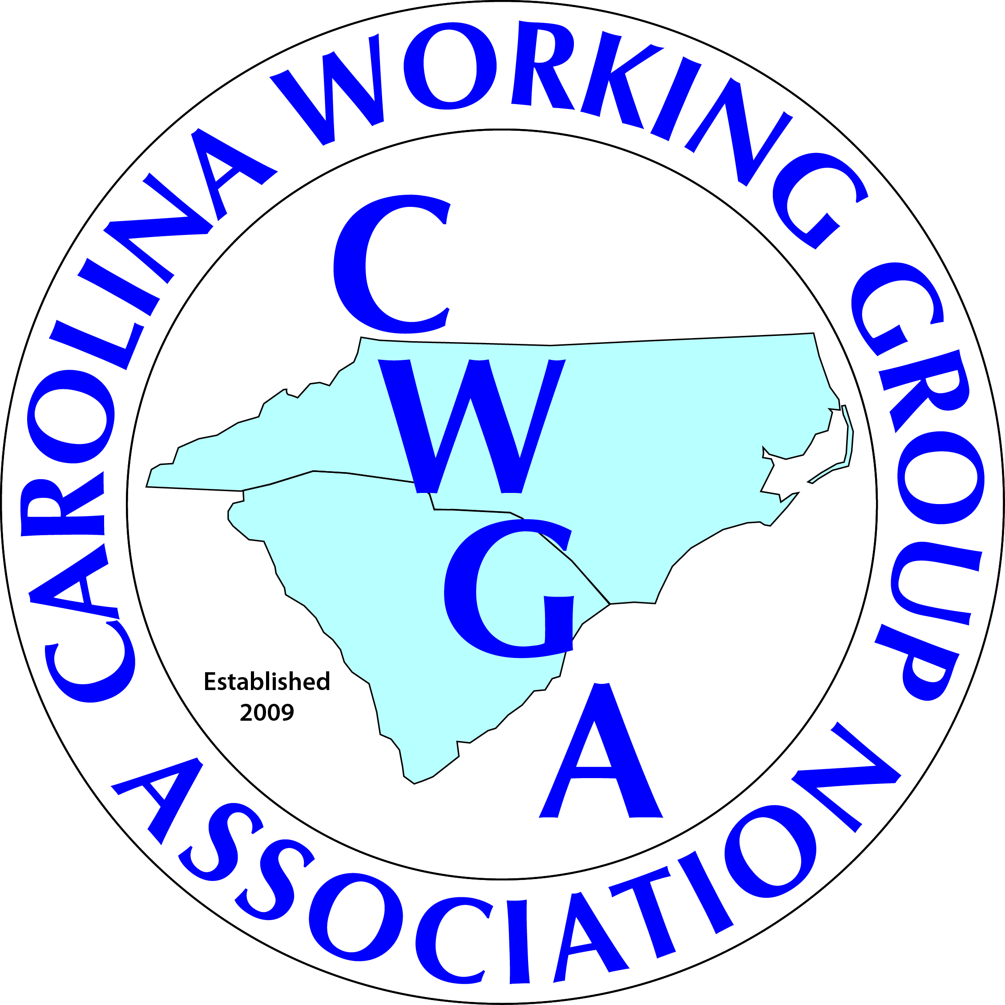Carolinas Working Group Association
STAR Awards Program
The CWGA has a STAR award program for all dogs who attained a new AKC (only) title(s) during the year.
- Eligible members must have renewed membership for the year prior to the deadline or joined the Club prior to July 1 of the year of the award.
- Eligible dogs must be owned by and reside with the member.
The award will be printed with the dog’s call name, the new title(s), and the year – 2015 (up to 18 characters and spaces - TOTAL). If the dog received more than one title you can include it. Please list only AKC titles.
These awards will be distributed at June shows /meeting so please plan to attend and CELEBRATE your achievements. (Those not attending who request that their stars be mailed will be required to submit a postage fee prior to the mailing.)
Notifications MUST be received by April 1, 2016.
Please mail or email the following information:
Call Name of Dog:

New Title (s) / Year:
Your Name:
***Don’t forget in include a copy of the dog’s AKC award certificate.
TO:
Linda M. Fowler..........1004 Cold Branch Drive, Columbia, SC 29223-554o.....
or e-mail to...... h2odogs@bellsouth.net
ALSO let her know if you will be attending our shows in June (or if you have any further questions), if not she can mail your ornament after the shows, after you submit the postage payment.

♣♣♣♣♣♣♣♣♣♣♣♣♣♣♣♣♣♣♣♣♣♣♣♣♣♣♣♣♣♣♣♣♣♣♣

