saundersstreetclinic
37 Jackson Street, Wynyard, TASMANIA. Phone 6442 1700
Newsletter July-Aug 2018
Opening hours
Monday - Thursday 9am-1230 pm, 2pm-5 pm
Friday 9am-1230 pm, 2.30pm-5 pm
Saturday, Sunday, Public Holidays closed
Doctors: Jim Berryman, Chris Hughes, Yas Sanli, Ali Johnson, Sarvin Randhawa, Lou Sykes.
Nurses: Fi Munday, Belinda Townsend, Stacey Shanahan.
After hours arrangements
Please phone the surgery number, you will be given the number for Health Direct which is a phone triage service providing advice by the Federal Government. This service will contact the doctor on call at Saunders Street if necessary, following assessment by a registered nurse and in some cases by a doctor. If your concern is about a medical emergency call the ambulance service on 000-there is no charge for ambulance call-outs in Tasmania.
If the matter is urgent but not an emergency call Health Direct 1800 022 222. A registered nurse using triage protocols will take your call. If necessary the call will be transferred to a GP at GP Assist in Hobart and if that GP thinks a call out or house call is warranted a GP from this clinic will be contacted.
Meningococcal disease and vaccination

What is meningococcal disease?
Meningococcal disease is a rare but serious illness caused by bacteria (germs) called Neisseria meningitidis. The different strains (‘serogroups’) of these bacteria are named by letters of the alphabet such as A, B, C, W and Y.
The most common strain has changed over time. Meningococcal C vaccine became part of the National Immunisation Program in 2003, and disease due to strain C is now rare.
Throughout Australia most meningococcal disease is now caused by strains W and B. Strain W increased significantly throughout Australia from 2014 onwards.

What are the symptoms?
People with meningococcal disease often go from feeling quite well to extremely unwell very quickly.
Symptoms include fever, headache, neck pain or stiffness, drowsiness or confusion, severe muscle aches and pain, vomiting and rash (a red rash which does not fade when pressed and can become dark purple).
Sometimes other symptoms can include lung infection (with fever, cough, chest pain and difficulty breathing), or severe throat infection (with pain, difficulty swallowing, and drooling).
Children and adolescents can have leg pain, cold hands and feet, and blotchy skin.
Babies and infants often don’t have these symptoms but can be unsettled or drowsy, floppy and not feeding.
It can take from one to seven days from being exposed to the bacteria to becoming sick. Symptoms can become life threatening within hours.

How is it spread?
Meningococcal bacteria are spread in secretions of the throat and nose. This is more likely to happen among people with close, regular and prolonged contact.
About 1 in 10 people can carry meningococcal bacteria in their throat or nose. These carriers do not typically become sick.
Regular exposure to tobacco smoke can increase the risk of catching the bacteria and becoming ill.
The bacteria don’t survive outside the body and don’t spread easily from shared drinks, food or cigarettes.

How is it diagnosed?
Meningococcal disease is diagnosed in blood samples, or fluid samples from around the spinal cord.

How is it treated?
People with meningococcal disease need urgent treatment in hospital. Treatment usually starts before test results are known. Treatments include, antibiotics, medications for fever and pain and fluids.
A person is no longer contagious after 24 hours of antibiotics.

How is it prevented?
Immunisation is the best way to prevent meningococcal disease.

Meningococcal ACWY vaccine
From 1 July 2018 a quadrivalent meningococcal vaccine for strains A, C, W and Y replaced the meningococcal C vaccine as part of the National Immunisation Program for all children aged 12 months.
Previously Tasmanian teenagers who were born between 1 August 1997 and 30 April 2003 were eligible to receive a free meningococcal W vaccine.
Population Health Services have recently established a rapid state-wide population response due to a further increase in meningococcal W cases in Tasmania. This will target all Tasmanians aged between six weeks and up to 21 years old. This includes all people born after 1 August 1997.
For further information regarding the Meningococcal W Vaccination response go to: www.dhhs.tas.gov.au/menw
Vaccine is also available on private prescription for the following:
- some travel destinations, medical conditions, and occupations
- can also be offered to those who wish to protect themselves or their family from these strains of meningococcal disease.
Meningococcal B vaccine is available on private prescription.
- Recommended for infants and young children, adolescents, young adults living close together (such as students in residential accommodation), some medical conditions and occupations.
- Can also be offered to those who wish to protect themselves or their family from this strain of meningococcal disease.

What should I do if I have had contact with someone who has meningococcal disease?
Antibiotics are given to people (contacts) who live in the same house, and those who have spent a long time or been intimately close, with someone with the disease. This is because one of these people may have the bacteria in their throat or nose. Antibiotics ‘clear’ the bacteria out of their throat and nose so they can’t pass it to other people. Contacts may also be offered a meningococcal vaccine.
It is rare for people to develop the illness after being in close contact with someone who has meningococcal disease, but you should still watch out for symptoms of meningococcal disease.
Contacts of someone who has meningococcal disease can go to work, school and childcare.

What should I do if I have meningococcal disease?
If you think you or someone close to you has meningococcal disease seek help immediately from your doctor, hospital emergency department or ambulance.

More information
www.health.gov.au/internet/main/publishing.nsf/Content/ohp-meningococcal-W.htm
Public Health Hotline – Tasmania on 1800 671 738 to speak to a Clinical Nurse Consultant
https://www.dhhs.tas.gov.au/publichealth/communicable_diseases_prevention_unit/infectious_diseases/meningococcal_disease

Vesicular and Dermatitis

What is vesicular hand dermatitis?
Vesicular hand dermatitis is a form of hand/foot eczema characterised by vesicles or bullae (blisters). It is also called vesicularendogenous eczema, dyshidrotic eczema and pompholyx. Pompholyx is sometimes subclassified as cheiropompholyx (hands) and pedopompholyx (feet).

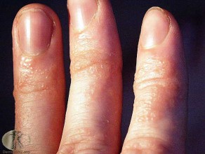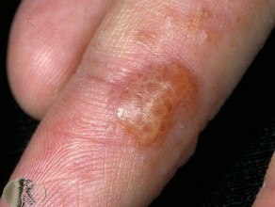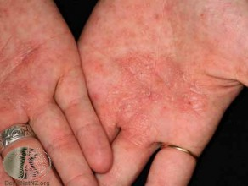

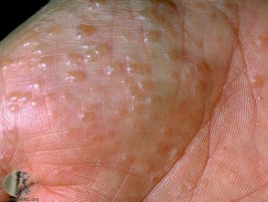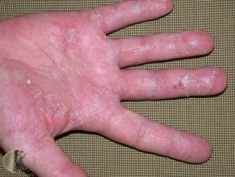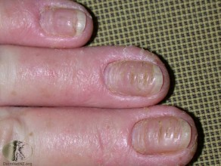

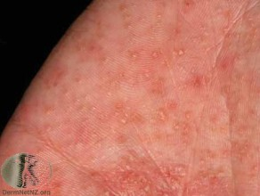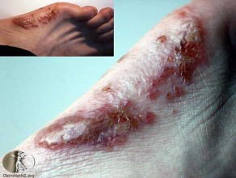

https://www.dermnetnz.org/topics/vesicular-hand-dermatitis/

