**PEOPLE TO PEOPLE – SHEBOYGAN**  

SHEBOYGAN/ESSLINGEN STUDENT EXCHANGE PROGRAM 2024

High School 5 Month Reciprocal

or Hybrid 5/2 Month Reciprocal

or Middle School Summer 3 Week Reciprocal

or be a Host Family for a German HS student 5 month

*Applications due October 15, 2023*

FOR IMMEDIATE RELEASE

Date: September 12, 2023

**Calling All Students! Opportunity to Experience Germany first hand - Staying with German Student & Family**

The Sheboygan Chapter of People to People has been sponsoring an annual exchange with Sheboygan’s sister city, Esslingen, Germany since 1970. Esslingen is a charming city of about 100,000 located in Southwest Germany on the banks of the Neckar River, near Stuttgart. Since that time over 170 Sheboygan County high school students have participated in this unique program. Many have made life long friendships. “For us, the student exchanges provide the best avenue to help foster the understanding of people and cultures with the youth of our community.” said President - Bob Quasius. People to People exchanges are a rare opportunity to experience another country and culture first hand. The student is not staying in a hotel and visiting local tourist attractions. They stay in a family home learning how a German family lives on a daily basis from food, job to transportation and more.

**High School 5 Month Reciprocal - An Immersive Cultural Experience - Fall ‘24/Spr ‘25**

The High School program offers a more in depth German experience over 5 months. The students are treated like a member of the family and engage in all activities with them. Applicants are usually first semester freshmen or sophomores. Applications should be returned by November 15, and the selection of students, which will include a family interview, is usually completed in December or January. Since classes in Esslingen are conducted in German, applicants should be strong students and have good study habits. The German students arrive the following July and stay until mid-December. The American students finish their fall semester and leave for Germany in midFebruary, returning in late July or early August. Students in grades 9/10 are eligible to apply for placement in Spring/Summer grades 10/11.

A hybrid version of the exchange is available with the same placement of the German student for 5 months but the American student would visit the following summer for 2 months over the June - August time frame (potential for summer before). This allows the American student some exposure to the German school and is an especially good option for those who don’t speak German or have conflicts with coursework or other activities during the school year.

**Middle School Summer 3 Week Reciprocal - 6 weeks total - Summer 2024**

This unique opportunity partners an American student and a German Middle School student to form a friendship and learn about each other, their countries and their culture. Students would visit their exchange partner/family in Esslingen, Germany, for 3 weeks beginning in mid-July and return in early August with their exchange partners. During the first week, American students participate in a basic German Course, an Esslingen tour along with two day trips to other German cities as a group during the day. The second two weeks are spent one on one with the German student and participating in family activities. German Students from Esslingen will be in Sheboygan for 3 weeks in August, returning to Germany before school starts. Typical time in the US includes a chapter picnic and group day trips to Chicago and Wisconsin Dells. Each middle school student group travels with an adult chaperone. There is no need for students or their families to speak German. Esslingen students usually speak excellent English. Students in grades 7 or 8 are eligible to apply.

**Host Family for a German High School Student - 5 months - August to Dec 2024**

Opportunity to learn about Germany - people, culture, customs, heritage and more - without travel or leaving Wisconsin - first hand from an Esslingen High School Student. Share Sheboygan, your home and family life with an exchange student. Consider helping a German student find a home away from home. Sheboygan’s Sister City Esslingen am Neckar in southwest Germany always has many students wanting to participate. Host Family Applicants with students/children are preferred but not required.

Applications for all of the programs are **due by October 15th, 2023** and can be found on the People to People website.

**More information**

People to People Sheboygan website: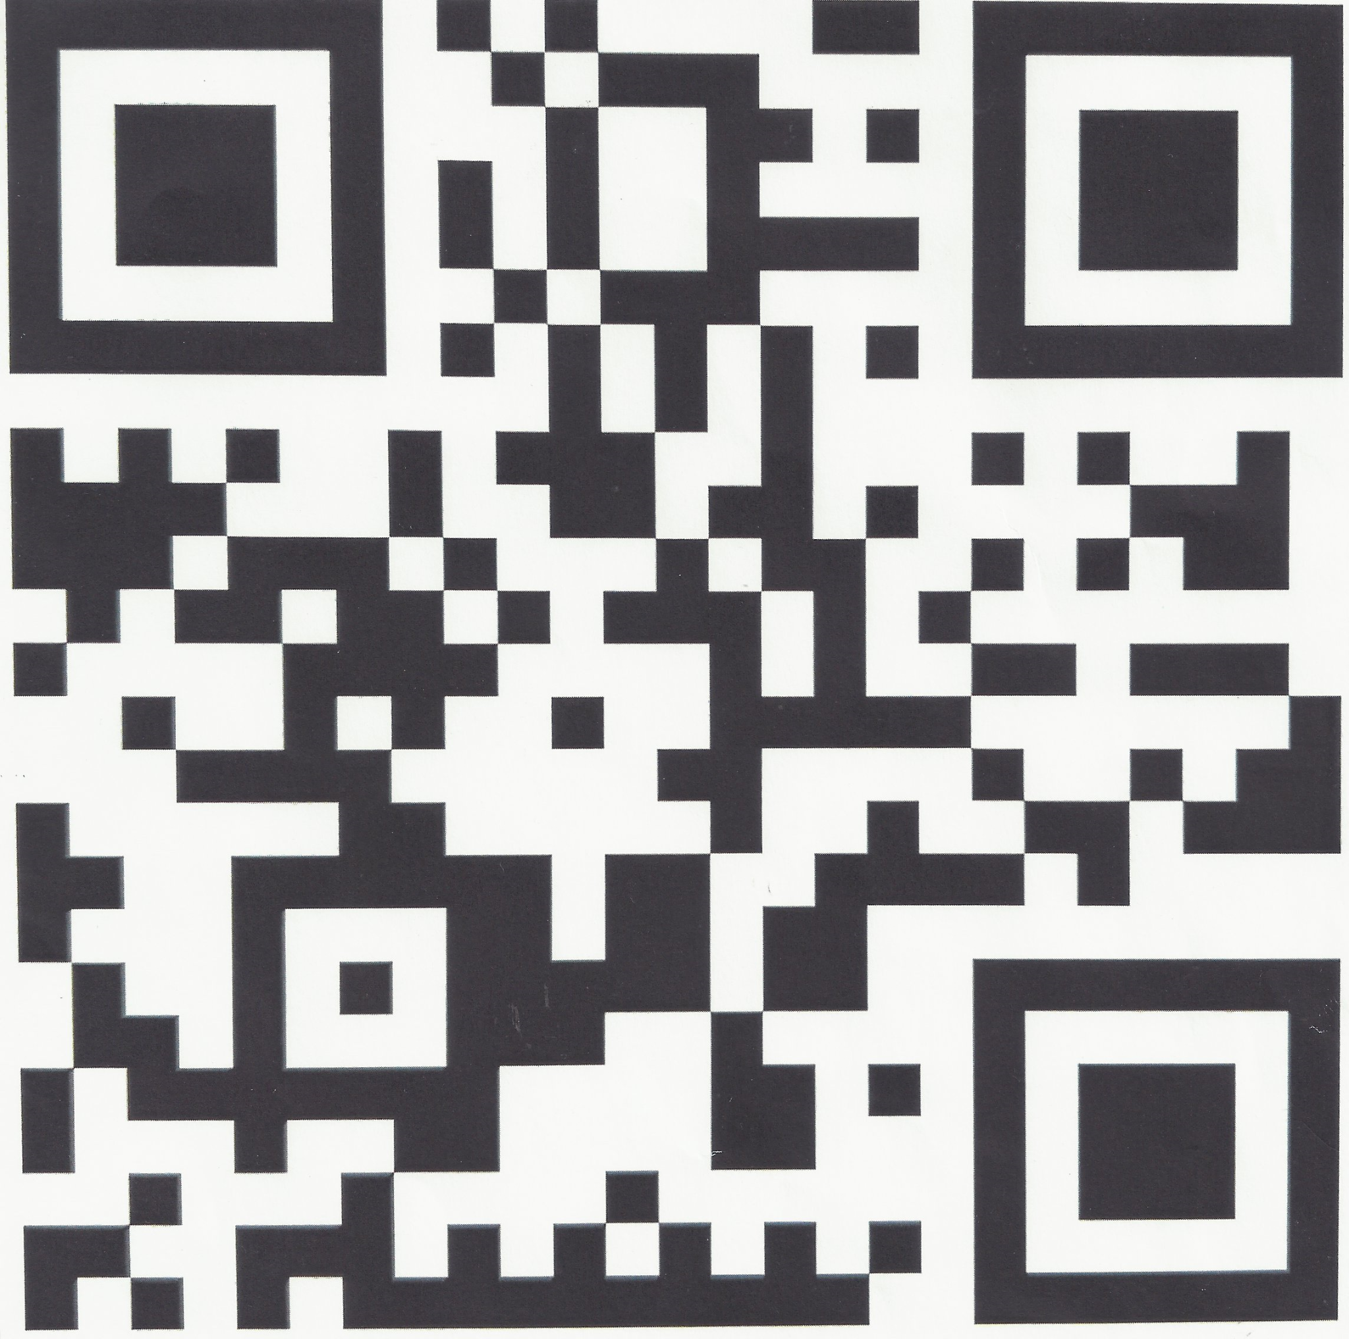

<http://www.ptpsheboygan.org/home.html>

Contact us on Facebook to ask questions:

<https://www.facebook.com/PTPSheboyganChapter>

High School Application:

<http://www.ptpsheboygan.org/high-school-exchange-in-germany.html>

Middle School Application:

<http://www.ptpsheboygan.org/middle-germany-1.html>

