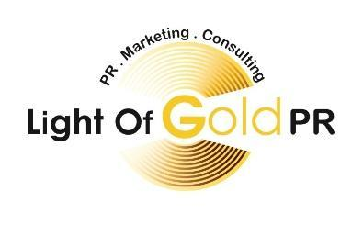
622 Bloomfield Avenue, Lower Level ■ Bloomfield, NJ 07003
NY - (646) 399-1678 ■ NJ - (862 ) 621-9699 ■ Cell - (917) 385-1079
E-Mail: info@lightofgoldpr.com ■ lightofgoldpr@gmail.com
Website: http://www.lightofgoldpr.com
For Immediate Release
Contact: Debra Dixon-Anderson, Light of Gold PR, Marketing, and Consulting LLC
E-mail: lightofgoldpr@email.com
Phone: (646) 399-1678 – NY office or (917) 385-1079
Website: http://www.lightofgoldpr.com
Light of Gold PR to Provide Access to TV Advertising
June 7, 2016 (New York, NY) – Light of Gold PR continually emphasizes the need for Brand Consistency and Brand Reinvention. This is why we’re excited to announce a new television and advertising initiative where Light of Gold will provide access to commercial time on major networks. Businesses will be allowed to create commercials and have them air in targeted time slots in an attempt to maximize brand exposure and creatively generate leads.
“Many owners would love to see their businesses marketed on the big screen, but are intimidated by the pricing. Our service will provide them with an affordable way to use the 30-second commercial format to reach millions of viewers as they watch their favorite shows,” said Light of Gold founder, Debra Dixon.
Branding is an essential aspect of competing successfully in the business world. According to Bop Design, 48% of Americans expect brands to know them and help them discover new products or services that fit their needs. And, 80% of consumers said “authenticity of content” is the most influential factor in their decision to follow a brand. These statistics indicate that customers want to feel “connected” with the brands that they support. “Our multi-functional approach uses video, sound, visuals and audio in a way that builds a feeling of connection,” said Dixon. And, if you don’t have your own video commercial, “we can shoot it for you for a separate, low cost,” added Dixon.
To secure your ad and share your business, reach out to Debra, Emily, Heather or Kevin today at lightofgoldpr@gmail.com or call 917-385-1079 or 646-397-7841
ABOUT LIGHT OF GOLD PR:
Light of Gold PR, Marketing and Consulting LLC sheds light on the gold that exists in organizations, businesses, and individuals. It exposes the hidden treasures, and brings these treasures to light through brand management, publicity, marketing, promotions, media relations, and today’s technologies. The Staying True to Brand Program was designed to teach businesses and individuals how their business image relates to their target audience, as well as how to stand out from other companies and professionals. Light of Gold PR, Marketing, and Consulting’s No. 1 goal is to position its clients for success. For more information about us, visit www.lightofgoldpr.com and http://www.goldbusinessconnect.com

