

Summer 2019
Week 3 – 17th April 2019
Doubles League
The first scheduled doubles league week saw many games cancelled despite the good weather.
In the Premier League, Ross Payne & Neil Selby got off the a flying start only conceding 6 points against Alex & Cassie Stewart as they bid for their first title as a team.
Two new teams joining the fold were both good sides with Wendy Ritzema & Gary Cowburn playing Andrew & Lorna Limbrick. This looked on paper to be a close game as was agreed by the Super 6 players. However the former opened their Liberation account with a comprehensive win 13 – 6, 13 – 1.
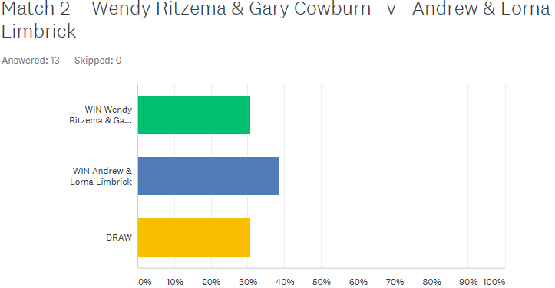

One of the favourites for the title Matt Pinel & Toby Northern played promoted Eamonn & Karen Bougeard. Eamonn was firing exceptionally well as both he and Karen took the first game before Matt & Toby stepped up a gear to gain a draw.

In Division 1 there was a very close match between Helene Retrosi & Natasha Romeril and Mo De Gruchy & Stephen Stoneman ending in a draw with just a couple of points separating the teams.
No one gave Jean Stewart & Chris Le Gallais a chance in their match against Alan Oliveira & Craig Kelly who dropped down from the Premier League and they were right. They should be the ones to beat in Division 1 this season.
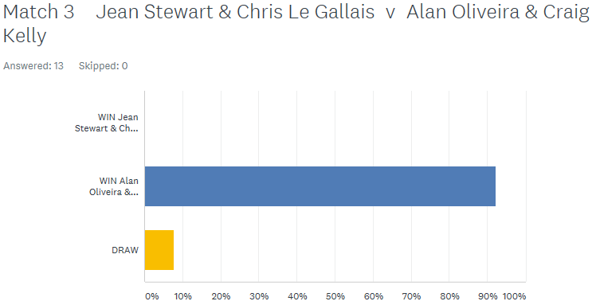

Colin Myers & Steve Simpkin v Harrison Marie & Richard Williams looked a close match with most people predicting a draw. It could have ended up a draw with one match going to 13 – 12 before Colin & Steve sealed the win.
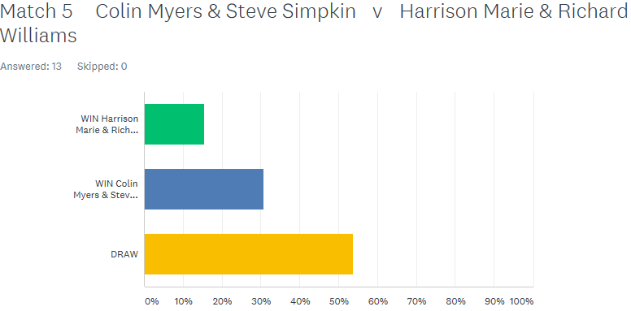

Tim Jackson & Brandon De La Haye hoping to get off the mark against Colin & Karen Hidrio, seasoned summer players but it wasn’t to be but still early days.
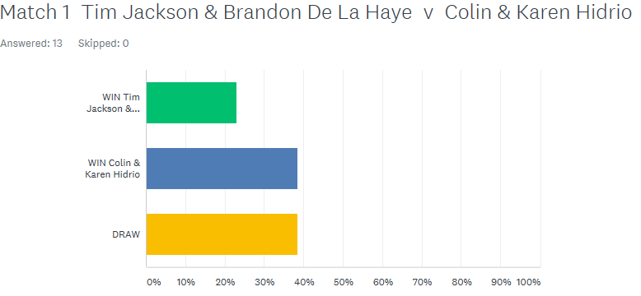

Last but not least the ever improving James Villalard & Daniel Villalard played tough opponents in Alan Mitchel & Mike Robinson and despite both James & Daniel improving all the time Alan & Mike proved too good as they look for back to back promotions.

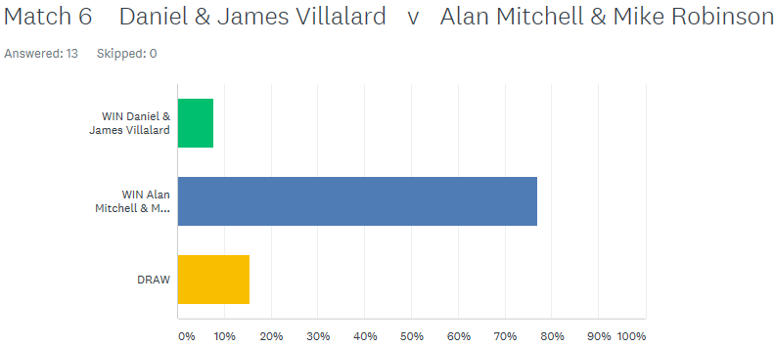

NEXT WEEK – 24TH April 2019 - SINGLES LEAGUE WEEK 3

Club email address - liberationpc@gmail.com

Club Website - www.liberationpetanque.co.uk

Kind Regards

Toby Northern

Chairman

Liberation Petanque Club

SPONSORED BY

