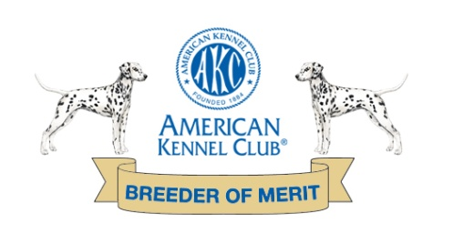
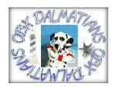
OBX Dalmatians Application
www.obxdalmatians.com

Date:
Your Name Phone
Address
City State Zip Code
Email Address Alt. Phone

How did you learn about our Dalmatians?

Check your preferences: Puppy Adult
Male Female
For what purpose do you wish to obtain a Dalmatian? (check all that apply)
Companion Show Obedience/Agility Protection
Other
Have you ever been to a dog show or performance event?

Do you have a color preference?
If yes… black/white or liver/white

Have you previously owned a Dalmatian? Yes or No
What are your current pets/ages?

Do you have a problem with neutering/spaying this Dalmatian?
If so, can you explain why?
Are you M S D W (Circle) Adults in your house
Children at home/Ages:
Occupation of adults
Who will be the PRIMARY CARETAKER of this dog?

Where will the dog be during the day?
At night?
Do you reside in the (Circle) City Suburbs Country
Do you live in a (Circle) House Apartment Townhouse
Do you have a fenced yard, dog run or other area?

Please explain:

What do you know about Dalmatians?

Health Problems?
Special Needs?
Life Span?

Would you have any objection to signing an agreement that in the future, if for any reason you do not want or cannot keep this dog, We would have the option of having it returned to us or help in the placement?

Your Veterinarian’s name and phone number?

Can you supply a reference other than family or close friend. Such as pet sitter, trainer, Vet, neighbor? (Name & number)?

Lastly and possibly most importantly… what should we know about you and your family to insure we would make a great decision placing a “OBX” puppy with you?

Thanks so much for taking the time to let us know more about you and the great home you could provide one of these great pups. Please do not hesitate to ask any questions you may have. We are committed to the wellbeing of these puppies and the Dalmatian breed!

Email the completed survey and ANY questions to:

obxdals@gmail.com
or
tyg142002@yahoo.com

http://obxdalpups.blogspot.com/2012/09/blog-post.html

