***Know Christ! Grow in Faith! Serve Others!***

Mission Statement of LTUMC (adopted 6/5/2024)

**WELCOME–ANNOUNCEMENTS** Mary Fulton

**JOYS AND CONCERNS**

**OPENING PRAYER**  Pastor Rod

**PRELUDE** Jenny Claybaugh, Jane Wildermuth

**SONG LEADER** Diane Lewis

**LITURGIST**  Tracy Notestine

*\*Please stand as able.*

**\*Call to Worship:** *from Psalm 138 NLT, modified*

L: We give You thanks, O LORD, with all our heart; we will sing Your praises before the gods.

***P: We bow before Your holy Temple as we worship. We praise Your name for Your unfailing love and faithfulness;***

L: for Your promises are backed by all the honor of Your name.

***P: As soon as we pray, You answer us; You encourage us by giving us strength.***

L: Every king in all the earth will thank You, LORD, for all of them will

hear Your words.

***P: Yes, they will sing about the LORD’s ways, for the glory of the LORD is very great.***

L: Though the LORD is great, He cares for the humble, but He keeps

His distance from the proud.

***All: The LORD will work out His plans for our life—for Your faithful love, O LORD, endures forever.***

**\*Hymns**  *America the Beautiful #696* UMH

*This Is My Song #437* UMH

***Recognition of Veterans***

**UNISON PRAYER**

***Faithful Father, we give thanks that you are good and that your steadfast love for us endures forever. Help us always remember and trust your faithfulness to fulfill all your promises, plans, and purposes to save us from the reign of sin and death and to make all things new. Fix our eyes firmly on Jesus, so that we will constantly remember your word and your works and trust your steadfast love and faithfulness by the power of your Holy Spirit so that our ways will always be faithful and fruitful.***

**SCRIPTURE:** *Ephesians 2:19-22 & 1 Corinthians 3:16-17*

**PRAYERS OF THE PEOPLE** Diann Gault

**THE LORD’S PRAYER**

***Our Father who art in heaven, hallowed be thy name. Thy kingdom come, thy will be done on earth as it is in heaven. Give us this day our daily bread, and forgive us our trespasses as we forgive those who trespass against us. Lead us not into temptation, but deliver us from evil. For thine is the kingdom, and the power, and the glory forever. Amen.***

**WORSHIPING GOD WITH TITHES & OFFERINGS**

**\*DOXOLOGY –** Praise God, from Whom All Blessings Flow #*95* UMH

\***PRAYER OF THANKFULNESS – *Accept these gifts, O God, as testimonies of our love for you and our desire to serve you. Let these offerings be an affirmation that we are bound to one another as your people. In your generous name we pray. Amen***

***Hymn*** *Take Time to Be Holy #395* UMH

**Prayer for Illumination**  *Prayer for Ash Wednesday, #353*UMH

***O God, maker of every thing and judge of all that You have made, from the dust of the earth You have formed us and from the dust of death you would raise us up. By the redemptive power of the cross, create in us clean hearts and put within us a new spirit, that we may repent of our sins and lead lives worthy of Your calling; through Jesus Christ our Lord. Amen!***

**Scripture:** *2 Chronicles 7:11-16*

**Message:** *Can You Hear Me Now? By Pastor Rod*

**Response:** *As The Holy Spirit Leads*

***\*Hymn***  *It’s Me, It’s Me, O Lord #352 UMH*

**BENEDICTION Going forth to achieve our mission!**

**THOSE ASSISTING IN CREATING OUR SERVICE:**

Musicians: *Jenny Claybaugh, Jane Wildermuth*

Sound/Video: *Andy Wildermuth, Kathy Berg*

Online: Traci Notestine, Sandy Shaner

**https://www.facebook.com/LewistownTrinityUnitedMethodistChurch**

Ushers: *Don Lewis, Bill Fulton, Denny Stryker, Lynne Snipes, Mike Brunson, Jason Bruns*on

Internet Prayer Chain: *Lorna Brunson*-- [doone53@centurylink.net](mailto:doone53@centurylink.net)

All-Call Prayer Chain: Julia Armstrong-- call her at 937-844-7964

Bulletin Items: *Rosemary LeVan*-- 937-722-7935 or rlevan1338@gmail.com

Internet Logins: Church Building-- ltumcfour1

Adult Sunday School Class/Lay Leader: *Mary Fulton* Sunday School Superintendent/VBS/God’s Team: Diane Lewis

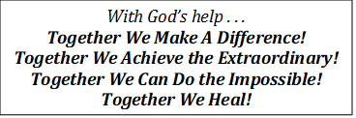



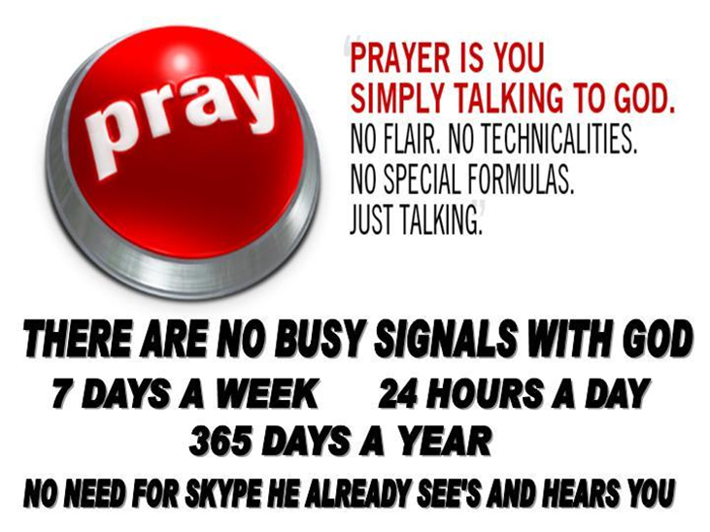

*November 10, 2024,*

*Veteran’s Sunday*

Thank You for Choosing to Worship Christ with Us Today!

*LEWISTOWN-TRINITY UNITED METHODIST CHURCH*

In-Person Worship Service – 11:00 - 8088 CR 54, Lewistown

Address: P.O. Box 90, Russells Point OH 43348

*Worship with us on Facebook*

**www.facebook.com/LewistownTrinityUnitedMethodistChurch**

Rod Brower, Pastor

*His contact Info:*740-727-9999 – pastorrodb@gmail.com

***Know Christ! Grow in Faith! Serve Others!***