Telehealth & Telemedicine

Telehealth & Telemedicine visits at Vista Complete Care are conducted through a HIPAA secure platform, called Doxy.Me.
Any iOS smartphone will be sufficient for a Telehealth & Telemedicine as well as a desktop, chromebook, or laptop that has BOTH webcam and microphone. Say cheese! If you do not have a webcam AND microphone enabled, the application will not work. And unless you and the clinician know sign language, the visit will not be possible.
Doxy.Me is an application that requires the use of good internet connection. If your internet connection is poor, your video with the clinician will be significantly affected. While we understand technical issues happen, should your internet bandwidth be insufficient for the Telehealth or Telemedicine visit, the charge and/or cost of the Telehealth and Telemedicine services will remain the same.
Telehealth and Telemedicine visits are the same charge as in-office visits; the charge is billed with a “Place of Service” code indicating the setting of the visit took place through telecommunication technology. But enough of the fancy billing lingo. The million-dollar question is, what does it cost? The cost varies greatly on your insurance and specific plan. As a good reference, the cost will likely be about the same as previous visits you have had at Vista Complete Care.
Below is a brief tutorial from an iOS smart phone. This tutorial is meant as a guide to help navigate patients through Telehealth and Telemedicine process, but the steps will vary depending on your operating system.
The first thing to do is schedule a Telehealth or Telemedicine appointment! You may call the office to set this appointment up (if you have not already done so) at 530-885-3951. Easy, right?
Second step is to answer your phone: our staff will contact you by phone prior to your scheduled Telehealth or Telemedicine visit to verify your demographic information, run insurance eligibility, and collect any copayments or balances that may be due. After our staff have done their initial check-in, you will be directed to proceed to the “Virtual Waiting Room”, which is your third step explained in the tutorial that begins on the following page.
Should you run into technical issues or problems, our staff will do our best to help navigate you through them, but we are not IT experts. This is a new process for our office, and we will have some growing pains. We are pleased to stay current with continuously changing healthcare landscape—but more importantly—we hope this is convenient option improves access to care.
Ready, set, go!

Patient’s navigate to the virtual waiting room, by visiting the following link:
https://doxy.me/drmarlervcc

Use will see this screen: Type in your name then press “Check-in”
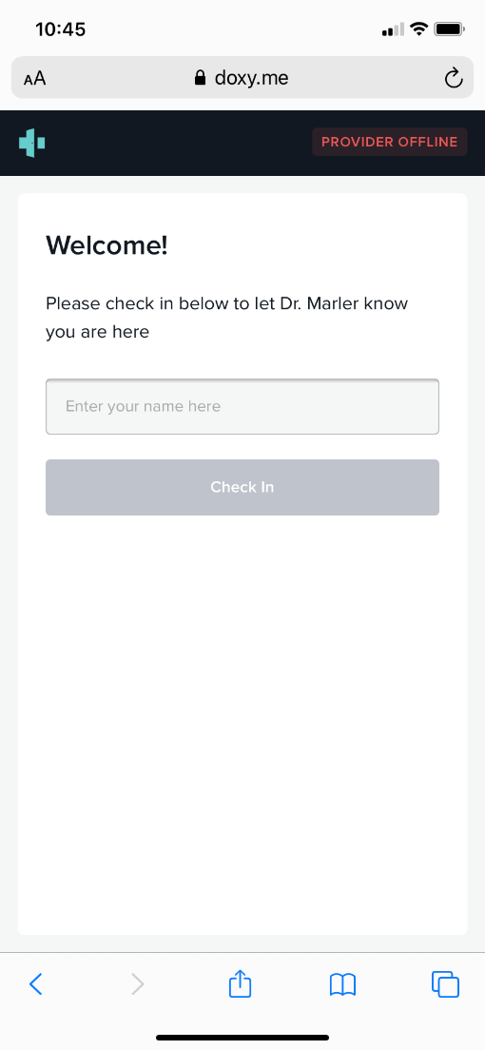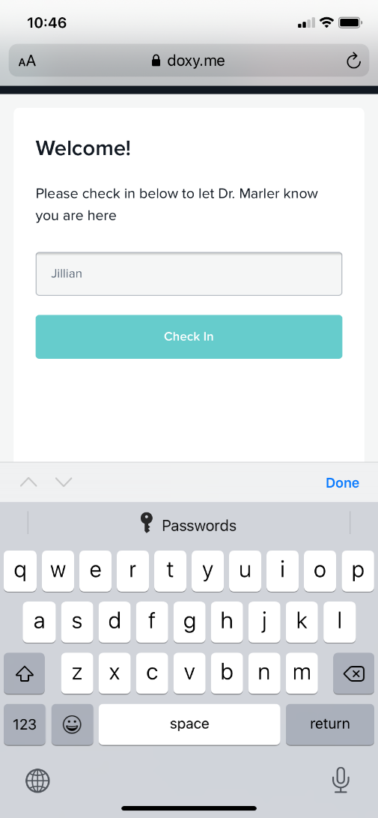

You MUST allow your camera and microphone access, or else you not be able to see -OR- hear. More importantnly, the physician will not be able to see or hear you either.

Select “Allow” when asked if you would like “doxy.met” to access your microphone and camera:

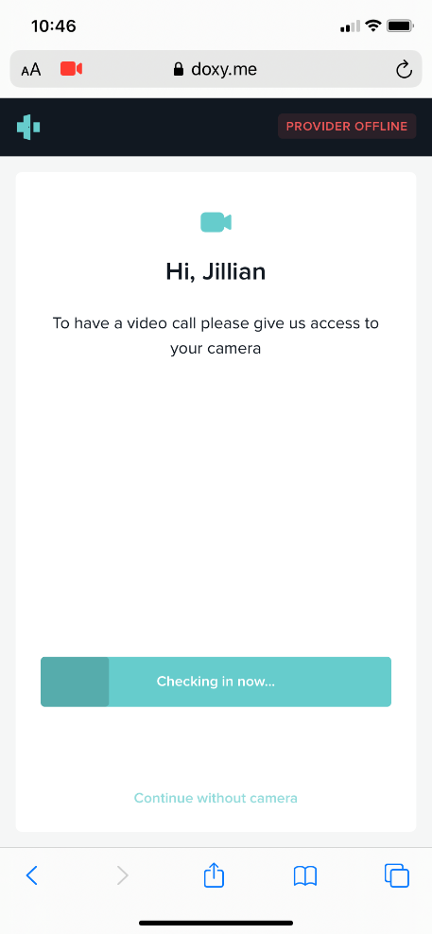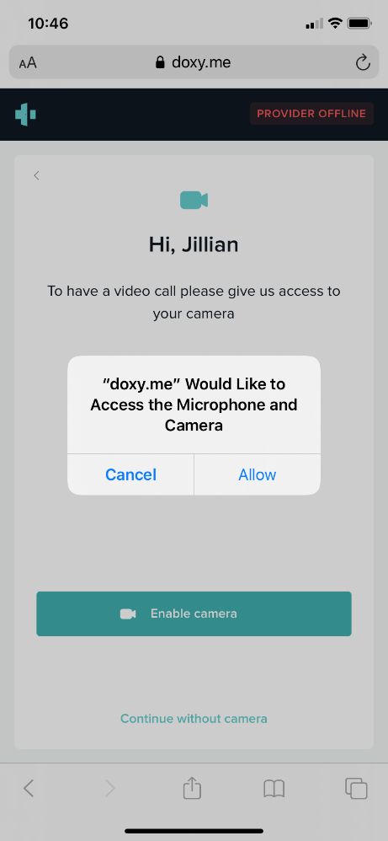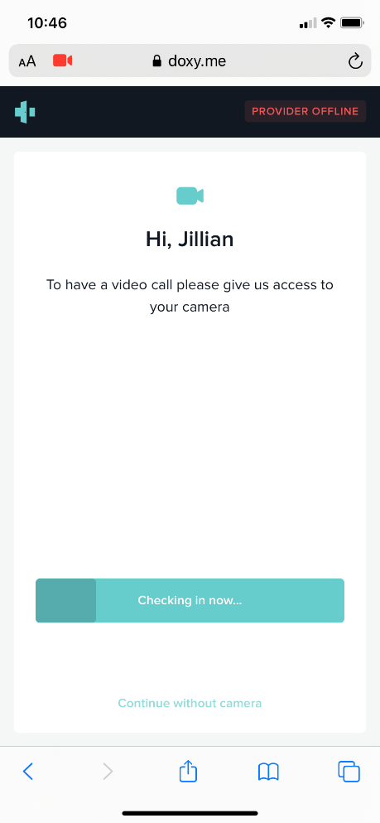
Press “enable camera” to continue “checking-in”

Once you have allowed doxy.me to access your microphone and you have checked in, you will
be in the virtual waiting room. The physician may appear to be “OFFLINE”. Once the clinician
logs in, the status will see the provider as “AVAILABLE”. This may take a few moments, so
please be patient.

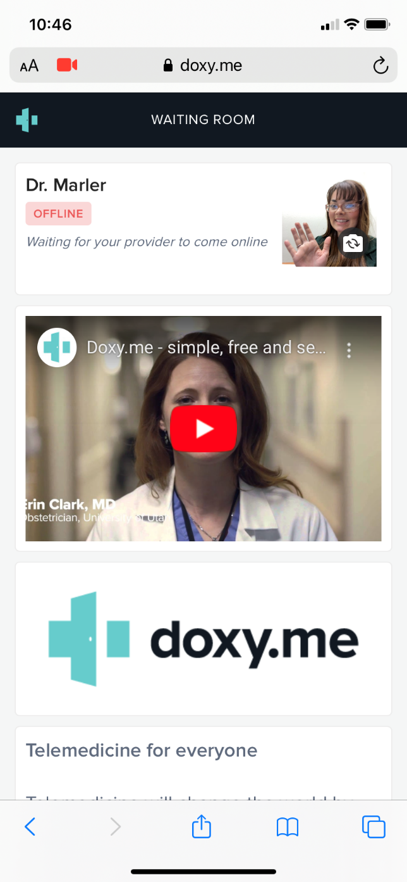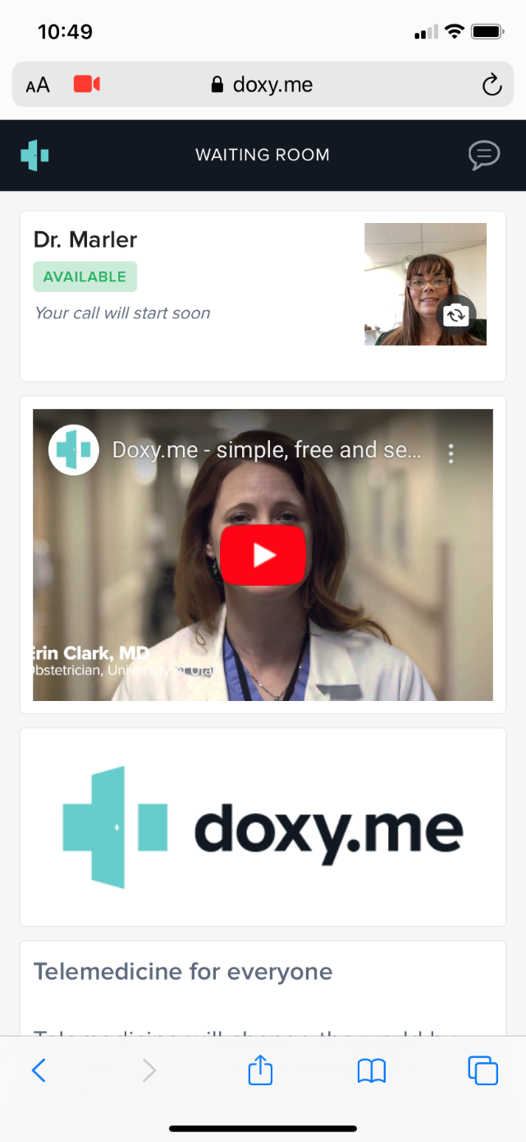

Once the clinician has connected, you will see the following screen(s) in order. This is also the
step in which you will be visible to the clinician. Once the connection is secured, your clinician
will begin the visit as if you were right in front of them.

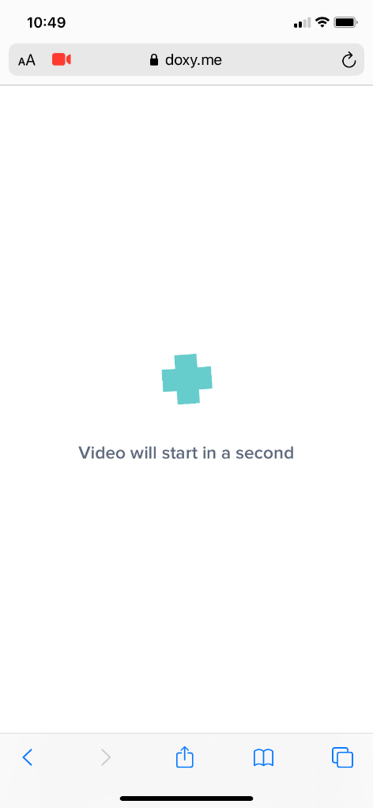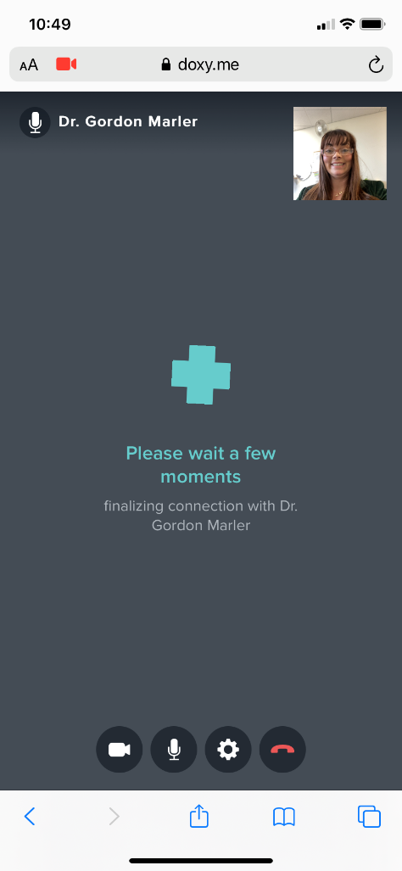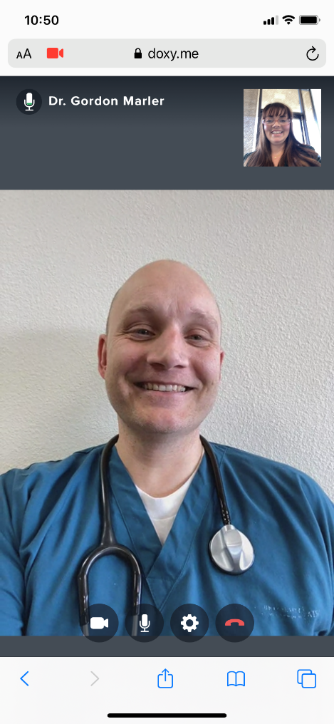

There is also an option to “chat” with the physician (not shown) once you have reached these
steps. You can find the chat option in the lower right hand corner.

Once the Telehealth and/or Telemedicine visit has ended, you may select “Yes, leave” to end
the call. You will then see a screen similar to the one below indicating the call has ended.

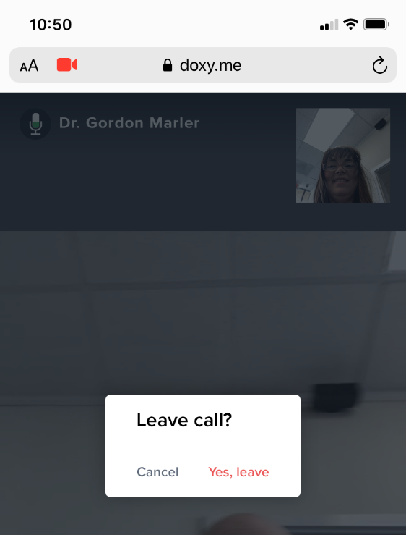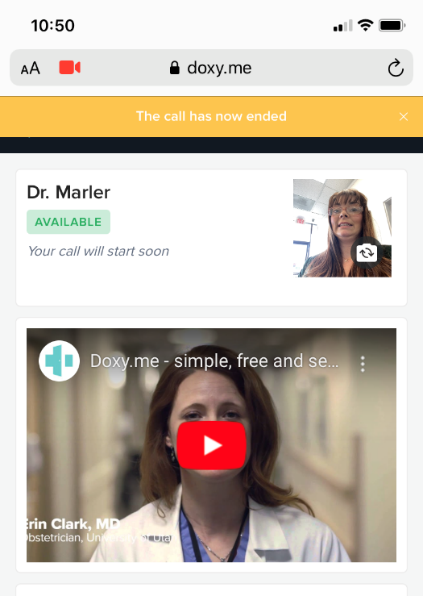

If the clinician placed any orders for you--such as medication(s), lab or imaging, referral, etc.—
those orders will be fulfilled by our staff as usual and per our standard operating policies.

If you have any questions following your visit, please call the office at 530-885-3951. Once the
doxy.me interaction has ended, it cannot be restarted without another scheduled appointment.

