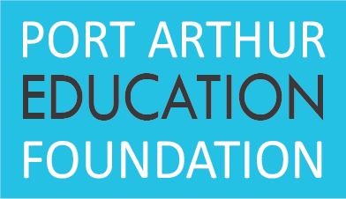

Purpose: The Port Arthur Education Foundation Grants Program is designed to encourage, facilitate, recognize and reward innovative instructional approaches to enhance academic excellence in the Port Arthur Public Schools.

Persons Eligible: Individuals or teams employed by Port Arthur Public Schools.
to Apply for Grants

Eligible Proposals: Instructional approaches or projects designed to begin during the specified school year and which meet the selection criteria.

Award of Funds: Grants of up to $1,000 will be awarded to teachers or librarian initiated programs, projects or instructional items. (Note: Check will be made payable to the grantee’s school and be for exclusive use of the grantee’s purpose.)

Due Date: Dates for announcing availability of grants, evaluating applications, closing date of application and awarding grants will be recommended by the Grants Committee and approved by the Port Arthur Education Foundation Board of Directors. Applications must be received by the date specified on the most current application announcement.

Selection Criteria: 1. The degree to which the proposal represents creative or innovative approaches to instruction.

2. The degree to which the proposal develops, supports, or promotes academic excellence.

3. The degree to which the project and the objectives, teaching methods, time schedule for implementation, and evaluation of project are clearly defined.

4. The degree to which student learning is directly impacted.

Selection Process: 1. Application forms will be available at each school campus in the office of the principal and on the website.

2. Applications must be signed by the principal.

3. Signed applications are due by the date specified in the announcement flyer forwarded to each school.

4. Application will be presented to the Grants Committee without the name of the person(s) requesting the grant, the name of the school(s), and the name of the principal(s).

5. A summary of the projects selected by the Grants Committee will be submitted to the Board of Directors for final approval. Projects selected will be kept confidential until the date that grants are actually awarded to recipients.

6. Materials and/or equipment will be ordered by the individual campus in cooperation with administration. The individual campus will provide a copy of the invoice, or other appropriate documentation to the Treasurer of the Port Arthur Education Foundation.

7. Recipients will be awarded grants at their individual campuses.

Responsibilities of 1. Use the awards for the purposes intended.
Grant Recipients:
2. Prepare a brief final report for sharing with other teachers and for inclusion in the Foundation’s Annual Report.

3. Agree to share successful procedures in staff development sessions or in other settings determined appropriate by the Foundation Board of Directors.

