INVESTIGATION REPORT

Reporting Date: June 7, 2013 Date Assigned: May 31, 2013
Our File Number: 13-038 Your File Number: JRT290984
________________________________________________________________________________________

Client: ABC Insurance Company
Requester: Ms. Jennifer Smith
Phone: 905-688-4300 ext. 328
Your Insured: Lindsey Thomas
Date of Loss: November 1, 2012
________________________________________________________________________________________

ASSIGNMENT: Conduct a period of surveillance on the subject in order to document his level of his mobility.

SUGGESTED INJURIES: Severe whiplash, months of constant headaches, a stiff neck, back spasm and sleep interruptions.

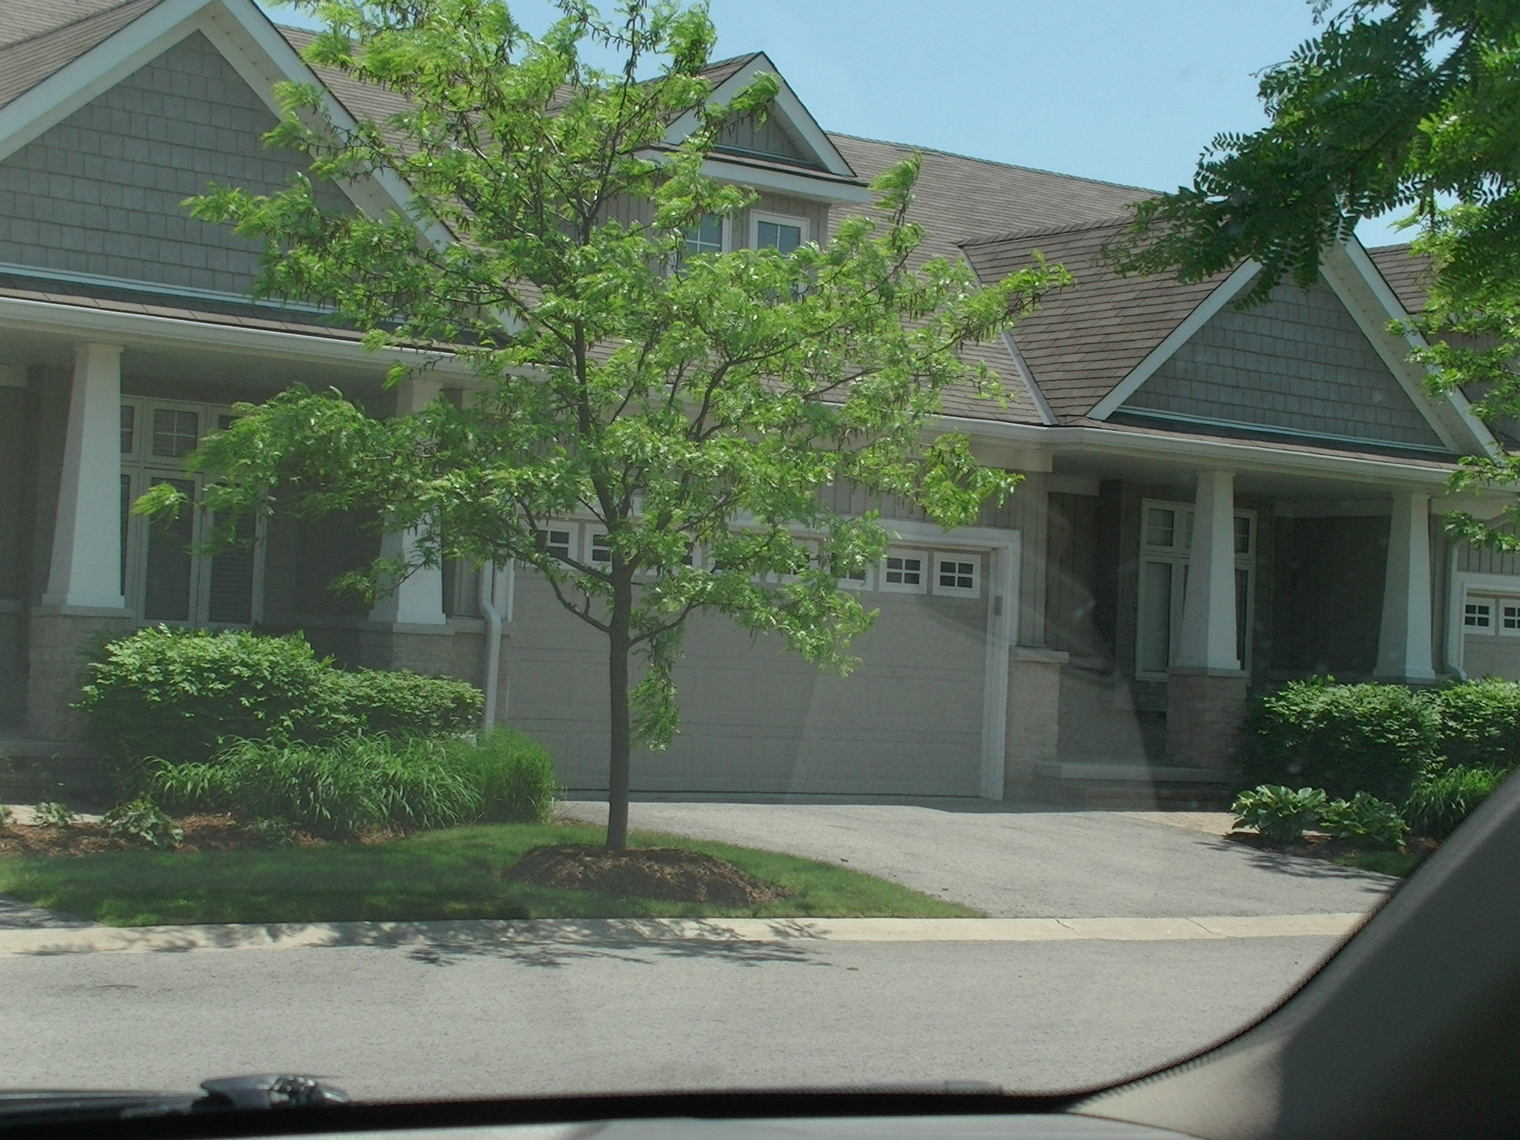
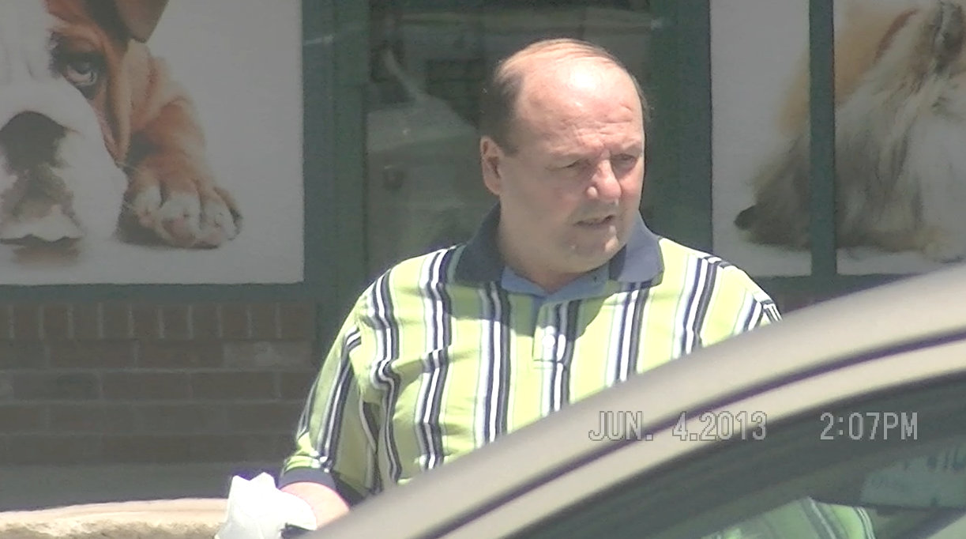

Subject: CONTI: Joseph
DOB: July 19, 1949

Description: Approximately 5’8” tall, 180-190 lbs., stocky, balding with protruding stomach.

Address: 18-56 Berta Drive
Niagara-on-the-Lake, ON
L0S 1T0

Description: New townhouse complex with attached garage, paved driveway and well-maintained property all situated within a middle-class subdivision

SURVEILLANCE SUMMARY

Surveillance/spot checks were conducted over 4 days; specifically, May 31, June 3, 4, and 5, 2013. Mr. Conti was only observed on one of the dates – Tuesday, June 4th. He traveled to a nearby Canada Post Office in the village of Virgil, then traveled to Niagara Falls and attended a Wal-Mart, Food Basics grocery store, a Bulk Barn and Scobey’s grocery store. Afterward, the subject returned to his residence.

Mr. Conti walked in what appeared to be a normal manner, moved his head and neck to the left and right multiple times, bent at the waist and was not observed using any medical aids to assist in his mobility. It should be noted that the subject entered his vehicle in a somewhat unorthodox manner by first placing his head into his vehicle and stepping into the car. It is unknown if this is due to any injury from which he might be suffering. He drove on the major highways in the area obeying all laws, changed lanes using his indicator and drove at the posted speed limits.

SURVEILLANCE

The following are the results of a surveillance investigation conducted by P.I. #065272 of Investigative Intel, a licensed private investigator in the province of Ontario.

Friday, May 31, 2013

12:57 p.m. The investigator departed the office and traveled to the subject’s residence.

1:17 p.m. We arrived at the residence at 56 Berta Drive in Niagara-on-the-Lake, ON and commenced observations. The subject resides in a new townhouse complex. His unit is attached to two other residences. The subject’s known vehicle was not parked on or near the property, however his residence does have an attached garage, which was closed throughout the surveillance period.

1:30 p.m. The spot check was concluded at this time and the investigator remained in the Niagara-on-the-Lake area.

2:25 p.m. Another spot check was conducted at the residence, however no changes were noted.

2:30 p.m. The investigator discontinued observations and departed the area.

2:50 p.m. We returned to the office.

2:26 a.m. The investigator departed the office on route the subject’s residence.

2:45 a.m. We arrived at the subject’s residence. Again, his vehicle was not located on or near the property. The garage door was closed and all lights were off inside the residence. No further observations were conducted.

3:10 a.m. The investigator returned to the office.

Monday, June 3, 2013

7:10 a.m. The investigator departed the office on route to the subject’s residence.

7:30 a.m. We arrived in the vicinity of Mr. Conti’s residence and commenced observations. His vehicle was not parked on his driveway or near his residence. The garage door was closed and no activity was noted on the property. Surveillance was maintained with an indirect view of the subject’s residence.

10:30 a.m. The investigator drove past the subject’s residence, however no changes were noted.

1:30 p.m. With no subject activity noted, and in order to conserve on the budget of the investigation, we discontinued surveillance.

1:50 p.m. We returned to the office.

Tuesday, June 4, 2013

8:00 a.m. The investigator departed the office on route to the subject’s residence.

8:20 a.m. We arrived in the vicinity of the subject’s residence. Mr. Conti’s vehicle was not observed in the area. His garage door was closed and no activity was observed on or near his property. Surveillance was maintained with a direct view of his residence.

12:15 p.m. In order to maintain discretion, we changed surveillance position and secured a direct view of the only exit of the subject’s townhouse complex.

12:43 p.m. A male matching the age of the subject and herein referred to as such departed the area in his known vehicle. (Video)

12:45 p.m. Mr. Conti arrived at the Canada Post Office at 1 Lorraine Street in Virgil. He parked the vehicle and entered just prior to our arrival.
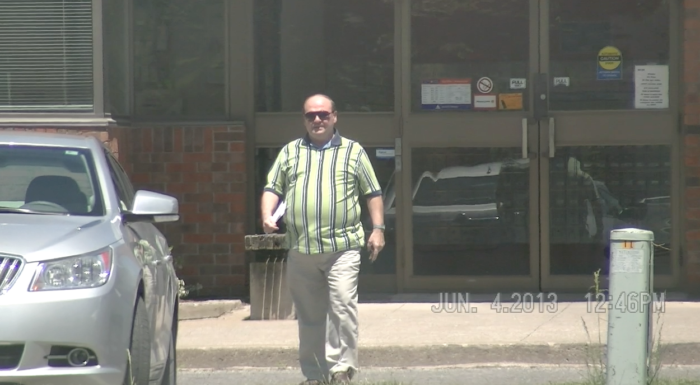

12:46 p.m. The subject exited the building holding a slip of paper in his left hand. He transferred it over to his right hand as he walked back toward his vehicle. Mr. Conti opened the car door with his left hand, placed his right foot inside the vehicle, and leaned his head and neck inside the vehicle using his left hand as support on the vehicle’s A-frame. He entered the vehicle and closed the door behind him. The subject leaned over and pulled the door shut. Mr. Conti reversed the vehicle using his side mirrors for assistance and departed the area. (Video)

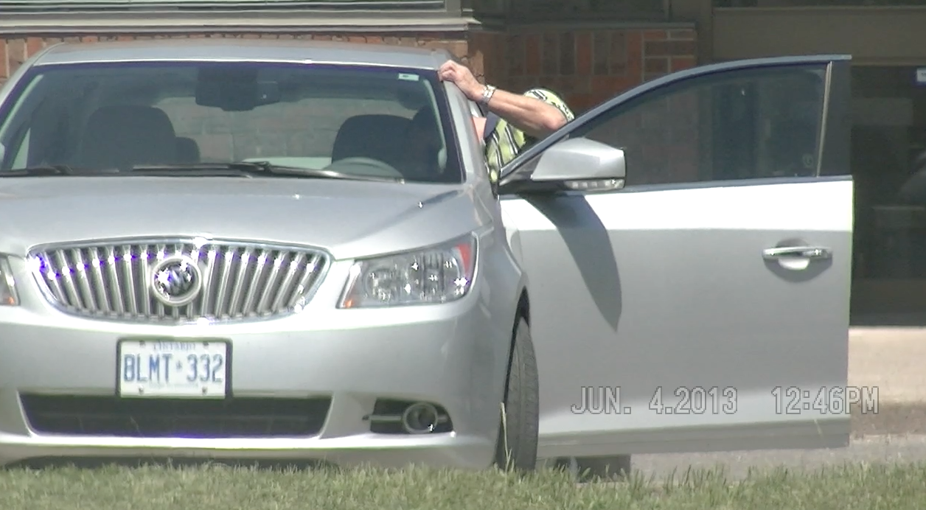
Mr. Conti then drove southbound on Four Mile Creek Road, ascended the escarpment, and traveled onto Portage Road in Niagara Falls, eventually onto the QEW highway southbound toward Fort Erie.

1:06 p.m. The subject exited at McLeod Road in Niagara Falls and continued eastbound. (Video)

1:09 p.m. Mr. Conti arrived at Wal-Mart at 7481 Oakwood Drive in Niagara Falls. He parked his vehicle in the parking lot, exited it, and walked toward the building. He moved his head and neck to the left and right observing traffic as he walked toward the building. Moments later, he entered Wal-Mart and went out of our view. (Video)

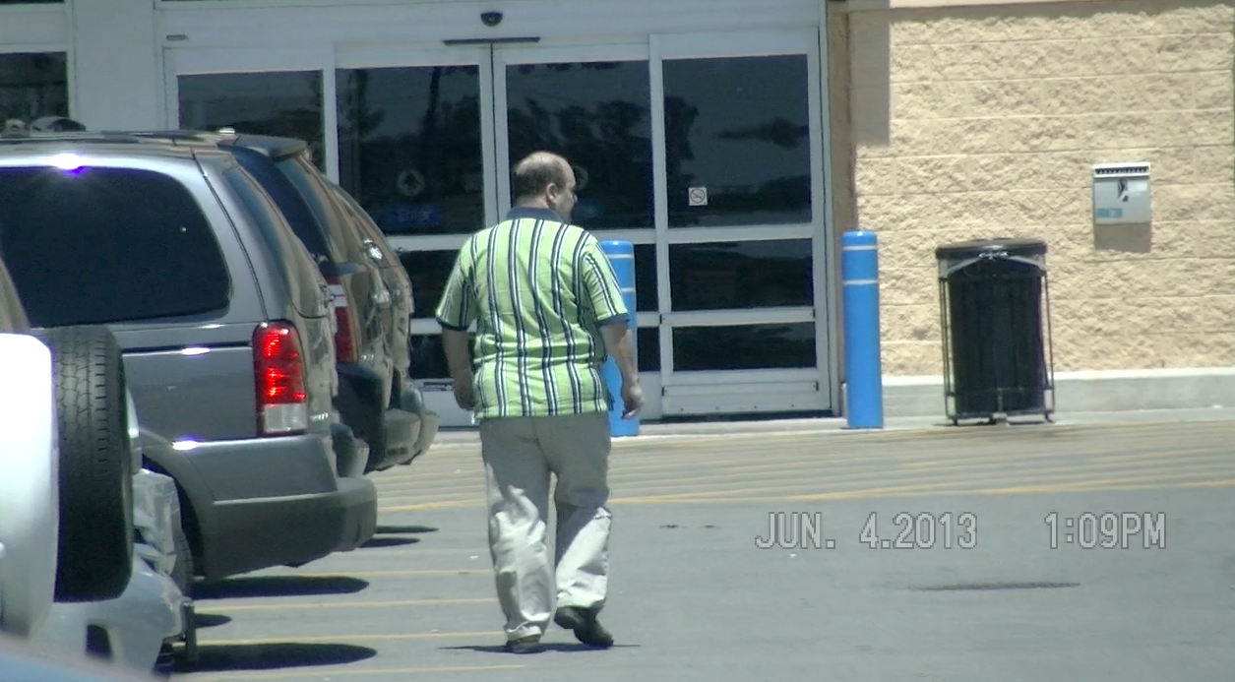
The investigator entered the building a few minutes later in order to continue documenting the subject’s movements.

1:19 p.m. The subject was documented as he held a movie in his right hand near the electronics department of the store. He carried a jug of what appeared to be vinegar in his left hand. Moments later, he went out of our direct view. (Video)



1:23 p.m. Mr. Conti placed the vinegar back on the shelf and walked out of Wal-Mart without making any purchases. (Video)

1:24 p.m. The investigator returned to the surveillance vehicle and documented the subject as he walked back toward his vehicle. The subject entered the vehicle again by placing his right leg into the car, and ducking his head and neck into the vehicle then placing the rest of his body inside. He reached over and closed the door. Mr. Conti placed his sunglasses over his eyes, reached back with his left hand and held his seat belt, eventually fastening it in place. The vehicle departed seconds later. (Video)

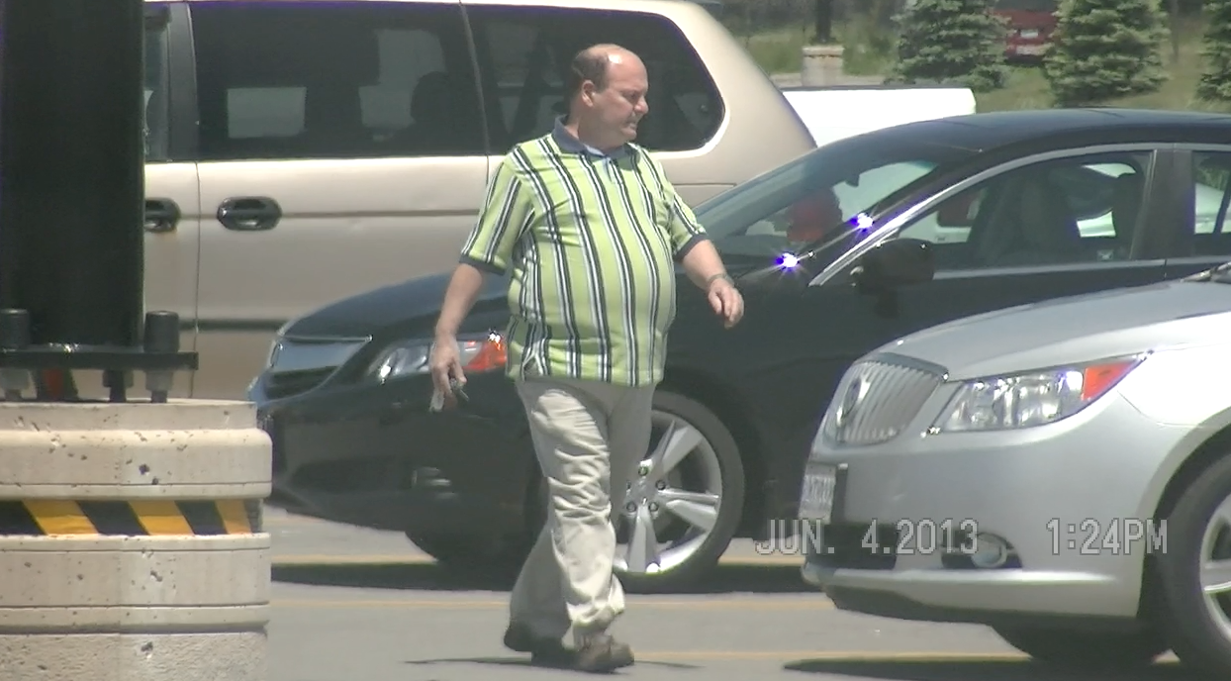

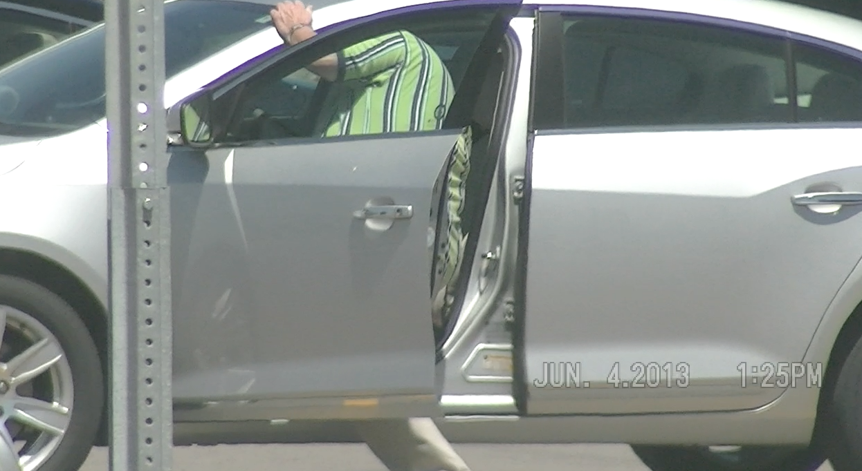
1:27 p.m. The subject arrived at Food Basics at 6770 McLeod Road in Niagara Falls. He exited, walked to the rear of his vehicle, opened the trunk remotely and leaned in slightly, taking hold of an empty bag in his left hand while keeping his right hand over his head on the trunk. The subject closed the trunk, locked the vehicle remotely and walked toward the grocery store. He entered the store and went out of our direct view. (Video)

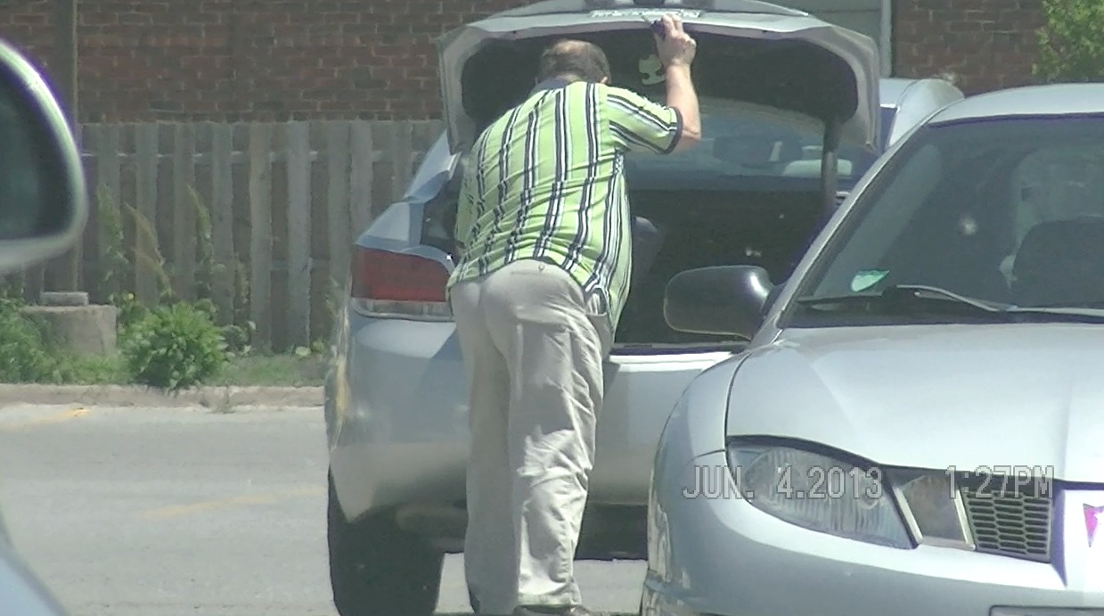
The investigator entered Food Basics shortly afterward in order to continue documenting the subject.

1:31 p.m. Mr. Conti was observed as he shopped near the produce area of the store. Over the next approximate 9 minutes the subject was documented intermittently as he shopped throughout the store. (Video)
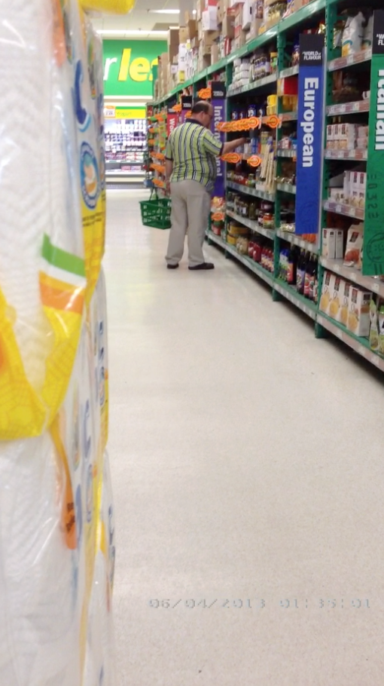
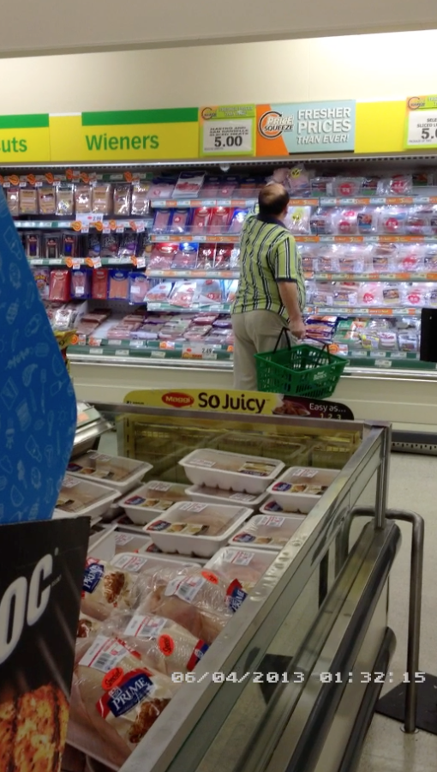
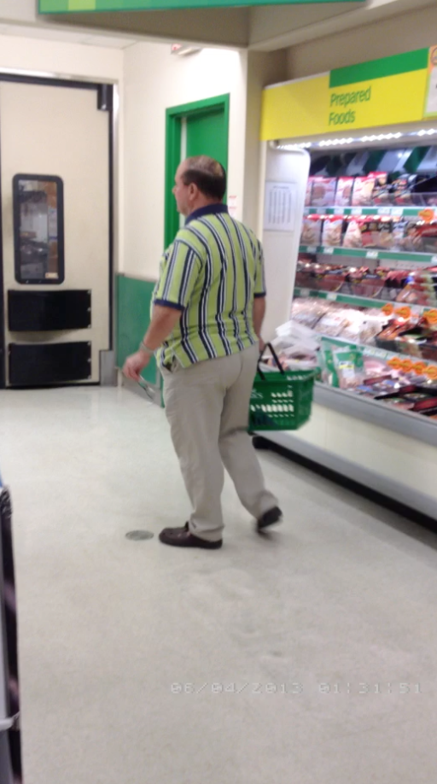


1:40 p.m. The subject entered a checkout lane and bent down and stood up repeatedly as he placed his groceries on the conveyor belt. (Video)

The investigator exited the store and returned to the surveillance vehicle.

1:43 p.m. Mr. Conti exited the store and returned to the vehicle carrying his purchases. However, we were block from view during this time. Eventually, he was observed opening the driver’s side door, and entering the vehicle in the same manner as mentioned previously. He departed the area moments later. (Video)

1:56 p.m. The subject arrived at a strip mall located at 3714 Portage Road in Niagara Falls. He parked his vehicle, walked to and entered Bulk Barn. The investigator opted to remain in the surveillance vehicle anticipating the subject’s quick return. (Video)

2:06 p.m. Mr. Conti exited Bulk Barn carrying a plastic bag in his right hand and his keys in his left hand. He arrived at the vehicle, opened the rear passenger’s door and placed the bag in the rear passenger’s area, closed the door, opened the driver’s door, and entered the vehicle in the same manner as previously mentioned. He departed from the area. (Video)

2:08 p.m. The subject drove to the other side of the strip mall and parked his vehicle. He exited the vehicle and walked toward Scobey’s grocery store. Mr. Conti stopped and waved a car through before he walked across the parking lot and entered the building. (Video)

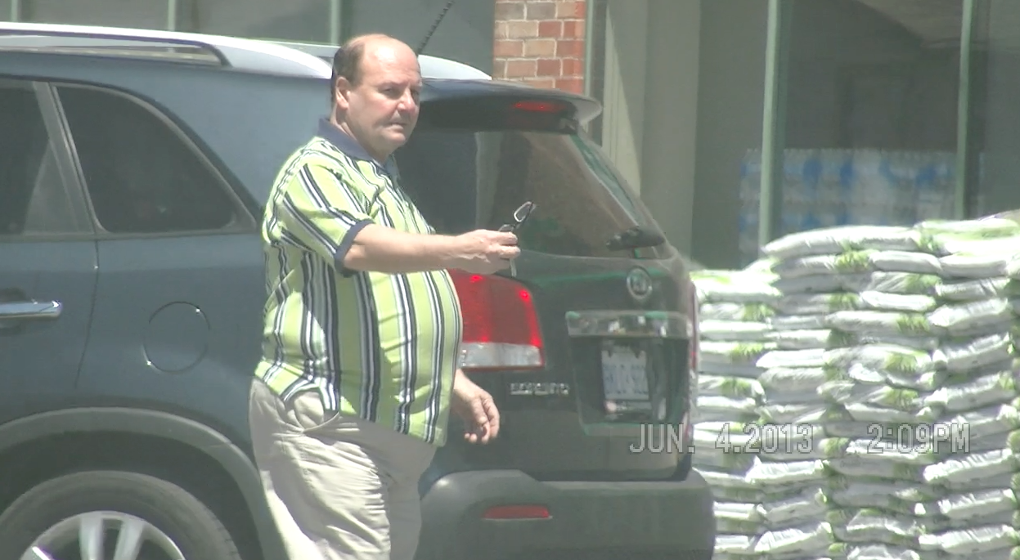
The investigator opted to remain in the surveillance vehicle in the interest of discretion and did not follow the subject into the grocery store.

2:13 p.m. Mr. Conti exited Sobeys and walked toward his vehicle. (Video)

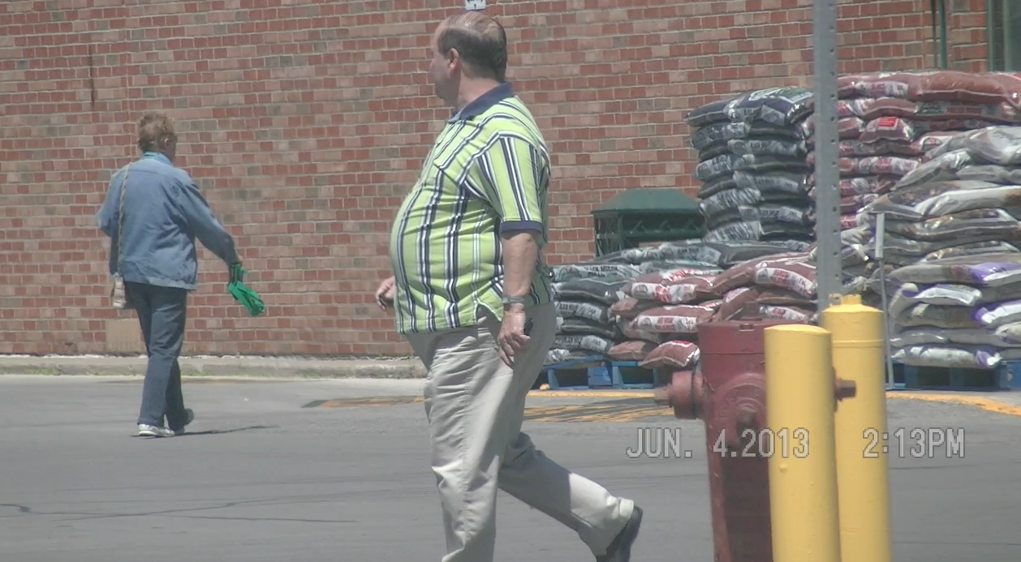
The subject entered the vehicle in the same manner by placing his left hand on the car’s A-frame, placing his right leg inside the vehicle along with his head and neck, then followed through with the rest of his body. (Video)

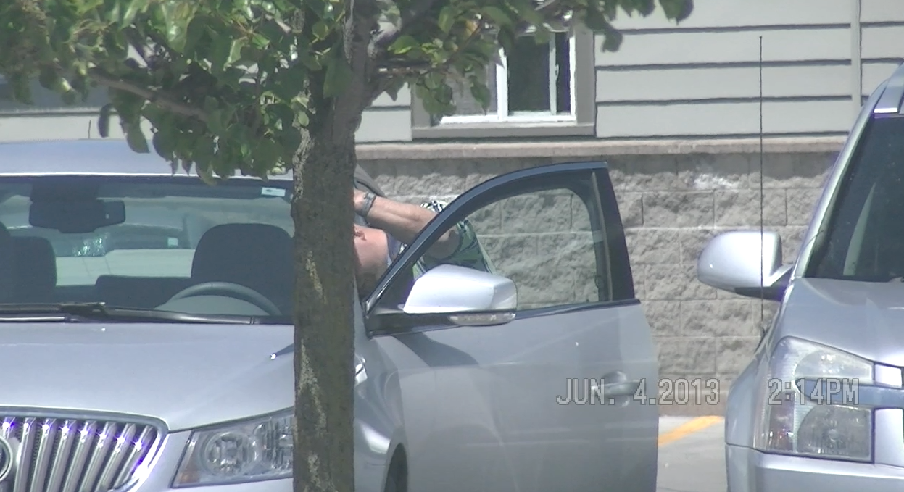
The subject placed his sunglasses on, moved his head and neck to the left and right, fastened his seatbelt and then departed from the area. (Video)

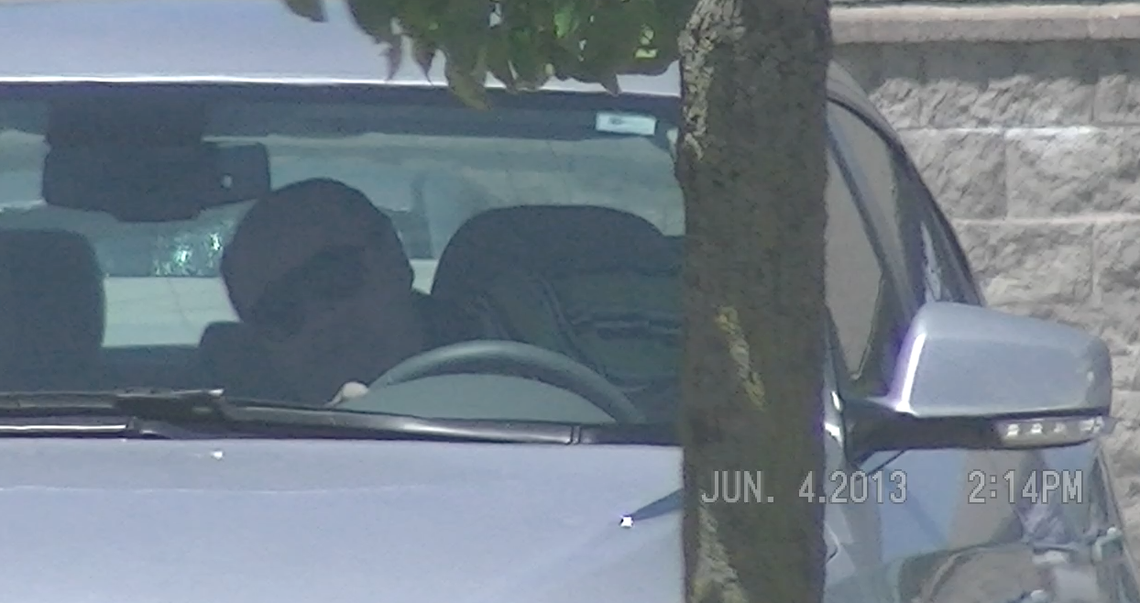

2:26 p.m. The subject traveled eastbound onto Line 2 Road, which leads to his residence. In order to maintain discretion, we did not follow the subject. (Video)

2:30 p.m. Surveillance was discontinued as we did not anticipate any further activity.

2:50 p.m. The investigator returned to the office.

Wednesday, June 5, 2013

11:41 a.m. The investigator departed the office on route to the subject’s residence in order to determine if he adhered to any daily pattern with his departures.

12:01 p.m. We arrived in the vicinity of Mr. Conti’s residence. His vehicle was not parked on the driveway and his garage door was closed. No activity was observed on or near his property.

2:30 pm. Due to budgetary constraints and the lack of subject activity, surveillance was discontinued.

2:50 p.m. The investigator returned to the office.

*******************

VIDEO REVIEW

During the course of our observations, we obtained approximately 44 minutes of video footage in order to document the subject’s activities. The original unedited footage will be catalogued and stored in the Investigative Intel’s video library under video identification numbers 13002M & 13002C. For your convenience, we have provided you with a copy on DVD, which may or may not have been edited to exclude any extraneous footage, which does not depict the subject.

RECOMMENDATIONS:

- Since Mr. Conti was discharged from his physiotherapy treatment due to having reached pre-accident health status and has suggested that he did not suffer any loss of earnings or permanent disability, we do not recommend any further surveillance at this time.

However, it was suggested that the subject is seeking compensation for pain and suffering due to severe whiplash, months of constant headaches, a stiff neck, back spasm and sleep interruptions. Therefore, it might be beneficial to conduct a neighbourhood canvass. It is possible that some of his neighbours might be privy to his accident and might be willing to speak on how much it is affected him, especially if they knew him both prior to and subsequent to your date of loss.

- Mr. Conti did appear to enter the vehicle in a slightly unorthodox manner. It is unknown if this is attributed to any such pain he might be experiencing. We recommend that his mobility be examined not only by you, but also by trained professionals (physiotherapists), who might be able to comment on his physical movements. This expense might only be worthwhile should your exposure escalate in time.

- It might also be beneficial to obtain a copy of the accident report and identify any possible witnesses to the accident. They might be able to comment on the subject’s driving habits and/or his level of mobility shortly after the accident. Interviews could be conducted at nearby businesses in an attempt to identify anyone who might have any recollection of the accident. Again, this would be recommended in the event your exposure increases on this claim.

***************

As per your request, we have concluded this assignment and are forwarding our report, video and invoice for your review. Should you determine that any further investigation might be required in this matter or have any questions please do not hesitate to contact us.

Yours truly,

Mike Bedrosian

President
Investigative Intel
905.325.8580
www.investigativeintel.com

