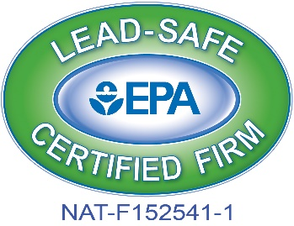
Set In Stone is a full service construction company that has been in business since 2009. We specialize in all forms of renovation, remodeling and construction. We are a 203K certified firm, we can manage your new construction or renovation project from beginning to end. In addition we offer full service restoration services and insurance claim settling. Set In Stone is a licensed lead and asbestos abatement contractor we also offer mold remediation services.

“For your business or home, it must be Set In Stone!”

Visit our website for more information @ www.setinstonerenovations.com

44872 Heydenreich, Clinton Township, MI 48038
Phone: (586) 994-6969 Phone: (586) 567-5653
Owner/President – Edward Amyot Vice President – Gerod Chapple Edward Amyot – Contractors License #2101205516 Construction Sales License# - 2105209719
Residential Builder Company – License # 2102209559 RRP – Lead Certified – Set In Stone # NAT – F152541-1

Phone: (586) 212-5539 Phone: (586) 604-0942
Marketing Manager - Greg Amyot Public Relations / Web Design – Matt Brashaw
Site Manager – General Contractor General Contractor
Lead Certified# – R-I-19167-15-00519 Lead Certified# – R-I-19167-15-00515
203K
Set In Stone
Guide to Close

A 203K loan is a renovation mortgage. Which gives the homebuyer freedom to purchase and create a home that is their own. This loan is backed by the federal government with competitive rates from the FHA. A 203K consultant is highly recommended for a streamline 203K. This keeps all scopes of work in order and creates less stress for the homebuyer.
Full 203k Loan
- Given to properties in need of structural or complex repairs
- Two different ways to determine how much money will be allowed
- Up to six months of your mortgage can be financed and used towards temporary residence
- 203k consultant is required

Set In Stone Guidelines
- Must provide written plan of work and cost estimates.
- Must provide type of repairs and how they will be completed along with cost.
- Contractor must have a written agreement confirming the completion of the work, cost estimate and time allowed.
- Contractor must obtain all permits and complete approved renovations in accordance with state and local building codes.
- Contractor must be licensed, insured, bond and 203K/FHA/HUD approved for all affected scopes of work.
Streamline 203k
- Allocates funds for repairs and renovations
- Recommended for small projects that do not require structural repairs
- Streamlined process is to uncomplicated future plans Consultants are not required but recommended

