SPECIAL MEETING

JANUARY 2, 2025

A Special Meeting (Organizational Meeting of 2025) of the Town Board of the Town of Hampton, County of Washington and the State of New York was held at the Town Hall, 2629 State Route 22A, Hampton, New York the 2nd day of January 2025.

PRESENT: David K. O’Brien------------Supervisor

Donald Sady------------------Councilman

Tamme Taran----------------Councilwoman - absent

Michael Pietryka------------ Councilman

Andrea Kugler---------------Councilwoman

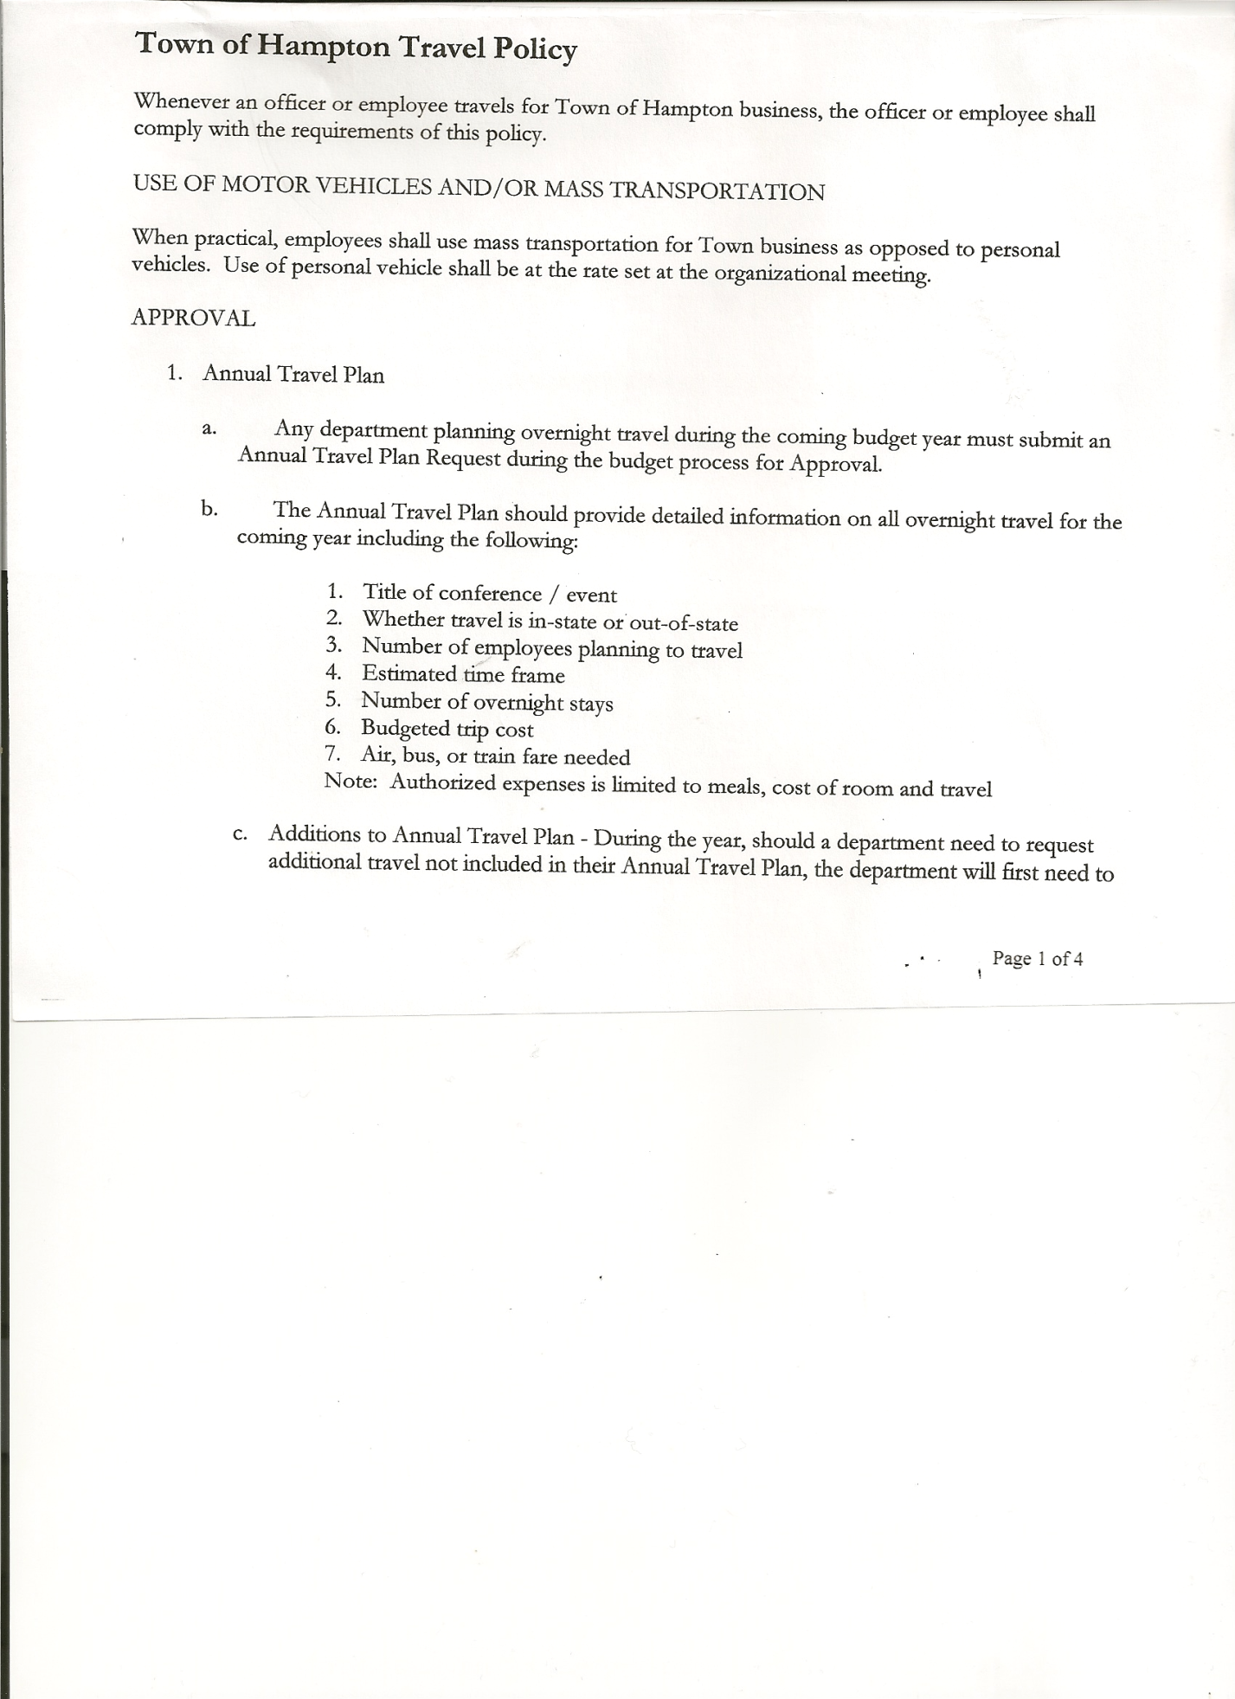 Rebecca Jones---------------Town Clerk

Camilla Shaw----------------Deputy Town Clerk - absent

Tyler McClure---------------Highway Superintendent

Planning Board Members: Matthew Pratt

Others present at the Town Hall: see attached sheet

The Special Meeting was called to order by Supervisor O’Brien at 7:00pm, followed by the Pledge of Allegiance. Location of Fire Exits were given. Quorum of board members present.

Supervisor O’Brien asked for a moment of silence in memory of Brenda VanDusen of Hills Pond Rd, Malcolm Brown and the victims of the New Orleans attack.

Discussion amongst the Board members to change the day of the monthly meetings…decided to stay on the 3rd Thursday of each month.

**RESOLUTION NO. 1-2025**

**APPOINTMENT OF TOWN OFFICIALS**

On a motion of Councilman Sady, seconded by Councilman Pietryka, the following resolution was

ADOPTED: Ayes 4 O’Brien, Sady, Pietryka, Kugler

Nays 0

Absent 1 Taran

RESOLVED, to appoint Town Officials as presented on attached sheet.

**RESOLUTION NO. 2-2025**

**HAMPTON ORGANIZATIONAL CHARTER FOR 2025**

On a motion of Councilman Sady, seconded by Councilwoman Kugler, the following resolution was ADOPTED: Ayes 4 O’Brien, Sady, Pietryka, Kugler

Nays 0

Absent 1 Taran

RESOLVED, that upon review, the Hampton’s Organizational Charter for 2025 is adopted as proposed. (Salaries are per budget, Holidays and Miscellaneous Info were approved)

Discussed Highway Department vacation, sick and personal time. Town Board members and Highway Superintendent agreed to convert to PTO (Personal Time Off). Supervisor O’Brien will work on a schedule/policy and present at the regular monthly meeting.

TOWN BOARD MEETING

JANUARY 2, 2025 PAGE 2

**OATH OF OFFICE**

The Oath of Office was administered to the Appointed Officials present:

* David O’Brien-Local Compliance Officer; Point of Contact for NIMS and Association

of Towns Voting Delegate

* Tyler McClure – Highway Superintendent
* Michael Pietryka – Deputy Town Supervisor
* Leonard Reed – Deputy Town Clerk (2nd)
* Andrea Kugler – member of Ethics Board
* Matthew Pratt – member of Ethics Board

Judge Sady administered the Oath of Office to Rebecca Jones as Registrar of Vital Statistics; and Association of Towns Alternate Voting Delegate (Appointed) prior to the meeting.

Town Clerk Jones will administer Oath of Office to other Appointed Officials by January 31st, 2025.

**RESOLUTION NO. 3-2025**

**PROCUREMENT POLICY 2025**

On a motion of Councilman Pietryka, seconded by Councilman Sady, the following resolution was ADOPTED: Ayes 4 O’Brien, Sady, Pietryka, Kugler

Nays 0

Absent 1 Taran

RESOLVED, to accept the Procurement Policy for 2025 (copy is attached)

**RESOLUTION NO. 4-2025**

**HAMPTON TOWN POLICIES**

On a motion of Councilman Sady, seconded by Councilman Pietryka, the following resolution was ADOPTED: Ayes 4 O’Brien, Sady, Pietryka, Kugler

Nays 0

Absent 1 Taran

RESOLVED, that upon review the following Policies:

1. Travel Policy
2. Investment Policy
3. Cell Phone Policy
4. Sexual Harassment Policy
5. Workplace Violence Policy
6. Credit Card Policy
7. On-line Banking Policy
8. Ethics Policy
9. Computer Usage Policy
10. Record Storage Policy

11.Drug/Alcohol Testing Policy

12.Town Hall Use

13.Road Side Tree Policy

14.Cyber Security Policy

Of the Town of Hampton are approved.

Employee Handbook…Supervisor O’Brien is redoing some parts of the Handbook, will present to town board for review when it’s done.

TOWN BOARD MEETING

JANUARY 2, 2025 PAGE 3

**RESOLUTION NO. 5 -2025**

**AUTHORIZE TO PRE-PAY ITEMS**

MOTION BY: COUNCILMAN DONALD SADY

SECONDED BY: COUNCILWOMAN ANDREA KUGLER

**TITLE: RESOLUTION AUTHORIZING THE TOWN SUPERVISOR TO PAY BILLS IN ORDER TO AVOID PENALTIES AND INTEREST**

**WHEREAS,** the Town has determined that due to certain bills being due prior to the Town Board Audit of bills,

**AND WHEREAS,** the Town Board is desirous of avoiding late fees, penalties and interest and maintain its good credit standing,

**NOW THEREFORE, BE IT RESOLVED:**

            That the Town Board of Hampton hereby authorizes the Supervisor to approve the payment of bills before audit if in the reasonable discretion of the Supervisor, it is necessary to do so to avoid any costs, penalties, interest or termination of service. The supervisor may pay claims for public utilities, postage, freight and express charges, gas and diesel before they are audited. The term “public utilities” includes electric, gas, water, sewer and telephone services and the purchase of fuel oil. All claims must be presented for audit at the next regular board meeting audit. The claimant and the town officer incurring or approving these claims are jointly and severally liable for any amount disallowed upon audit.

**BE IT FURTHER RESOLVED:**

That the Town Board is not required by law to pre- audit payments of fixed salaries, compensation of officers or employees, principal and interest indebtedness, or amounts coming due on certain contracts.

**BE IT FURTHER RESOLVED** that in the absence of the Supervisor, the Deputy Supervisor is authorized to review the bills and make the determination to authorize payment for the same reason.

**BE IT FURTHER RESOLVED** that the Town Clerk is hereby authorized and directed to add the following policy to the policy manual/employee handbook for the Town of Hampton**.**

DATED: January 2, 2025 Supervisor O’Brien AYE

Councilman Sady AYE

Councilman Pietryka AYE

Councilwoman Kugler AYE

Councilwoman Taran ABSENT

TOWN BOARD MEETING

JANUARY 2, 2025 PAGE 4

**RESOLUTION NO. 6 -2025**

MOTION BY: COUNCILM AN DONALD SADY

SECONDED BY: COUNCILWOMAN ANDREA KUGLER

**BOND RESOLUTION AUTHORIZING THE ISSUANCE OF**

**$334,025.00.00 AGGREGATE PRINCIPAL AMOUNT OF SERIAL BONDS OR STATUTORY INSTALLMENT BONDS OF THE TOWN OF HAMPTON TO PAY THE COSTS ASSOCIATED WITH THE PURCHASE OF A 2025 WESTERN STAR 49X TANDEM AXLE TRUCK AND AUTHORIZING THE ISSUANCE OF BOND ANTICIPATION NOTES OR STATUTORY INSTALLMENT BONDS OF THE TOWN OF HAMPTON FOR THE AFORESAID PURPOSES AND IN CONNECTION THEREWITH**

WHEREAS, the Town Board (the “Board”) of the Town of Hampton determined that the purchase of a new 2025 Western Star 49X tandem axle truck with hydraulics, plow, dump body, and related equipment in accordance with the October 9, 2024 quote from Tenco Industries, is in the public interest and that the health, safety and welfare of the residents of the Town would be benefited by said purchase where the Town would like to use for future Town public purposes (the “Project”); and

WHEREAS, the total contract price for the purchase of a new 2025 Western Star 49X tandem axle truck with hydraulics, plow, dump body, and related equipment is Three Hundred Thirty Four Thousand Twenty Five and 00/100 U.S. Dollars ($334,025.00) all of which is the responsibility of the Town of Hampton; and

WHEREAS, in order to further finance the costs associated with the Project, the Town desires to issue serial bonds or a statutory installment bond, in lieu of serial bonds (the “Bonds”) in the aggregate principal amount Three Hundred Thirty-Four Thousand Twenty Five and 00/100 U.S. Dollars ($334,025.00); and

WHEREAS, no bond anticipation notes have been previously authorized or issued in anticipation of the issuance of Bonds authorized by this resolution and the bond anticipation notes authorized by this resolution will not serve to renew any other existing bond anticipation notes.

**NOW, THEREFORE, BE IT RESOLVED** by the Board of the Town as follows:

Section 1. The specific object and/or purpose of the Project for which the obligations authorized by this Resolution is the purchase of 2025 Western Star 49X tandem axle truck with hydraulics, plow, dump body, and related equipment, is Three Hundred Thirty Four Thousand Twenty Five and 00/100 U.S. Dollars ($334,025.00) and the Town desires to issue Three Hundred-Thirty Four Thousand Twenty Five and 00/100 U.S. Dollars ($334,025.00) in serial bonds or statutory installment bonds of the Town of Hampton.

Section 2. The financing of the Project shall be undertaken by the Town through the issuance of a bond anticipation note or notes in accordance with and pursuant to the Local Finance Law of the State of New York in an amount not to exceed Three Hundred Thirty Four Thousand Twenty Five and 00/100 U.S. Dollars ($334,025.00). The Town hereby authorizes any bonds, including a statutory installment bond, in lieu of serial bonds, to be issued for this Project in an amount not to exceed Three Hundred Thirty-Four Thousand Twenty-Five and 00/100 U.S. Dollars ($334,025.00).

Section 3. The Town hereby authorizes the Supervisor of the Town (the “Supervisor”) to utilize funds held within the Fund and within the Budget for the purpose of physical public betterment or improvement and the payment of services rendered in connection with the Project and further authorizes the Supervisor to repay

TOWN BOARD MEETING

JANUARY 2, 2025 PAGE 5

any funds expended from the Fund with funds borrowed in connection with any bond anticipation note or bonds, including statutory installment bonds, issued pursuant to and authorized by and through this bond resolution.

Section 4. There are hereby authorized to be issued bond anticipation notes (“Notes”), including the renewal of such Notes, for the aforesaid specific objects or purposes in amounts up to but not exceeding the maximum amount of the Bonds herein authorized. Any such Notes issued shall be approved as to form and executed by the Supervisor and issued in anticipation of the sale of the Bonds herein authorized.

Section 5. It is hereby determined that the period of probable usefulness of the aforesaid specific objects or purposes is five (5) years pursuant to Section 11.00(a)(32) of the Local Finance Law.

Section 6. The full faith and credit of the Town is hereby irrevocably pledged for the payment of the principal of and interest on any Bonds or Notes issued in connection with this bond resolution, as the same respectively become due and payable. An annual appropriation shall be made in each year sufficient to pay the principal of, and any interest, if applicable, on the Bonds or Notes becoming due and payable in such years.

Section 7. The maximum maturity of the Bonds shall not exceed the periods of probable usefulness set forth above and shall mature on or before the date of the expiration of the aforesaid periods of probable usefulness as measured from the date of the Bonds or from the date of the first bond anticipation note or statutory installment bond issued in anticipation of the sale of such bonds, whichever date is earlier. If deemed necessary by the Supervisor, or in the absence of the Supervisor, the Deputy Supervisor, the Bonds or Notes to be issued hereunder may be issued in two or more separate series. The maturity of the Bonds issued in connection with this bond resolution will not exceed five (5) years.

Section 8. Any Notes or Bonds issued hereunder shall be payable from the proceeds derived from the issuance and or sale of the Bonds authorized herein or otherwise redeemed in the manner provided by Section 23.00 or Section 62.10 of the Local Finance Law.

Section 9. There are no bond anticipation notes or Bonds outstanding for this Project.

Section 10. Subject to the provisions of the Local Finance Law, the power to issue and sell the Bonds and/or Notes, including all powers and duties pertaining or incidental thereto, is hereby delegated to the Supervisor, or in the absence of the Supervisor, the Deputy Supervisor, of the Town, except as herein provided. The Bonds and/or Notes shall be of such terms, form and content, and shall be sold in such manner, whether by public or private sale, as may be determined by the Supervisor, or in the absence of the Supervisor, the Deputy Supervisor, pursuant to Local Finance Law, this resolution and any further resolution which the Board may hereafter adopt. The Supervisor, or in the absence of the Supervisor, the Deputy Supervisor, is authorized to execute and deliver any documents and to take such other action as may be necessary and proper to carry out the intent of the provisions of this resolution, including any resolutions, contracts or authorizations necessary to secure any Federal or State issued grant(s) or loan(s).

Section 11. The exact date of issue of the Bonds and/or Notes and the exact date upon which the same shall become due and payable shall be fixed and determined by the Supervisor, or in the absence of the Supervisor, the Deputy Supervisor, provided however, that the maturity of said Notes or renewals thereof shall not exceed one year from the Note's or renewal's date of issue except as permitted by the Local Finance Law.

TOWN BOARD MEETING

JANUARY 2, 2025 PAGE 6

Section 12. The Supervisor, or in the absence of the Supervisor, the Deputy Supervisor, shall prepare, or cause to be prepared, such Bonds and/or Notes and sell the same in accordance with the applicable provisions of the Local Finance Law, and at such sale shall determine the interest rate to be borne by such Bonds and/or Notes, whether fixed or variable.

Section 13. The proceeds of the sale of the Bonds and/or Notes shall be deposited and/or invested as required by Section 165.00 of the Local Finance Law, and the power to invest the proceeds of sale is hereby delegated to the Supervisor and the power to invest in any instruments described in the said Section 165.00 is expressly granted.

Section 14. To the extent that it is permitted to do so under the Internal Revenue Code of 1986, as amended (the "Code"), the Issuer hereby designates the Bonds and/or Notes as "qualified tax-exempt obligations" under Section 265(b)(3) of the Code. The Issuer hereby covenants that it will (i) take all actions on its part necessary to cause interest on the Bonds and/or Notes be excluded from gross income for purposes of Federal income taxes and (ii) refrain from taking any action which would cause interest on the Bonds and/or Notes to be included in gross income for purposes of Federal income taxes.

Section 15. The validity of such Bonds and/or Notes (collectively "Obligations") may be contested only if:

(1) Such Obligations are authorized for an object or purpose for which the Town is not authorized to expend money, or

(2) The provisions of law which should be complied with at the date of publication of this resolution are not substantially complied with, and an action, suit or proceeding contesting such validity is commenced with twenty (20) days after the date of such publication, or

(3) Such Obligations are authorized in violation of the provisions of the constitution.

Section 16. This resolution, or a summary hereof, shall be published in full in the newspapers Granville Sentinel and Whitehall Times, which have been designated as the official newspapers of the Town for such purpose, together with a notice of the Clerk of the Town in substantially the form provided in Section 81.00 of the Local Finance Law.

Section 17. Pursuant to Section 33.00(a), this resolution shall be adopted by at least two-thirds (2/3) vote of the voting strength of the Town Board.

Section 18. The adoption of this Resolution is considered an action under the New York State Environmental Quality Review Act (SEQRA). The Town hereby declares that this action is a Type II action pursuant to 6 NYCRR 617.5 (25), and hereby declares that the action does not have a significant impact on the environment and the action is hereby precluded from further environmental review.

Section 19. This resolution shall take effect immediately.

TOWN BOARD MEETING

JANUARY 2, 2025 PAGE 7

The question of the adoption of the foregoing resolution was duly put to a vote by roll call, which resulted as follows:

Voting: Ayes: Nays: Abstain: Absent:

David O’Brien, Supervisor X

Tamme Taran, Councilwoman _X

Andrea Kugler, Councilwoman X

Donald Sady, Councilman X

Michael Pietryka, Councilman X

The foregoing resolution was thereupon declared duly adopted.

[Seal]

___________________________

Rebecca S. Jones, Town Clerk

Town of Hampton

**2025 ANNUAL AUDIT**

**RESOLUTION 7-2025**

**END OF YEAR COURT AUDIT**

On a motion of Councilman Pietryka, seconded by Councilwoman Kugler, the following resolution was ADOPTED: AYES 3 O’Brien, Pietryka, Kugler

NAYS 0

ABSENT 1 Taran

ABSTAIN 1 Sady

RESOLVED, to accept the Court Audit for 2024.

**RESOLUTION 8-2025**

**MEETING ADJOURNED**

On a motion of Councilman Pietryka, seconded by Councilwoman Kugler, the following resolution was ADOPTED: Ayes 4 O’Brien, Sady, Pietryka, Kugler

Nays 0

Absent 1 Taran

RESOLVED, that the meeting adjourned at 7:50pm.

Respectfully submitted,

Rebecca S. Jones, RMC

Town Clerk