Winter Newsletter 2018
Ilarion Residence

Table of Contents

Page 2 Ilarion News- Upper Lounge Facelift

Page 3 Disability Benefit Credit and other info

Page 4 Globe Walk 2018 info and Winter Birthdays

Page 5 Event Reminders and Special Services at Ilarion

Page 6 Staff Christmas Party photos and Newsletter Competition

No winter lasts forever; no spring skips its turn. – Hal Borland

2509 Louise Street Saskatoon SK. S7J 3L7
www.ilarion.ca T: (306) 373-7011

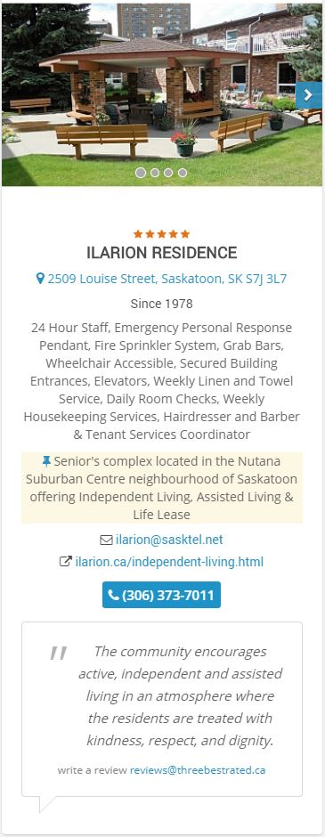
Ilarion made Top 3!

Check out what this

website had to say about

how they chose the top

three Retirements Homes

in Saskatoon, and why we

were chosen!

“Best Retirement Home in

Saskatoon, SK

Handpicked Top 3

Retirement Homes in

Saskatoon. How do we

actually find the most

highly rated retirement

home? Our 50-Point

Inspection includes

everything from checking

reputation, history,

complaints, local reviews,

nearness, satisfaction, trust

and cost to the general

excellence. That's not all...

businesses do not pay us

to list them. You deserve

only the best!”

–www.threebestrated.ca

/retirement-homes-in-saskatoon-sk

Ilarion News- What’s new at Ilarion?

Upper Lounge Facelift
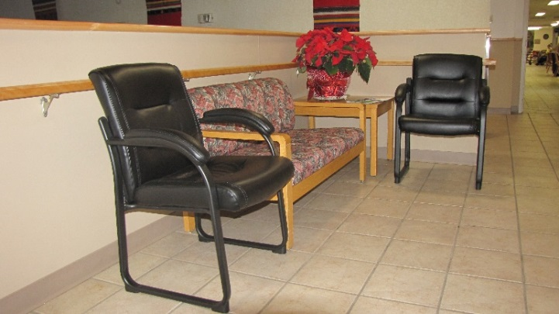
The new comfortable guest chairs adorning the upper front lounge are catching the attention of all residents as well as visitors. They are a great addition to our home. What is not well known is that 22 of those chairs were purchased from the proceeds of the Coffee Corner Committee. They were made possible through the patronage of those coffee and tea drinkers who supported the work of the committee from 2012 to 2017. In those five years a net total of $3,915 was earned and when the Coffee Corner Committee ceased operating last March 31, 2017, the money was turned over in trust to the Executive Council with the specific request that it be spent only on replacing upper lounge furniture.
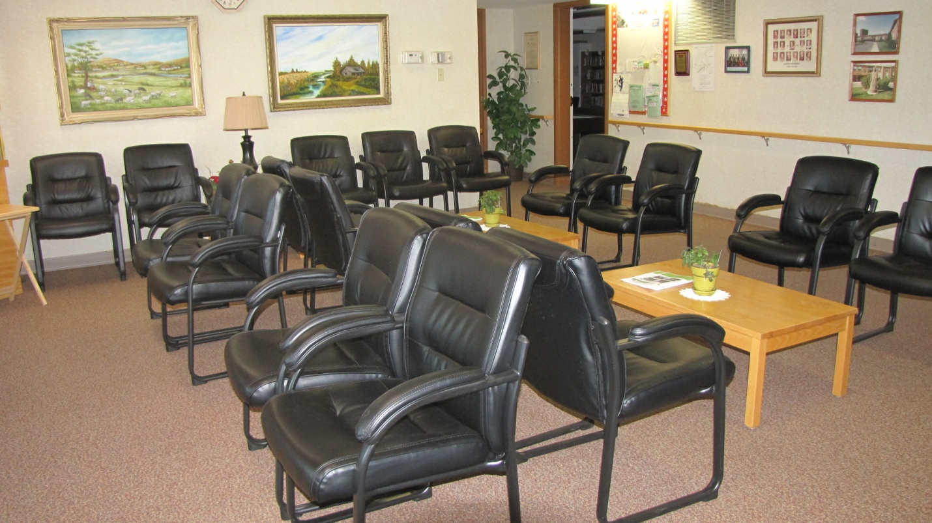
This fulfilled a General Meeting motion made way back on February 27, 2013 about buying new raised furniture for the front lounge. It took a long time, but the intent of the motion made by the late & previous Tenant Association President Elizabeth Boyko and seconded by current resident & previous Committee Convener Frances Robinson was finally fulfilled.
The selection of the chairs was made by residents Dorothy Cook, Olga Kaye and Adele Danyliuk, who were convenors on the Coffee Corner Committee, before its dissolution. A lot of thought went into the selection. The selection criteria included comfort, durability, maintenance, height and cost. The Executive Council extends its appreciation for their work in the selection. Also, Executive Council decided to recognize the work of the Coffee Corner Committee with a plaque to be hung in a conspicuous place in the upper lounge to express their gratitude for the five years of coffee service and monthly birthday parties and to create awareness that the surplus funds went into the purchase of the 22 guest chairs. Thank you to all those involved in the Coffee Corner Committee. Continued on next page. . .
. . . Continued from last page
In support of their purchase of 22 chairs, the Executive Council has purchased 4 guest chairs and 4 were purchased by the Administration of Ilarion Residence. We look forward to many years of enjoyment on our thirty new chairs!

Disability Benefit Credit - Find out How You Can Benefit

On Tuesday, January 16 at 2:30 pm, Tom Plishka will be giving a talk on what the disability benefit tax credit is all about. Tom is a Chartered Accountant and a former Board Member of Ilarion. He is a Risk Partner in MNP's Saskatoon office and specializes in Financial Services.
According to Canada Revenue Agency, “The disability tax credit (DTC) is a non-refundable tax credit that helps persons with disabilities or their supporting persons reduce the amount of income tax they may have to pay. An individual may claim the disability amount once they are eligible for the DTC.” As the 2017 tax reporting season is now here, this is a great time to take in this presentation to see if you could qualify for this tax credit.

General Meeting on January 24 at 7:00 PM

The Executive Council has called for a General Meeting of tenants for Wednesday, January 24th at 7:00 PM. The agenda will include committee reports as well as reports on the following items:
- Purchase of Upper Lounge Chairs
- Grant Fund
- Letter to City of Saskatoon regarding traffic concerns in our neighbourhood
- Christmas Dinner 2017
- Availability of information on fraud schemes
- Need for a presentation on identifying and dealing with pests

A full agenda along with the minutes of the October General meeting will be posted in the mail room lobby area a week or so before January 24th.

-Above articles submitted by Tenant Martin Zip

Globe Walk 2018 – by Beth Hill Globe Walk Coordinator

Winter Birthdays
Ilarion wants to wish a happy birthday to all of our tenants who celebrate a birthday in the winter.
Dec. Sylvia A. Nick B. Steve C. Henry F. John F. Mary I. Annie K. Vera K. Helen M. Lyman P. Glennis P. Frances R. Lenora S. Robert T. Natalie T. Jo W. Martin Z.  Jan. Pauline B. Mary B. Elsie C. Doreen D. Grant I. Nellie K. Orest M. Kay P. Stella P. Sylvia S. John S. Syl S. Elizabeth U. Annie W. | Feb. Bill B. Inez C. Anne C. Adele D. Vi H. Ernest H. Rose J. Phyllis K. Grady K. Bob K. Sylvia O. Mary P. Lorraine S. Mary U.

Get ready for the 5th Anniversary SCOA Globe Walk celebrating the Olympic/Paralympics Winter Games 2018! We want as many people participating this year as possible! Walking laps around Ilarion is very convenient, but if you want to get out of the building, here is some information about events and walking lanes:

Walking Lanes:
When: Mondays and Wednesdays from 1-2 pm OR 2-3 pm
Tuesdays and Thursdays from 1-2 pm OR 2-3 pm
Where: Saskatoon Field House
Cost: A minimal fee of $20 will allow access to the tracks from January – April for any one of the above times. That’s a great value at less than a dollar per visit! Lanyards are required in order to access the walking tracks.
How to purchase lanyards:
Since December 1st, 2017, lanyards have been available at the SCOA office (8:30 am to 4:30 pm, Monday to Thursday. Closed over lunch-12 noon to 1 pm).
If you wish, you can purchase more than one lanyard, allowing you to use the track on different days or in more than one time slot.
Globe Walk Social Activities for 2017: (More details will follow).
Put them on your calendar!
- February 19 Family …In Motion Walk (Forestry Farm). This event is for the whole family!
- March St. Patrick’s Event (Details to follow)
- April Surprise Event (Details to follow)
- May 9 Celebration Luncheon at the Western Development Museum
For more information, contact Council on Aging 306-652-2255 or go to globewalk@scoa.ca. Let’s make 2018 “Olympic” Globe Walk the most successful one yet!

Extra Reminders for January and February
Mondays in January: 1:30 Free Shuttle to Dance Program (sign up for shuttle)
Tuesday January 16th: 2:30 Speaker: Tom Plishka on “Disabilities Benefits”
Wednesday January 17th: 9:30 Bank
Wednesday January 17th: 2:30 Travel Slides (Jack)
Wednesday January 17th: 7:00 Entertainment Nite & Music
Sunday January 21st: 3:45 Lastiwka Choir
Wednesday January 24th: 7:00 General Meeting for Tenants
Friday February 2nd: 7:00 Community Dance @ St. Volodymyr Villa
(Must sign-up for free shuttle; bring $2 for refreshments)
Be sure to read the monthly Ilarion’s Calendar of Events for all activities!

Special Services offered at Ilarion - Don’t miss out!
There are multiple special/extra services that are offered at Ilarion. If you are interested in any of these services and want more information, contact the office or Dianne. The special services offered include:
- Personal garbage pickup ($1 per pickup; (pay at the office). Must pre-register by phoning the office by 9:30 a.m. on Tuesday or Friday- 306-373-7011. Pick-up days are Tuesdays and Fridays only).
- Foot Care (By We Care trained staff). Sign-up is outside of the AL office.
- Hair salon (By Cindy Rees. To make an appointment call 306-244-0400).
- AVON (By Maureen Thomas. See calendar of events for AVON dates and times).
- Massage therapy (By Rebecca Giesbrecht, Registered Therapist. Appointments must be made directly through Rebecca. Her phone number is 306-292-6016).
- Reflexology (By Janice Davis a retired nurse. Appointments must be made through Janice. Her phone number is 306-261-9475).
- Indoor recycling collection (deposit bins are located in laundry rooms, near front elevator & main kitchen, & parkade; and collected regularly).
- Bank (New Community Credit Union monthly visits).
- Blood pressure clinic (Last Tuesday of each month from 2:30-3:30pm. Sign-up is outside of the AL office. Presented by the Pharmacy at Safeway/Sobeys).
- Flu shot clinic, CPAS assessments and MORE. (By health professionals).

Staff Christmas Party
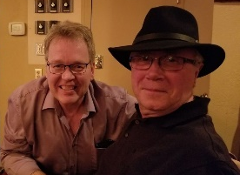
On Friday December 9th, 2017, the Ilarion staff enjoyed a wonderful dinner and night out. They all participated in a Secret Santa gift game, and were able to share a lot of laughs with each other. Of course not all of the workers/staff at Ilarion were able to make it, but for those who did here are a few pictures from the evening:

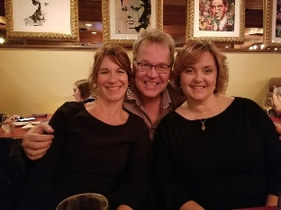

Newsletter Competition
Submit your answers to these fun brainteasers by Thursday February 1st to the Program Coordinators office (deposit your entry into mail slot under the window). All correct submissions will be placed into a draw, and two winners will be chosen to receive prizes. Shortly after the competition is over, a notice of winners will be posted on the front bulletin board. Good luck!
Brainteaser questions:
1) My posterior is adorned with feathers. I have a rather long neck and quite a pointy nose. I am able to fly, yet I have no wings. What am I?
2) The rungs of a 10 foot ladder attached to a ship are 1 foot apart. If the water is rising at the rate of one foot an hour, how long will it take until the water covers over the ladder?
3) What sneaks through doors and windows without knocking? What heats an unlit stove? What gives the cat a snug place to rest?
4) Though liquid in nature, don't push me too far; For then I will break, and the damage may scar. What am I?
Thanks for reading!
If you have anything to submit for the next Newsletter, please contact the office.

