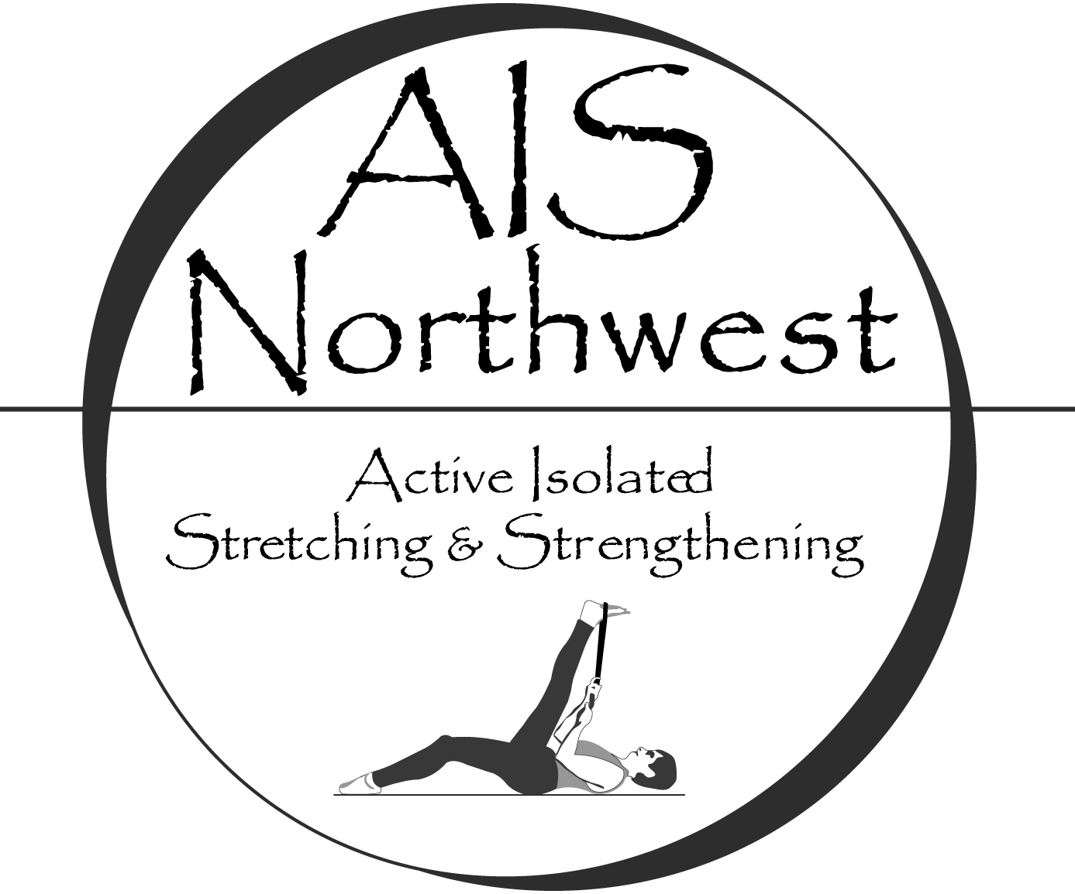

Active Isolated Stretching for the Lower Extremities

May 6th, 2018

Anamosa, IA

Active Isolated Stretching (AIS) is a dynamic technique that stretches muscles, tendons, and fascia, specific to anatomical planes of movement. It remodels the body using gentle, rhythmic movements that avoid triggering the myotactic reflex, which causes a contraction in the tissues being stretched. Utilizing the principles developed by Aaron Mattes, this unique stretching modality restores joint mobility, reduces muscular/fascial tension and improves circulation. The simple yet profound difference is holding the stretch for only 2 seconds. Repeated, active muscle contractions along with gentle stretches create a venous/lymphatic pump, decreasing inflammation and combating disease. Dysfunctional movement patterns are exposed and retrained; unfavorable postural habits shift.

In this basic level class you will learn the physiology behind AIS and how to stretch yourself and assist your clients. Learn how to evaluate range and quality of movement before and after stretching and how to apply the techniques to treat a wide variety of disorders in the lower extremities. The material presented addresses plantar fasciitis, heel spurs, Morton’s Neuroma, hammer toes, bunions among other disorders. Course content is geared towards healthcare professionals and athletic trainers.

This class completes one of the requirements for gaining basic AIS level certification with AIS Northwest.

Instructor: Joshua Morton, LMT, MAISS, MMLT
CE Contact Hours: 6 hours (NCBTMB, BOC)
Tuition: $175, tuition includes a stretching strap for new students.
Discount: Register for all classes Friday through Sunday, 22 CEs, $500.
Materials: Free electronic access to the instructional manual. A handout of the stretches covered in class will be provided.
Cancellation/Refund Policy: Carlson College of Massage
Day/Time: Sunday 9 AM – 5:00 PM (1 hour for lunch)
Location: 11809 Co Rd X28, Anamosa, IA 52205
Registration/Info: Carlson College of Massage
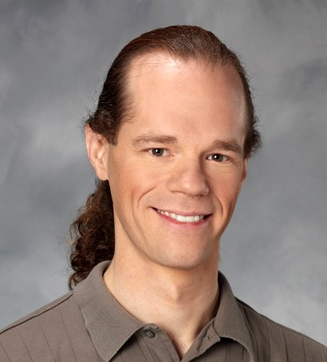 | Joshua Morton, LMT, MAISS, MMLT - Co-owner/Master Instructor with AIS Northwest, LLC. Joshua has over 2000 hrs. training with Aaron Mattes, the creator of Active Isolated Stretching and over 15 years teaching AIS. Joshua is one of the leading AIS practitioners and instructors internationally. Joshua offers students in-depth experience and expertise in a supportive learning environment. (#MA00008567). | 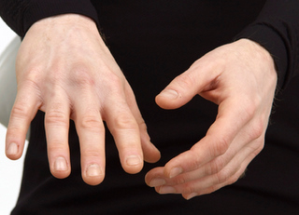
AIS Northwest, LLC is approved by the Board of Certification, Inc. to offer continuing education for Certified Athletic Trainers.
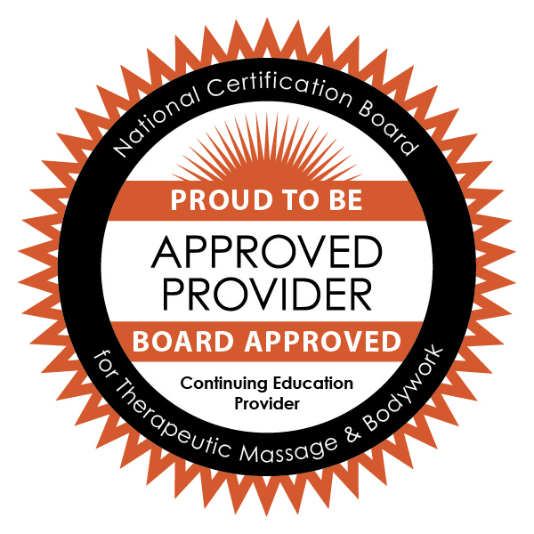AIS Northwest is approved by the National Certification Board for Therapeutic Massage & Bodywork (NCBTMB) as a continuing education Approved Provider (Provider ID: 451194-09).

