Our Lady of the Holy Rosary
Church Festival
www.geauxlafete.com
geauxlafete@gmail.com

•••Poster Contest Entry Form •••
Deadline for submissions is October 5th

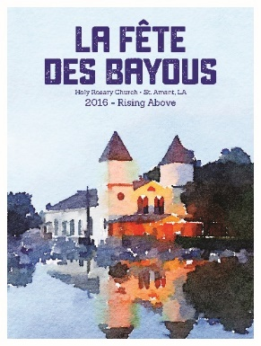
- Entry must be an original work by the contestant that focuses on our theme “Everyday Saints.”
- Open to all ages; parent/guardian must sign release for children under the age of 18.
- Entry may be submitted by mail (or delivered) to Holy Rosary Catholic Church, Attn: La Fête des Bayous, 44450 Hwy 429, St. Amant, LA 70774 or as a high res 300 dpi JPEG or PDF emailed to geauxlafete@gmail.com no later than 4:00 pm by Friday, October 5, 2018. Entries will NOT be accepted the day of the event.
- Artwork must be no larger than 18”x24” with a white border of ¼ inch around all four sides; may be vertical or horizontal.
- There are no restrictions on the choice of technique or media, photography entries are accepted. All work must be self-produced.
- Completed entry form must accompany entry and participant’s name is to be written on the back, not on the front of the entry.
- Only one entry per participant will be accepted.
- Entries that do not comply with all of the contest rules will be disqualified.
- Artwork for this contest may be picked up after contest from the parish office.

2018 Poster Competition Entry Form
Name:
Phone: |  | Age:
Email:
Address:
City, State, Zip:

ENTRANT AGREEMENT
All art submitted shall become the property of La Fête des Bayous/Our Lady of the Holy Rosary Catholic Church. The contestant, by submitting the work, relinquishes all rights to, and ownership interest in, the submission. By submitting this form, the entrant:
- Warrants that the participant is the original creator of the work.
- Agrees to allow free use of the work by the La Fête des Bayous and assigns an irrevocable license to reproduce the submitted work, in whole or in part, for any purpose, including on the Internet, in print production and any other medium without compensation of any kind and to photograph and identify the entrant by name in conjunction with the work.

Print Entrant’s Name Entrant’s Signature

Print Parent/Guardian Name (for Entrants 18 & under) Parent/Guardian’s Signature (for Entrants 18 & under)

