+ FIRST CONGREGATIONAL CHURCH
An Open and affirming congregation of the
United Church of Christ, Saugus, Massachusetts
Service of Worship, 10 A.M.
3rd Sunday after Pentecost, June 25, 2017
*Indicates for those who are able to, please stand.
Bold print indicates congregational response.
NCH = New Century Hymnal (black cover)
HOP = Spiral bound cover

Scripture reader is John Gilmore.
Greeter & Usher is Jessie Allison.
Deacon of the Month is Terri Leander.

PRELUDE Mae Stroshane
WELCOME & ANNOUNCEMENTS
LIGHTING THE CANDLE OF PEACE HOP 119
“Make Me a Channel of Your Peace”

CALL TO WORSHIP* (“God, we’re here!”):
L: We awake to this new day created by God.
P: We offer our gratitude and appreciation for the gift of life.
L: We enter sacred space to be with our God and each other.
P: We present ourselves as living testimonies to God’s grace.
L: We are witnesses to the power of God’s transformative love.
P: We offer abundant love, support and care to one another.
All: Thanks be to our loving and compassionate God!

*OPENING HYMN: “We Are Singing” HOP 19

*PRAYER OF CONFESSION (“God, we’re sorry): Holy God, we know that you ask much more of us than we give. You poke and prod us to take a stand against intolerance and hatred, but we would rather sit on the sidelines. Forgive us. Help us answer your call to be strong, courageous and compassionate to those who call on us as allies and peacemakers. Amen.

CHORAL RESPONSE: “Open My Eyes” HOP 112
Silently now, on bended knee/ ready I wait your will to see. /Open my eyes, illumine me/Spirit divine!

*ASSURANCE OF PARDON (“God forgives us”), in unison:
When we receive the refreshing rains of your Holy Spirit, forgiving us and renewing us, we feel humbled, grateful, and once again whole. Thank you, Holy One. Amen.

*GLORY TO GOD “Holy, Holy, Holy” NCH #277
Holy, holy, holy, God the Almighty! Early in the morning we praise your majesty./ Holy, holy, holy! Merciful and mighty/ God in three persons/ blessed Trinity!

SCRIPTURE: Genesis 21:1-7; 22:1-12 (SP14, LP29)
(SP=Small print Bible; LP=Large print)

MESSAGE:
“You Want Me to Do What, God?” Rev. Martha Leahy

PRAYER INTRO: “Sanctuary” HOP 135
PASTORAL PRAYER & LORD’S PRAYER
Our Father, who art in heaven, hallowed be thy name.
Thy kingdom come, thy will be done, on earth as it is in heaven. Give us this day our daily bread; and forgive us our trespasses, as we forgive those who trespass against us; and lead us not into temptation,
but deliver us from evil. For thine is the kingdom, the power and the glory forever. Amen.
PRAYER RESPONSE: “Take My Life & Let it Be” HOP 129

OFFERTORY INVITATION (“God, we give back”), in unison:
Generous God, you have given us so much – life, guidance, support and love. How can we repay all these abundant gifts? Teach us how, God, and show us the way. Amen.

OFFERTORY:
“How Much Would You Give?” Mae Stroshane

*DOXOLOGY: NCH #778
Praise God from whom all blessings flow;
Praise God all creatures here below;
Praise God for all that love has done.
Creator, Christ and Spirit, One. Amen.

*PRAYER OF DEDICATION FOR OUR GIFTS & PLEDGES (“God bless our gifts”), in unison: Thank you for the blessings in our lives that allow us to give back to your church. We ask for your blessing and your challenge to use these gifts wisely and well, to build up this community of caring, hope and healing. Amen.

*CLOSING HYMN: “Rock My Soul” (see insert)

*COMMISSION AND BLESSING (“God, we will try”), in unison: God of Challenges, we will try to answer your call to greater service in your name, trusting you will be there to guide us on the way, whether it be rocky or smooth. Bless us in our trying. Amen.

BENEDICTION (“God, please bless us”):
L: We awake to this new day created by God.
P: We offer our gratitude and appreciation for the gift of life.
L: We enter sacred space to be with our God and each other.
P: We present ourselves as living testimonies to God’s grace.
L: We are witnesses to the power of God’s transformative love.
P: We offer abundant love, support and care to one another.
All: Thanks be to our loving and compassionate God!

CHORAL BENEDICTION: “This Little Light” NCH 524
This little light of mine, I’m gonna let it shine (3x)
Let it shine, let it shine, let it shine.
Everywhere I go, I’m gonna let it shine (3x)
Let it shine, let it shine, let it shine.

POSTLUDE Mae Stroshane
***Please remain in your seats for our special congregational meeting. Thank you.***

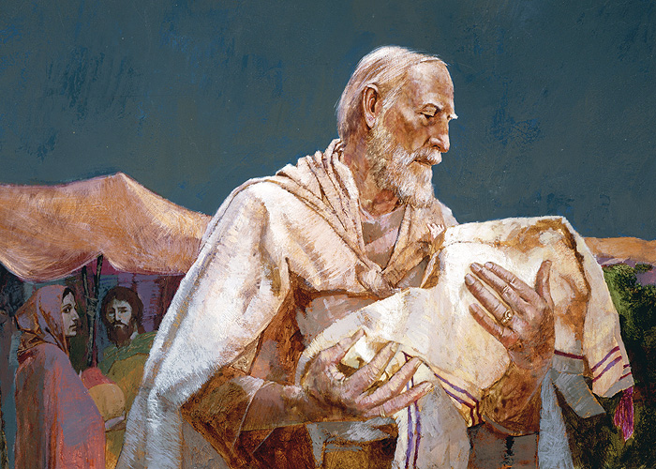
Abraham and Isaac
By William Whitaker
www.lds.org

“You Want Me to Do What, God?
3rd Sunday after Pentecost, June 25, 2017

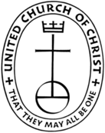
First Congregational Church, United Church of Christ
300 Central Street, Saugus, MA 01906
Rev. Martha Leahy, Pastor
Office 781-233-3028 Cell phone 617-763-7354
Mae Siu-Wai Stroshane, Music Minister
Carolyn Davis, Church Secretary
E-mail address: uccsaugus@verizon.net
Website: http://1stchurchsaugus.org
Facebook: www.facebook.com/uccsaugus
Healing Circle: www.facebook.com/healingcirclesaugus

The Birth of Isaac, Genesis 21:1-7
21 Now the Lord was gracious to Sarah as he had said, and the Lord did for Sarah what he had promised. ² Sarah became pregnant and bore a son to Abraham in his old age, at the very time God had promised him.³ Abraham gave the name Isaac (meaning “he laughs) to the son Sarah bore him. ⁴ When his son Isaac was eight days old, Abraham circumcised him, as God commanded him. ⁵ Abraham was a hundred years old when his son Isaac was born to him.
⁶ Sarah said, “God has brought me laughter, and everyone who hears about this will laugh with me.” ⁷ And she added, “Who would have said to Abraham that Sarah would nurse children? Yet I have borne him a son in his old age.”

Abraham Tested, Genesis 22:1-12
22 Sometime later God tested Abraham. He said to him, “Abraham!”
“Here I am,” he replied.
² Then God said, “Take your son, your only son, whom you love—Isaac—and go to the region of Moriah. Sacrifice him there as a burnt offering on a mountain I will show you.”
³ Early the next morning Abraham got up and loaded his donkey. He took with him two of his servants and his son Isaac. When he had cut enough wood for the burnt offering, he set out for the place God had told him about. ⁴ On the third day Abraham looked up and saw the place in the distance. ⁵ He said to his servants, “Stay here with the donkey while I and the boy go over there. We will worship and then we will come back to you.”
⁶ Abraham took the wood for the burnt offering and placed it on his son Isaac, and he himself carried the fire and the knife. As the two of them went on together, ⁷ Isaac spoke up and said to his father Abraham, “Father?”
“Yes, my son?” Abraham replied.
“The fire and wood are here,” Isaac said, “but where is the lamb for the burnt offering?”
⁸ Abraham answered, “God himself will provide the lamb for the burnt offering, my son.” And the two of them went on together.
⁹ When they reached the place God had told him about, Abraham built an altar there and arranged the wood on it. He bound his son Isaac and laid him on the altar, on top of the wood. ¹⁰ Then he reached out his hand and took the knife to slay his son. ¹¹ But the angel of the Lord called out to him from heaven, “Abraham! Abraham!”
“Here I am,” he replied.
¹² “Do not lay a hand on the boy,” he said. “Do not do anything to him. Now I know that you fear God, because you have not withheld from me your son, your only son.”

******************************************
How Much Would You Give?

REFRAIN:
How much would you give for God’s love?
What kind of sacrifice?
How much would you give for God’s love?
How high the final price?

Abraham went up the mountain
With his beloved son
Ready to sacrifice
Isaac’s very life.
And though his heart was broken
He knew his God had spoken.
So faith did he stand
That God stayed his hand.

REFRAIN

If God puts us to the test
Sending us upon a quest
Asking for our all
Should we go when we’re called?
When all is pain and sorrow
It seems there’s no tomorrow
In our darkest hour
We’ll know God’s power and love.

REFRAIN

Mae Stroshane
C 2017

SPECIAL CONGREGATIONAL MEETING
Sunday, June 25, 2017

There will be an all church meeting on Sunday June 25, 2017 after worship.

Agenda: A vote will be taken to approve use of additional Pumpkin Patch funds to continue repairs of the church. These repairs will include new windows in the sanctuary, outside siding on the left of the outside of sanctuary, and correcting areas that need attention.

It is important that everyone attend so that together we can continue the upkeep of our beautiful church.

Board of Trustees
Brenton Spencer chairman, Scott Davis,
Carl Spencer, Steve Rich, Carolyn Davis

