How to load a GoPro video to YouTube.
- Take a video using your GoPro camera (or any other camera)
- Transfer the video on your GoPro (or other camera) to your computer:
  - Turn your GoPro (camera) on
  - Tether your GoPro (camera) to your computer
  - Go to your “Computer” and double click your GoPro (camera) icon:
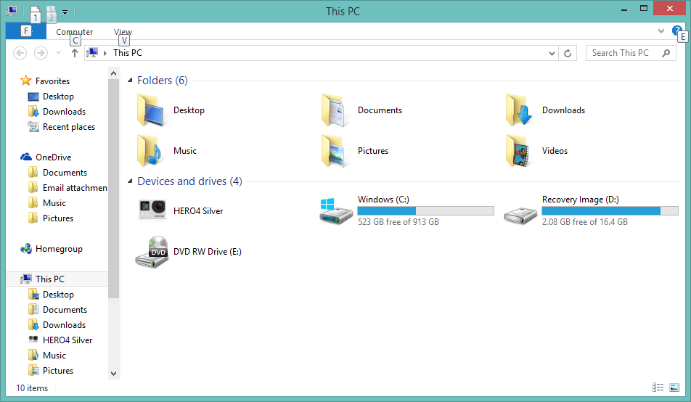
- Continue to double click until you see the videos on your camera:
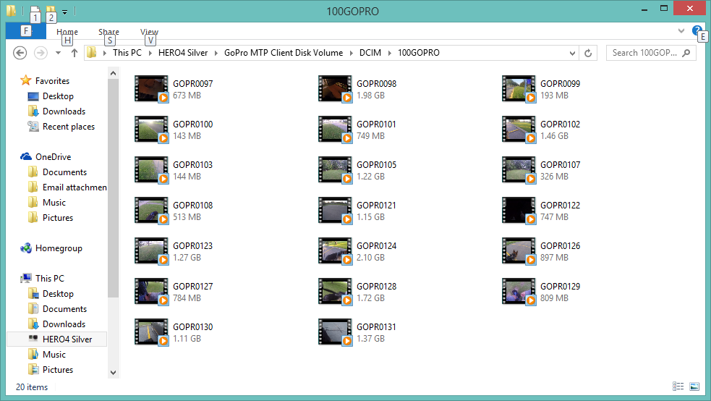
- Select the video you want, left click on it, and drag it to the left until it hovers over “Pictures” folder in the left column, then release your mouse.
- A “Copying” screen will pop up showing the progression of the transfer. Larger files take longer to transfer:
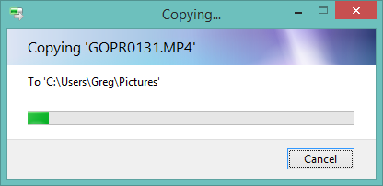
- Once the transfer is complete, open your pictures file and move this video to whichever folder you want to place it in, i.e. GoPro videos, or Tracking videos, or Doggy videos, etc.
- If you have not already done this, download GoPro Studio: http://shop.gopro.com/softwareandapp/gopro-studio/GoPro-Studio.html#/start=1
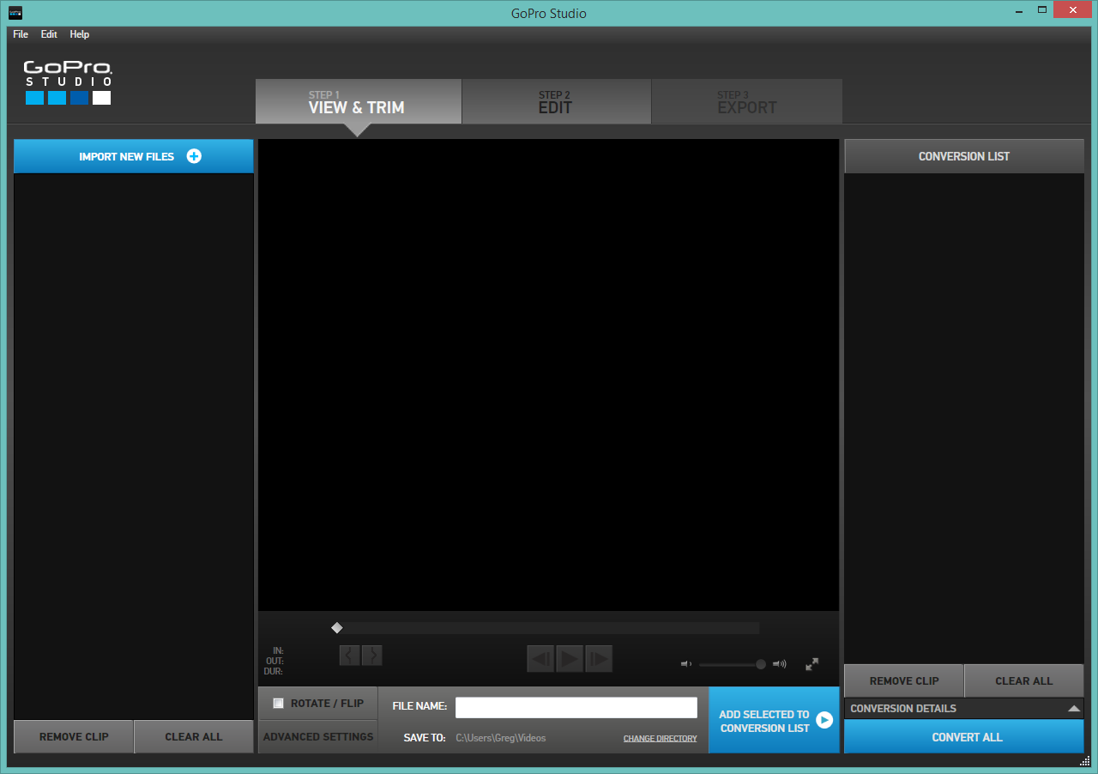
- Open GoPro Studio, and click Import New Files in upper left corner:
- Select the file you just transferred and it will populate as below:
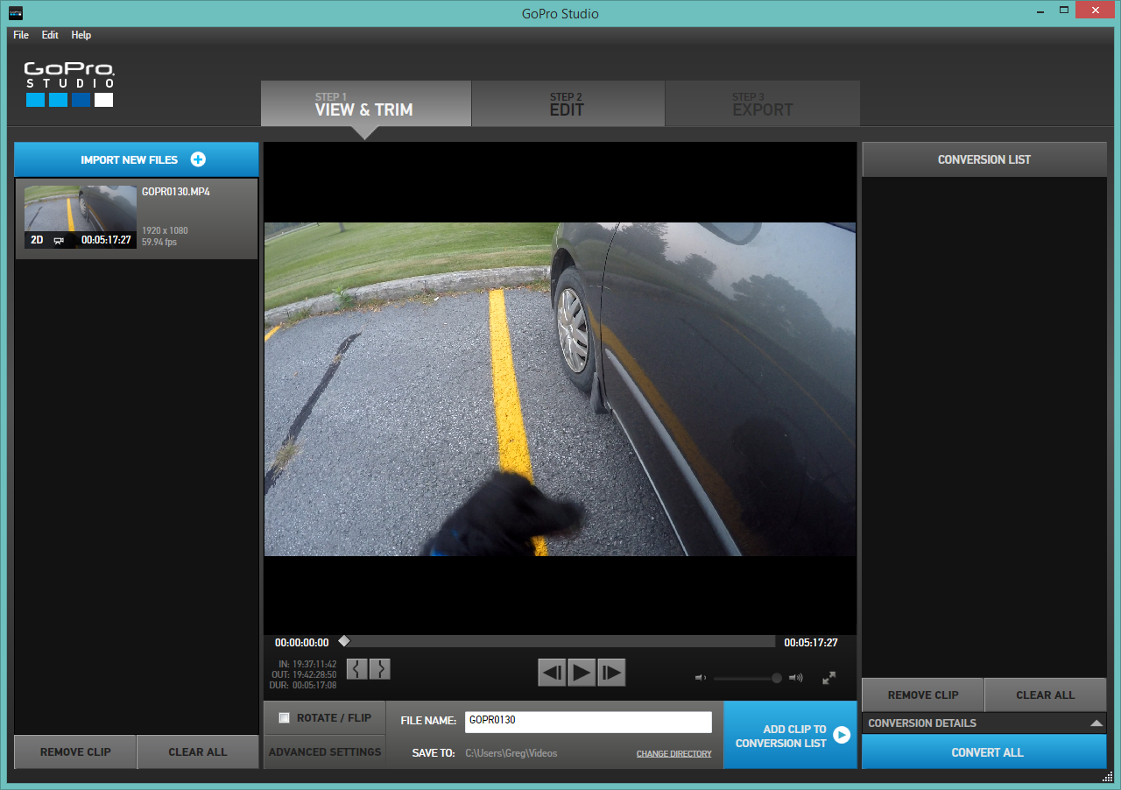
- If you want to cut off part of the beginning or part of the end, this is where you can do it: start to view the video and when you get to where you want your finished clip to start, hit

Pause. Then click the Mark In button: left button with the squiggly line:

- This will show a shortened clip, and you will now click the blue button “Add Clip to Conversion List”.
- It will take a while, depending on the size of your file, to complete the conversion:
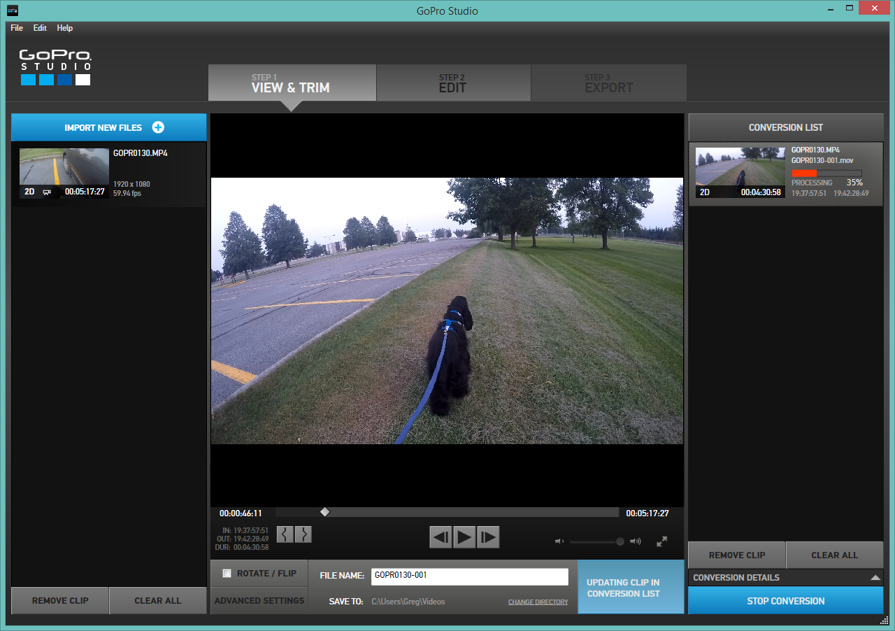
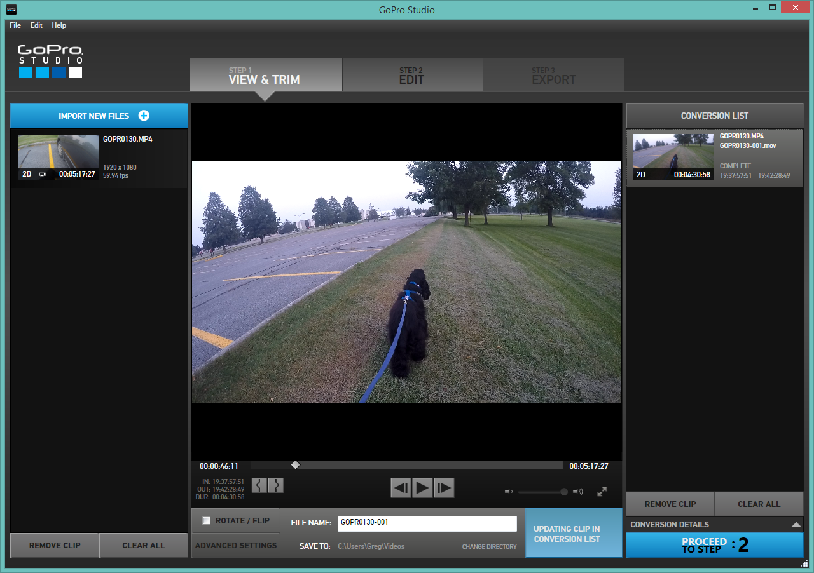
- When the file is converted, the blue button on the right will show “Proceed to Step: 2”
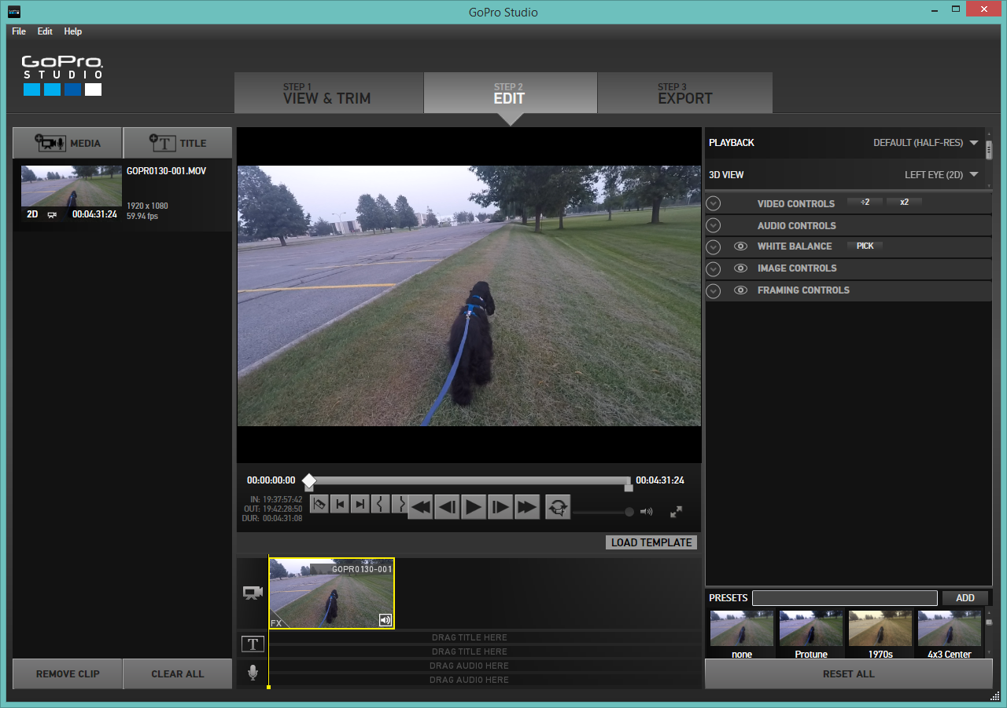
- Click the Proceed to Step 2 button (and close any template popup that comes up).
- Drag the file from the “Media” on the left to the “Drag Video Here” in the middle bottom.

- While the file is in this step, you can cut out segments, add titles, and do any other editing you need.
- When you are finished editing, click Step 3: Export in the top right
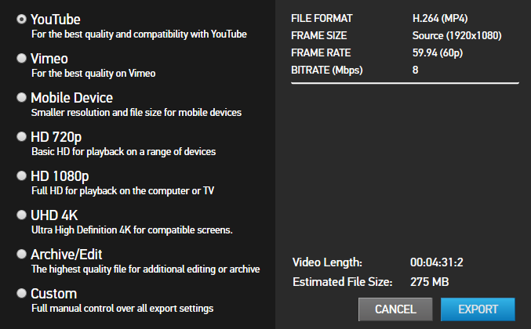
- A pop-up screen will show, and click “YouTube”, then click the blue “Export” button on the bottom right.

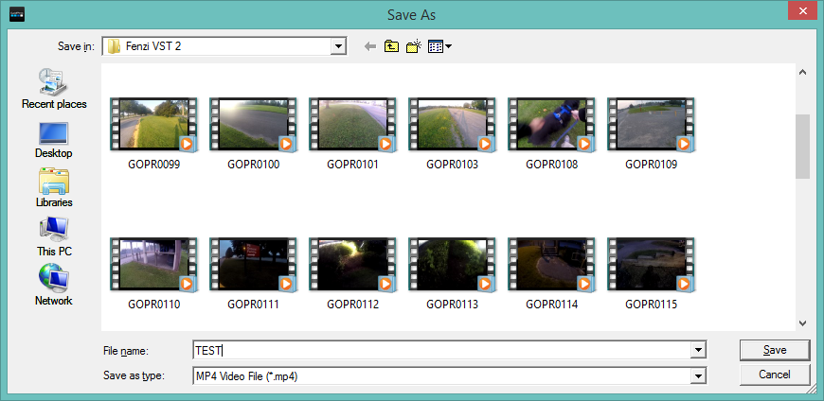
- A pop-up screen will ask you where you want to export the file to: pick the same file as your original video was in, but re-name it and Save:

- It will take a while for the file to export: 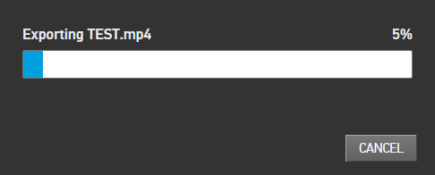
- When the file export has completed, you are ready to upload to YouTube.
- If you have not already done so, create a YouTube Channel: https://accounts.google.com/SignUp
- Sign in to your YouTube account
- Click the Upload button at the top of the page
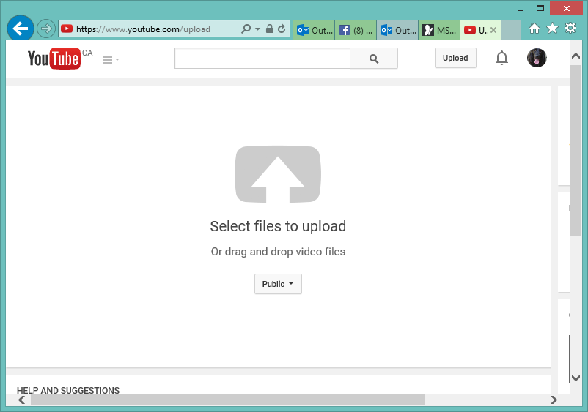
- A new screen will populate, click the big arrow in the Select files to upload button, and click/open the file that was converted by GoPro:

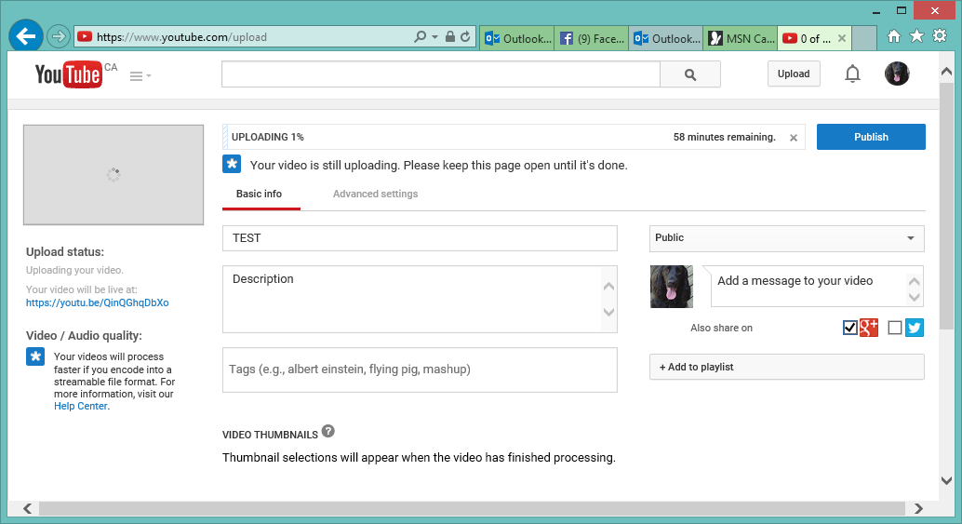
- The screen will now show the progress of the upload, and again it will take some time:

- When the file is uploaded, it will then on its own, prepare itself for publishing.
- When this second step of the upload is completed, click the blue Publish button.
- You will now see a link to your video loaded on YouTube. You can post/email this link and the viewers can click the link to view your video.
https://youtu.be/QinQGhqDbXo

