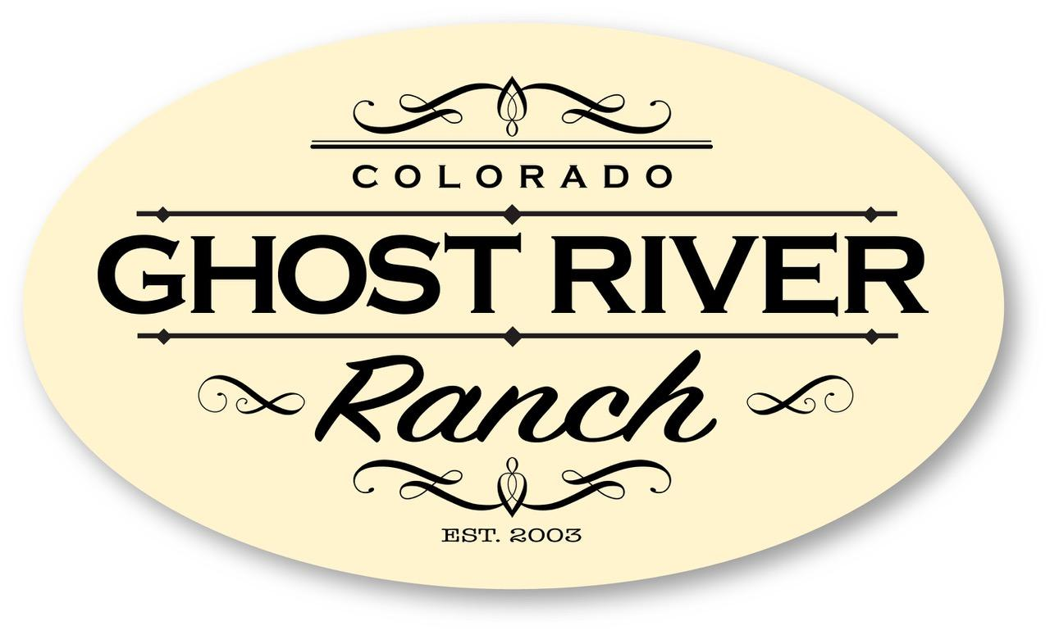
Property Owners’ Association
Notice of
2022 ANNUAL Meeting

Saturday, August 20 at 10:00a

Colorado City Rec Center
(Behind the swimming pool)
5000 Cuerno Verde
Colorado City, CO 81019

A virtual meeting will also be set up for members to either join via video or phone.
A link will be sent to all members who have shared their email address.
If you would like an invitation and did not receive one,
please contact Debbie Oborny at daoborny@aol.com.

If you have any questions, please contact a Board member.

Board of Directors
Gib Rokich, President 801-647-5534 gibrokich@gmail.com
Barbara Dickey, Vice-President 719-582-0153 badcad48@aol.com
Debbie Oborny, Secretary/Treasurer 720-837-7774 daoborny@aol.com

Mailing Address: 320 Morning Star Rd, Rye, CO 81069
Find us on Facebook at "Ghost River Ranch Colorado".
www.GhostRiverRanchPOA.com

(See the Agenda on the back of this notice)

Property Owners’ Association
AGENDA
ANNUAL Meeting
August 20, 2022 at 10:00a
Colorado City Rec Center

Introductions & Call to Order

- President’s Address/Report
- Fall Clean Up Event
- Road Report
- Secretary/Treasurer’s Reports
  - 2022 Budget - Revised
  - YTD 2022 Income/Expense Statement
  - Summary of Funds (Reconciliation Report)
  - PayPal/Zelle Accounts
  - New CCIOA Laws Effective 8/10/2022
  - Meeting Minutes
- Annual Election
  - Nominations
- Grazing Lease
  - Water for Cows/Fire Suppression
  - Renew Lease
- Compliance
  - County Code Presentation by Huerfano County Building & Code Enforcement

Member Concerns/Comments/Discussion

Adjournment

