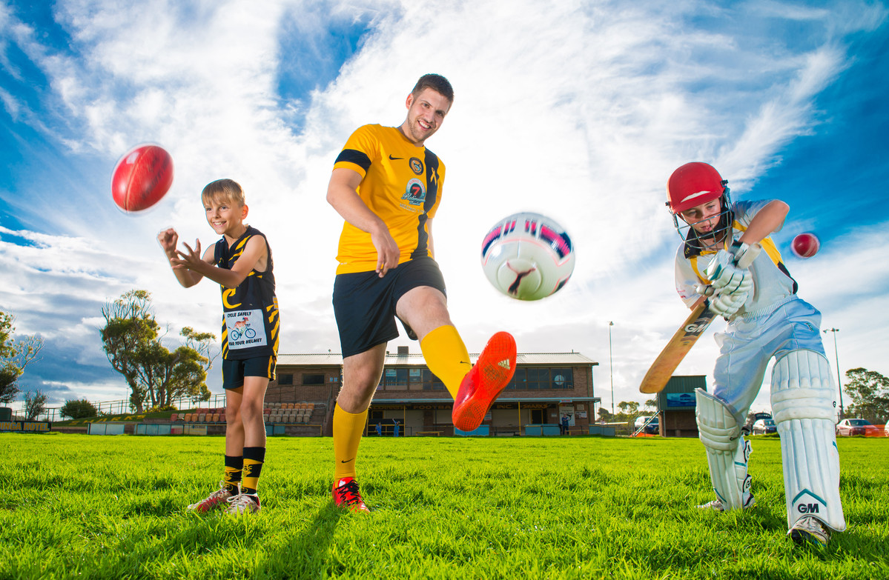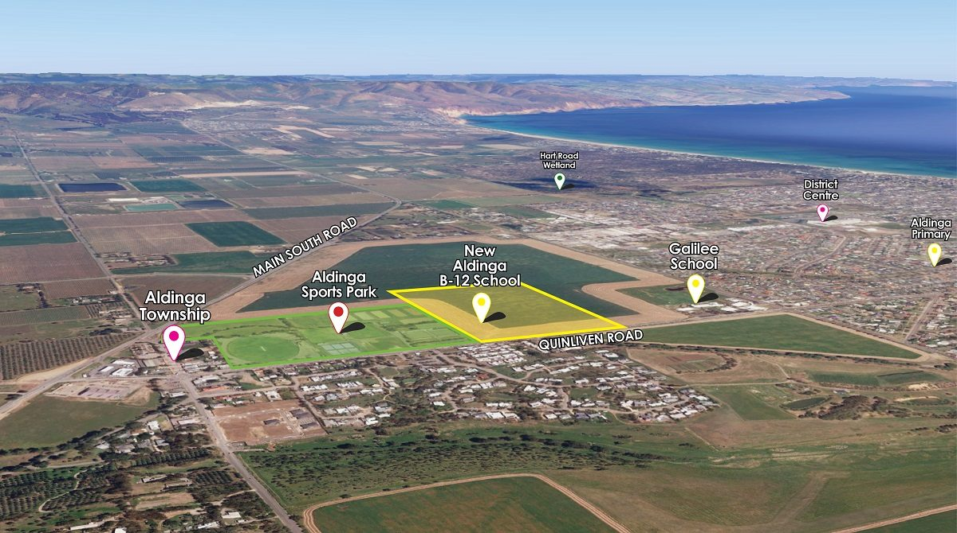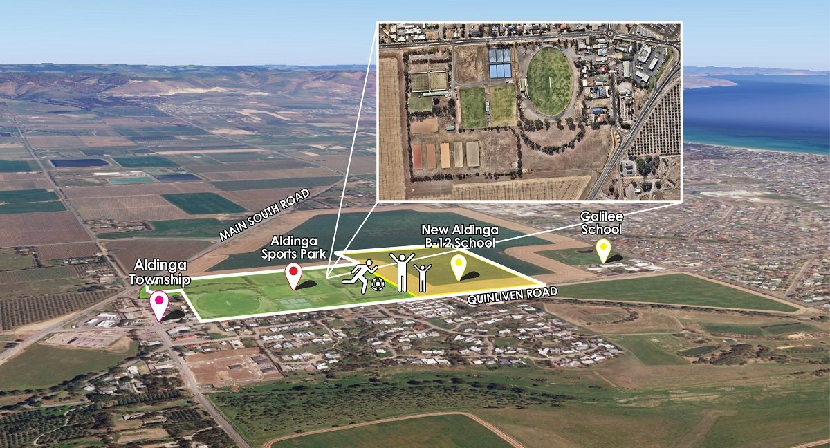

17 JULY 2020

$4.6 million upgrade for Aldinga Sports Park

A $4.6 million upgrade for Aldinga Sports Park received the green light last week, with City of Onkaparinga allocating $2.35 million towards the redevelopment in its 2020-21 Budget.
The funding comes in the wake of $2.26 million in federal government funding announced by Rebekha Sharkie MP late last year, with the project set to benefit families across the growing region.
City of Onkaparinga Mayor Erin Thompson says the project is a great example of local, state and federal government working together to help improve community wellbeing and connectedness for thousands of people.
“This major project will deliver much-needed sport and recreation facilities to support growth of the region,” Mayor Thompsons says.
“It will also build on our work with state government to ensure an integrated approach to planning for the new Aldinga B-12 School, opening in January 2022.
“The school’s location adjacent the Sports Park provides a unique opportunity to integrate planning of sports and recreation facilities to create a sports and community hub to cater for the broader southern region.
“Council has now secured a shared-use agreement with Aldinga School to allow community use of two soccer pitches, the senior oval, and two indoor courts once the school is opened.
“This investment complements Council’s ongoing investment in sporting facilities including those for AFL, cricket, soccer, netball, and tennis across our City.
“Council has commenced concept planning for Aldinga Sports Park to ensure that new sport park facilities are integrated with the school facilities and consider the further growth of the region.
“There will be opportunity for the community to contribute to the future vision of the Sports Park during engagement on the draft concept plans in late 2020.
“Council has a good working relationship with Aldinga Sports Park’s clubs and is continuing to work with them to deliver important facilities of greatest community need.”
Priority facilities will include a new netball club facility, hockey clubrooms and lighting, additional lighting for bowls and croquet, new cricket nets and redeveloped netball courts in 2020-21.
New Aldinga Sports Park soccer facilities including an irrigated pitch with lighting and shared-use unisex changerooms with amenities will also be collocated adjacent the planned school facilities to create an integrated sporting hub.
Concept planning is also underway to set out a 15+ year vision for the Sports Park to ensure Council is well-placed to respond to the changing needs of the growing Aldinga community into the future.
Aldinga Netball Club President, Samara Bryant, says the upgrade will have an “amazing” impact on the community.
“It’s absolutely amazing council is investing money into the local area because the park desperately needs it,” she says.
Samara says the club – which included about 550 players across 56 teams during the summer season – can’t currently use the Park’s three northern courts due to their condition.
She says their upgrade will attract more club members, allow it to host home finals and benefit the entire community.
“Sporting facilities in the community help lower the crime rate because children have something to do,” Samara explains.
“It allows kids to open up and make new friends, and it teaches them life skills like working in a team.
“Bringing more people to the community isn’t just a positive for us, it’s a positive for local businesses.”
Samara also welcomes the opportunity to use the Aldinga B-12 School’s facilities when it opens.
Aldinga Sports Park services the growing communities of Aldinga, Aldinga Beach, Port Willunga and Sellicks Beach.
It’s currently home to nine clubs, including bowling, croquet, netball, football, cricket, soccer, hockey and two equestrian clubs.

