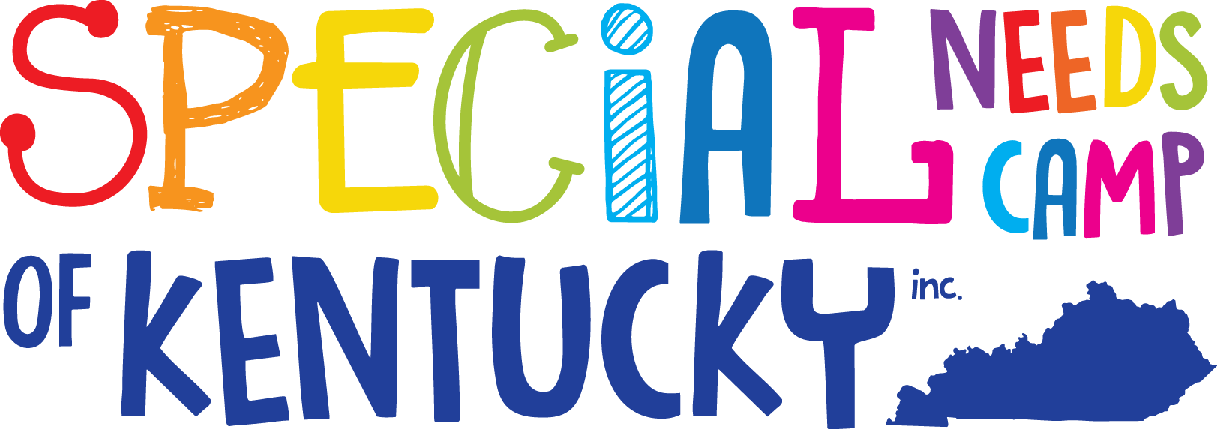

Special Needs Camp of KY, Inc.
PO BOX 875
Owingsville, KY 40360
(606) 336-0326
Email: Katie.SNCKI@gmail.com
Website: www.specialneedscamp.org

Dear Volunteer:
Thank you for taking the opportunity to complete this application as a volunteer for Special Needs Camp of Kentucky, Inc. Summer Camp 2024. We have many exciting activities and events planned for this year’s camp. The camp dates are June 24th through 28th at Bath County High School from 9:00 am - 4:00 pm.
We are an official 501(c) 3 non-profit organization now known as Special Needs Camp of KY, Inc. (SNCKI). This has brought many changes, including all donations are now 100% tax-deductible.
Camp has always been free for campers and volunteers to attend, and it will continue to be free this year with the help of continued financial support. The cost of the camp is constantly increasing each year. Expenses have gone from $2,000 to fund camp ten years ago to over $25,000 to support Camp 2023; please help us with this need. It takes a minimum of $500 per camper just for them to be able to attend camp. If you know of any potential camp supporters (individuals or businesses), please contact them to see if they would like to contribute to the camp or even sponsor your camper. We gratefully appreciate your continued support.
Here are a few things to consider when completing the application:
- Volunteers must meet the age requirement for camp, 13 years of age.
- Please ensure that ALL sections of the application are filled out completely. Only completed applications will be allowed.
- We MUST receive all applications by May 1st, 2024, via mail, email, or hand delivery to 6255 E. Hwy. 60, Salt Lick, KY 40371, or Katelyn Harvey at Morehead State University.
- Acceptance or denial letters will be sent out to applicants the 2nd week of May. In addition, if you are accepted, additional information will be needed and described in the acceptance letter.
If you have any questions, please contact us via any of the sources at the top of this letter!
Sincerely,
Katelyn Harvey
Katelyn Harvey, President
Special Needs Camp of Kentucky, Inc.

Special Needs Camp of Kentucky Inc.
PO BOX 875
Owingsville, KY 40360
(606) 336-0326
Email: Katie.SNCKI@gmail.com
Website: www.specialneedscamp.org

Volunteer Application Form
June 24th - 28th, 2024
MUST BE RETURNED BY May 1st

Name of Volunteer: _____________________________ Date of Birth: ____/____/______
Street Address/P.O. Box: ____________________________________________________
City: ________________________ State: _______ ZIP: ___________
Phone: (___)______________ Gender: __________________ Shirt Size:___________________
Email Address: _____________________________________________________
Parent/Guardian(s)Name: _____________________________________
Address (If Diff. From Above): _________________________________________________
Phone (where they can be reached during camp hours) :(___) _______________________
Emergency Contact: ___________________________________
Relationship to Volunteer: ______________________
Emergency Phone:(____) ________________________

Parent/Guardian Signature (if under 18yrs): _________________________________________
Date: ______/______/___________

*SNCKI reserves the right to accept or deny this application. Notification of the decision will be made in the second week of May. *

