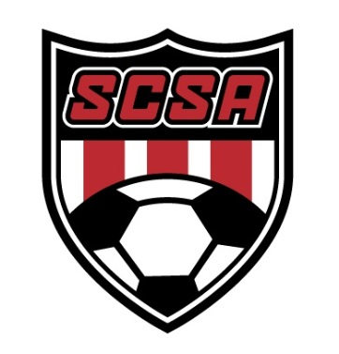
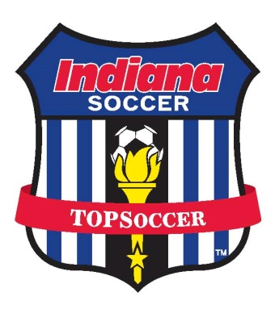

TOPSOCCER is coming to SCSA and we want YOU!

WANTED Enthusiastic and energetic athletes 7 years of age and older to become the newest members of the South Central Soccer Academy TOPSoccer program! Laughs, smiles and the ability to have fun are a must while learning the fundamentals of soccer!

WHAT IS TOPSOCCER? The Outreach Program for Soccer

TOPSoccer is a free, community-based training and team placement program for athletes with disabilities, organized by youth soccer association volunteers. The program is designed to bring the opportunity of learning and playing soccer to any players, age 7 and older, who have a mental or physical disability. Our goal is to enable the thousands of young athletes with disabilities to become valued and successful members of the Indiana Soccer & US Youth Soccer families.
TOPSoccer was formed to perpetuate the Indiana Soccer & US Youth Soccer mission statement which is, in part, "to foster the physical, mental and emotional growth and development of America’s youth through the sport of soccer at all levels of age and competition." There are thousands of children with disabilities who need, and can be provided with, the opportunity to play soccer through the TOPSoccer program.

Who is SCSA? The South Central Soccer Academy is located at 4899 Whiteland Rd. Bargersville, IN. We offer soccer leagues for the following groups (Recreation 3-18, Travel 7-18, Adult 18+, and Special Needs 7-Adult). We are offering the best training and player development that youth soccer has to offer in central Indiana! For more info you can visit our website www.scsaindy.com .

How to become and athlete: Free registration is now open at www.scsaindy.com If you have participated in the past you will still need to register to ensure all information is up today and correct.

Schedule.
Game 1 - Saturday, August 29th @ 11:30 am
*** Games will NOT take place Labor day weekend***
Game 2 - Saturday, September 12 @ 11:30 am
Game 3 - Saturday, September 19 @ 11:30 am
Game 4 - Saturday, September 26 @ 11:30 am
Game 5 - Saturday, October 3 @ 11:30 am
Game 6 - Saturday, October 10 @ 11:30 am

Interested in Becoming Involved? If you would like to become a SCSA TOPSoccer athlete or volunteer contact Stephanie Roberts We would LOVE to have you join our program!
Stephanie Roberts - robertsjstephanie@hotmail.com

