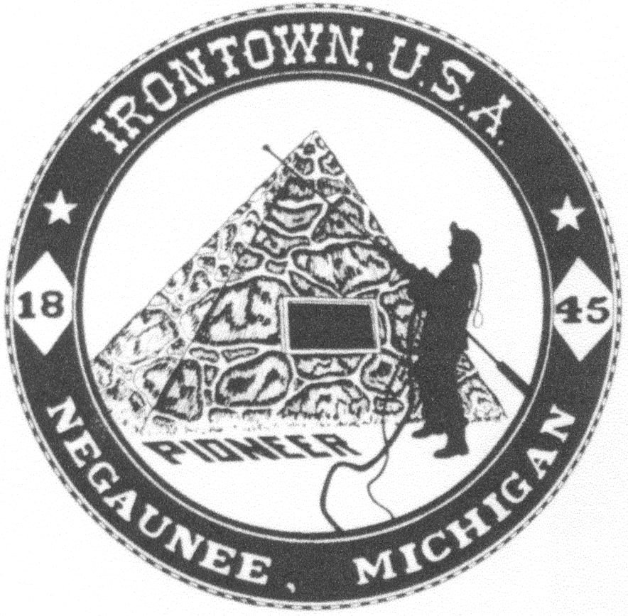 **Negaunee Irontown Association**





# P.O. Box 128 Negaunee, MI 49866 Phone: 906-486-8084

**www.negauneeirontown.com**

***2017 Community Picnic Hold Harmless Agreement***

It is hereby understood and agreed that vendors will hold and save harmless the Negaunee Irontown Association, their directors, officers, agents and employees from any and all liability arising from the services or products provided by vendors. This shall be effective during set-up, display/operations and break down of the 2017 Pioneer Days Community Picnic on July 8, 2017.

I (we) understand this form shall be on file, and the below named entity will not be allowed to operate at the 2017 Community Picnic unless the requirement is met.

Name of Company______________________________________________________________

Authorized Representative________________________________________________________

Signature______________________________________________________________________

Date__________________________________________________________________________

Please make a copy of this form for your records, and return the original with your completed registration form, certificate of insurance and applicable fee to:

Negaunee Irontown Association

P.O. Box 128

Negaunee, MI 49866

***PLEASE NOTE:*** THIS SIGNED FORM MUST BE ON FILE IN ORDER TO OPERATE/SELL DURING THE 2017 PIONEER DAY EVENTS

 **Negaunee Irontown Association**





# P.O. Box 128 Negaunee, MI 49866 Phone: 906-486-8084

**www.negauneeirontown.com**

### 2017 Community Picnic Vendor Form

Organization/Business Name______________________________________________________

Contact Person_________________________________Phone___________________________

Address__________________________________City/ST/Zip___________________________

Fax Number_______________________________E-mail_______________________________

Types of goods to be sold—please be specific:

______________________________________________________________________________

Amount of space required (area)____________________________________________________

Will you need electricity? YES NO If yes, how many AMPS service will you need?_______

If yes, how many VOLTS service will you need?________

What items will be using power, if required?__________________________________________

**All paperwork is due by Friday, June 9, 2017—NO EXCEPTIONS!**

**Vendor Space is Awarded on a First-Received, First-Awarded basis.**

**Your fee and paperwork listed below must be in to reserve your spot.**

All of the following must be sent to the above address by the deadline:

• This completed form with no lines left blank (do not leave a line blank, put “N/A”).

• A copy of a valid certificate of Commercial General Liability insurance, including products coverage is required. The certificate must show coverage in force on the day of the event. “Negaunee Irontown Association” must be listed on said certificate as certificate holder, with a 10-day cancellation clause.

• The enclosed Hold Harmless Agreement must be completed and signed.

• FOOD LICENSE REQUIREMENTS—If you are cooking food on site, you will need to apply for a temporary license through the Health Department. For details, call the Division of Environmental Health at 475-4195 or visit www.mqthealth.org. Vendors are responsible for securing their own license. The Health Department checks for licenses on site at the event.

• A check or money order for $100 for non-profit organizations or $125 for commercial organizations is required prior to the event as a vendor fee.

*E-mail info@negauneeirontown.com for details.*

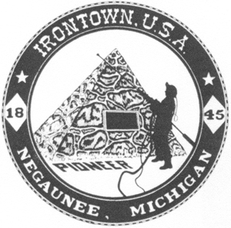

Negaunee Irontown Association

P.O. Box 128

Negaunee, MI 49866

906-486-8084

**Vendor Agreement Form**

I, _____________________ hereby release, waive, discharge, and covenant not to sue and hold harmless from any and all liability, claims, costs, and expenses whatsoever arising out of or related to any loss, damage or injury that may be sustained at this event.

I, _____________________ release the Negaunee Irontown Association, all employees, volunteers, or related parties associated with the activity from any and all claims or liability arising out of this participation.

I, _____________________ hereby agree to pay the vendor’s fee of $100 (non-profit organization) or $125 (commercial organization) prior to the event.

Signature of Vendor ____________________________________ Date _________________

Signature of Irontown Representative _________________________Date________________