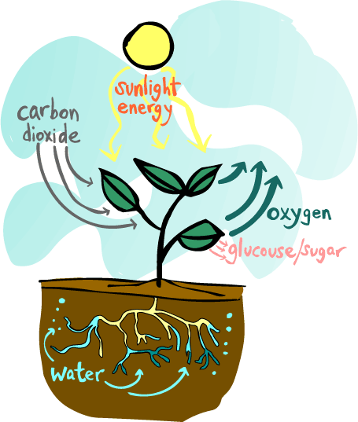

Assignment: Explain how each environmental (abiotic) factor plays a role in the process of photosynthesis.

Requirements:
- List: List all of the environmental (abiotic) factors that are present in our environment

- Characteristics: Describe the characteristics of each abiotic factor and how it influences an ecosystem

- Picture and Labels: Take a picture of plants or trees in your ecosystem. Label all of the abiotic factors that are present in the process of photosynthesis

- Steps: Make a list the steps that take place in photosynthesis

- Creativity: Create a poem, song, rap, commercial, radio announcement, children’s story book, etc., that fully explains the process of photosynthesis. Be creative, have fun, be original! You can perform it live or submit a cd, or a video if you like. You can also create a children’s book online if you’d like at www.storyjumper.com

