REGULAR MEETING
APRIL 19, 2018

A Regular Meeting of the Town Board of the Town of Hampton, County of Washington and the State of New York was held at the Town Hall, 2629 State Route 22A, Hampton, New York on the 19th day of April, 2018.

PRESENT: David K. O’Brien------------Supervisor
Tamme Taran----------------Councilwoman
Donald Sady-----------------Councilman - absent
Andrea Sweeney------------Councilwoman
Roger Weeden---------------Councilman
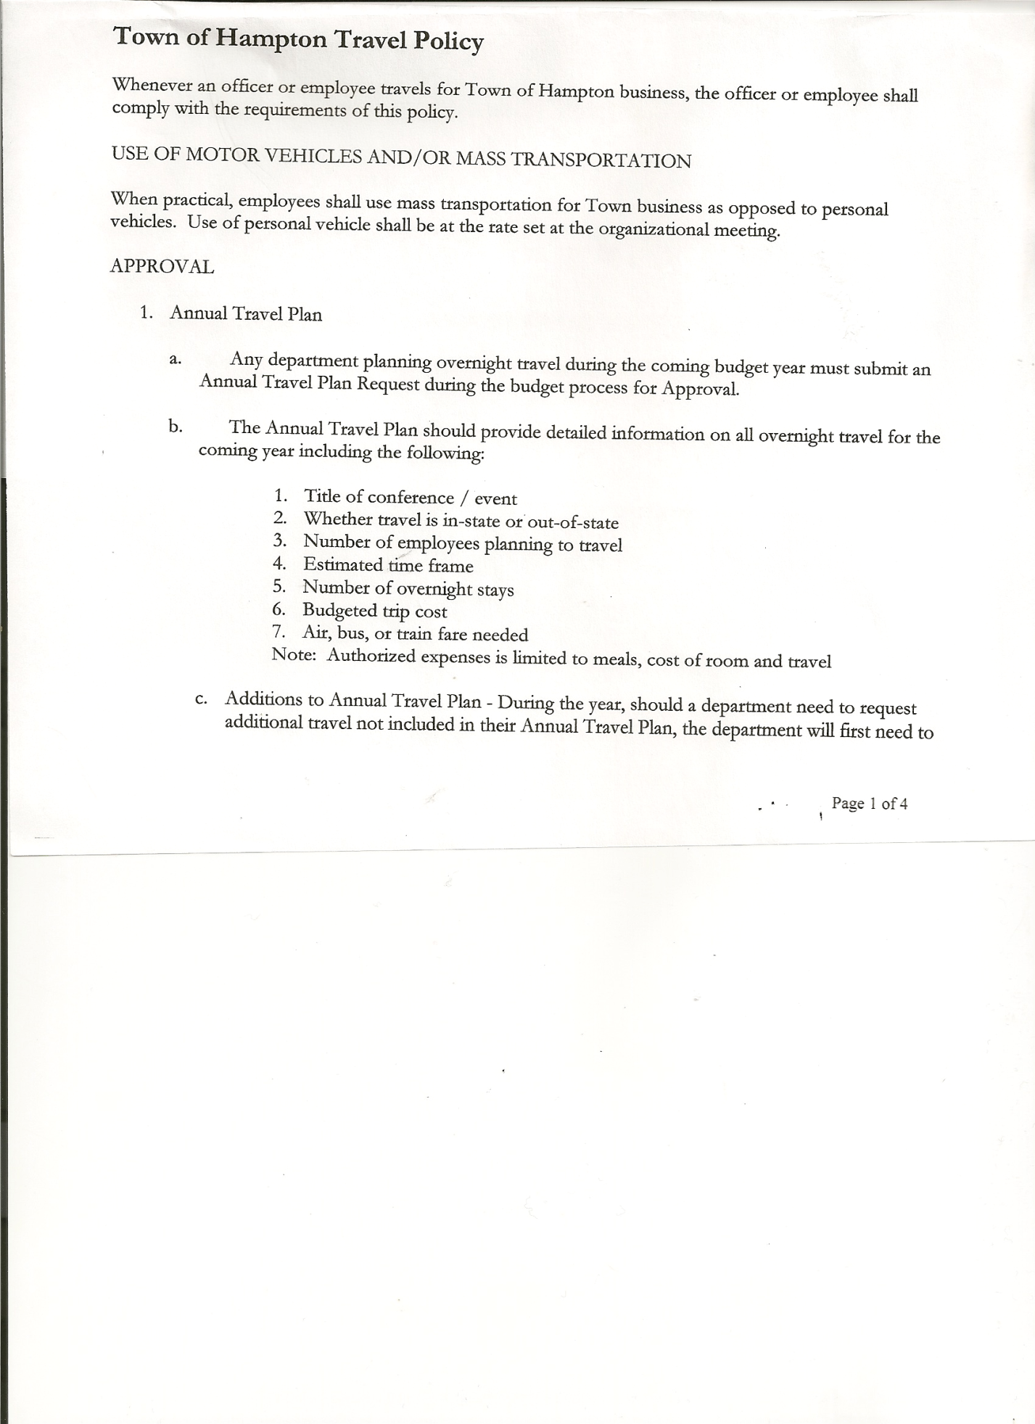
Rebecca Jones---------------Town Clerk
Camilla Shaw----------------Tax Collector/Deputy Town Clerk
Herbert Sady, Jr.-------------Highway Superintendent

Planning Board Member(s): Bonnie Hawley, Chair and Ginny Kinsey

Also present: see attached list

The Regular Meeting was called to order by Supervisor O’Brien at 7:30pm, followed by the Pledge of Allegiance. Location of Fire Exits was given. Quorum of board members present.

RESOLUTION NO. 28-2018
APPROVAL OF THE MINUTES
On a motion of Councilwoman Taran, seconded by Councilman Weeden, the following resolution was ADOPTED: Ayes 4 O’Brien, Taran, Sweeney, Weeden
Nays 0
Absent 1 Sady
RESOLVED, that the Regular Town Board Minutes for March 15, 2018 are approved.

Camilla Shaw, Tax Collector- submitted her March 2018 report. Check to Supervisor for $1072.34 for Penalties & Interest. Tax season is done for 2018, and she has settled with the County. Also submitted Bank Statement to the Board for review and signatures.

Larry Carman, Dog Control Officer submitted his report, which was read by Supervisor O’Brien, copy of report is attached for 3/20/18-4/13/18.

Planning Board…Bonnie Hawley, Chairperson
- Members Ginny Kinsey and Steve Fernett attended a webinar presented by
NY Serda on Solar.
- Working on revising Site Plan Law
- John Graham @ Washington County is handling solar permits
- Renee Rountree interested in being a member of the Planning Board
- Next meeting will be May 9th @ 7:00pm at the Town Hall

Herbert Sady, Jr., Highway Superintendent submitted his report, copy of which, is attached.

TOWN BOARD MEETING
APRIL 19, 2018 PAGE 2

RESOLUTION NO. 29 -2018
APPROVAL OF SUPERVISOR’S MONTHLY REPORT
On a motion of Councilwoman Taran, seconded by Councilwoman Sweeney, the following resolution was ADOPTED: Ayes 4 O’Brien, Taran, Sweeney, Weeden
Nays 0
Absent 1 Sady
RESOLVED, that the Supervisor’s Monthly report be accepted as submitted for MARCH 2018.
02/28/18 03/31/18
ACCOUNT BALANCE RECEIPTS DISBURSEMENTS BALANCE
General Fund $ 88,777.87 $ 1,304.99 $ 14,202.81 $ 75,880.05
Highway Fund $188,231.75 $ 7.82 $ 14,858.12 $173,381.45
Equipment Reserve $ 76,609.75 $ 3.25 $ 0.00 $ 76,613.00
Fire #1 $ 40,800.00 $ 0.00 $ 0.00 $ 40,800.00
Fire #2 $ 5,460.00 $ 0.00 $ 0.00 $ 5,406.00
Cemetery $ 1,696.00 $ 2.03 $ 0.00 $ 1,698.03
Totals $401,521.37 $ 1318.09 $ 29,060.93 $373,778.53

All Board Members present signed Supervisor’s Report.

NEW BUSINESS
Phone System….Following a discussion regarding purchasing new phones and new phone system thru Verizon, the following resolution was introduced.

RESOLUTION NO. 30 -2018
On a motion of Councilwoman Taran, seconded by Councilwoman Sweeney, the following resolution was ADOPTED: Ayes 4 O’Brien, Taran, Sweeney, Weeden
Nays 0
Absent 1 Sady
RESOLVED, to purchase new phones and new phone system thru Verizon.

The Town Clerk’s report for March 2018 was submitted to the Board. The Town Clerk had Board Members review and sign bank reconciliation statements for the Town Clerk Account and Special Town Clerk Account dated March 31, 2018.

Public Comments/Council Comments:
Ginny Kinsey…commented that Nelson Tree Service, hired thru National Grid, is doing a great job at clearing brush/trees on the roads they were working on.

Renee Rountree…(1) Inquired about money to SUNY Adirondack. Supervisor O’Brien explained that the Washington County Supervisors 1st plan was to have a ¼% increase on mortgage tax, their 2nd plan would go to a tax levy for Warren and Washington Counties.
(2) Concerned about a particular property on Hills Pond Road…health issue. The Washington County Code Enforcement has been notified.

Highway Superintendent Herb Sady’s daughter Brynna placed Gold in Team effort for National History Day…it was a display on Slavery and Sugar Islands. Going on to Cooperstown for state competition on April 23rd.

Councilman Roger Weeden’s son Tiernan placed Bronze as a single participant for National History Day….his entry was titled “When Religion Causes Conflict”.

TOWN BOARD MEETING
APRIL 19, 2018 PAGE 3

RESOLUTION NO. 31-2018

AUDIT OF CLAIMS
On a motion of Councilwoman Sweeney, seconded by Councilwoman Taran, the following resolution was ADOPTED: Ayes 4 O’Brien, Taran, Sweeney, Weeden
Nays 0
Absent 1 Sady
RESOLVED that the bills have been reviewed by the Town Board and are authorized for payment in the following amounts.
General Fund No.43 through No.53 $ 2,280.72
Highway Fund No.35 through No.45 $ 7,105.82
Total both funds $ 9,386.54

On a motion of Councilwoman Sweeney, seconded by Councilwoman Taran, the meeting adjourned at 8:23pm. All in favor Aye.

Respectfully submitted,

Rebecca S. Jones, RMC
Town Clerk

