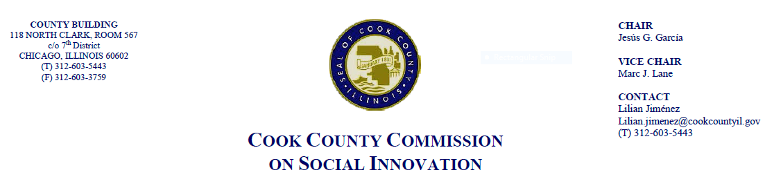June 21, 2018, 4 P.M.
69 W. Washington, 22nd Floor Conf. Rm. A and B
MINUTES

- Call to Order

The Cook County Commission on Social Innovation convened via an in-person meeting to discuss committee updates and hear from a guest speaker. The meeting was chaired by Chairman García. The meeting was open to the public and took place from 4:06 p.m. to 5:25 p.m.

Commission Members Present:
- Commissioner Garcia
- Wendy Raymer
- Maria Kim
- Marc Lane
- Matt Erickson
- John Yonan
- Harold Rice
- David Doig
- Xochitl Espinoza
- Ana Guajardo
- Marc Loveless
- Mark McHugh
- Christyn Henson

Commission Staff Present:
1. Lilian Jimenez
2. Victoria Moreno

Public Speakers:
- Mark Armstrong

Meeting Notes and Decisions Made:
- Committee Updates
  - No committee updates
- Guest Speaker: Richard C. “Dick” May, American Working Capital
  - Looking at Employee Stock Ownership Plans (ESOP) as tool for economic development which is anchored to keep wealth in the county.
  - ESOP’s are a retirement plan from 1974 focused on work empowerment and social responsibility.
  - It is one of few social policies with agreement on both sides of the aisle. There is also no federal tax applied to it since it is entirely employee owned.
  - No federal tax applied to it - entirely employee owned
  - Top 1% owned 63% of business equity and Top 10% own 94% of business equity
  - Ownership in ESOP vs. worker in non-ESOP company is that the retirement cohort has 5-7x longer than non ESOP
  - 2 major approaches to employee ownership which are ESOP and worker co-ops.
  - Benefits of an ESOP include employee owners being 4x less likely to be laid off during recession, higher retirement assets, 3.5% more jobs per year.
  - There are several major ESOP companies in Illinois including S&C Electric which is the largest ESOP in Cook County.
  - ESOPs are privately owned, and usually family owned as well
  - Actionable ideas of promoting inclusive capitalism include promoting local ownership an control.
Post Presentation Discussion
- Comm. Raymer asked about the difference between an ESOP and co-op: ESOP can attract equity capital and is like a mortgage. With a co-op, there is no equity stake in worker cooperative so it is hard to grow and hard to gain critical mess.
- Comm. Guajardo mentioned the importance of worker co-ops lack of support for low-wage workers. Members serve 1000 hours and vote on different issues under the law. ESOP is a creation of the state and is a corporation with a Board of Directors and corporate identity. Shareholders meet once a year to vote on composition of the board. Employee ownership is indistinguishable from worker co-op.
- Comm. Espinosa: With worker co-ops, people have control over co-op. Easier to get capital for ESOPs. The difference is that you get more votes the longer you work at the company. ESOP secures retirement for workers. Having a corporate firm and ESOP ownership establishes wealth in the community.
- Approval of Minutes
  - Comm. McHugh moved to approve the Commission’s minutes from April 19, 2018. Comm. Erickson seconded the motion and the motion passed unanimously by a voice vote.
- Celebration of passage of Good Food Purchasing Policy (with refreshments)
  - Certificate of appreciation presented to Good Food Policy Action Council
  - Remarks by partner organizations were made
  - Good Food Policy Action Council will continue to have regular meetings with the Cook County Public Health Department and other stakeholders. Social Innovation Commissioners are welcome to participate.
- Adjourn
  - Comm. Rice moved to adjourn the meeting. Comm. Doig seconded the motion. Meeting was adjourned at 5:25pm.

