SPECIAL MEETING
OCTOBER 4, 2022

A Special Meeting of the Town Board of the Town of Hampton, County of Washington and the State of New York was held at the Town Hall, 2629 State Route 22A, Hampton, New York on the 4th day of October, 2022.

PRESENT: David K. O’Brien-----------Supervisor
Donald Sady-----------------Councilman
Tamme Taran----------------Councilwoman
Andrea Sweeney------------ Councilwoman
Michael Pietryka------------Councilman
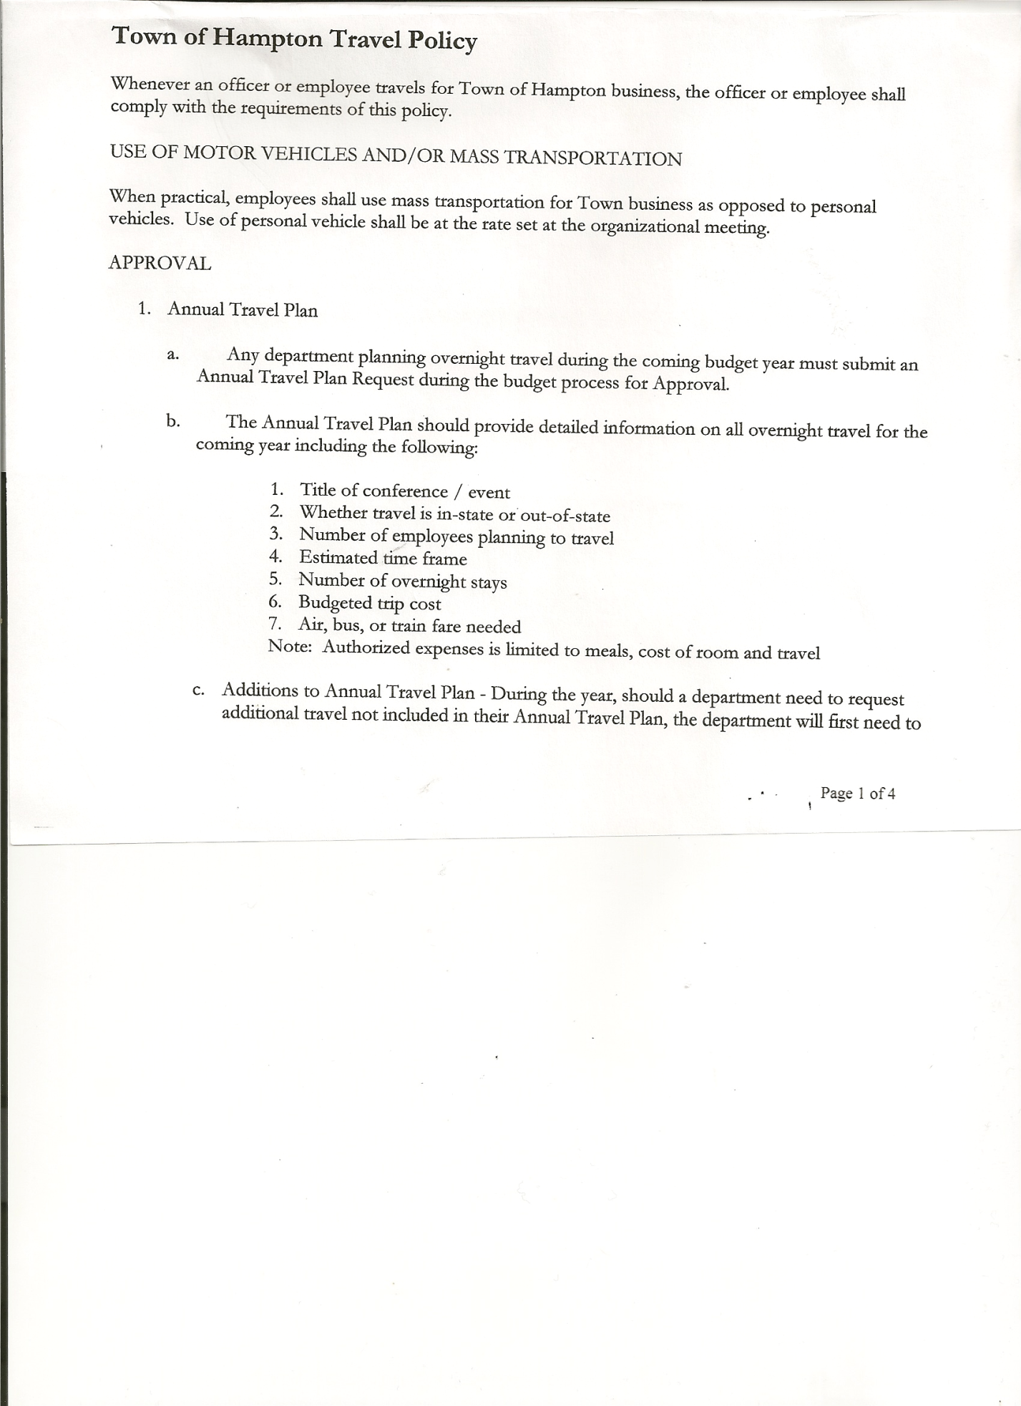
Rebecca Jones---------------Town Clerk
Camilla Shaw----------------Tax Collector/Deputy Town Clerk-absent
Tyler McClure---------------Highway Superintendent
Kim Perry--------------------Bookkeeper/Budget Officer

Planning Board Member(s):….Bonnie Hawley, Chair, Richard Cole and Matthew Pratt

Also present: Artie Pratt

The Special Meeting was called to order by Supervisor O’Brien at 6:01pm, followed by the Pledge of Allegiance. Location of Fire Exits were given. Quorum of board members present.

Town Clerk Jones read the Legal Notice of the Special Meeting (copy attached), which was published in Manchester Newspapers on 09/29/22.

RESOLUTION NO. 74-2022
PRE-AUTHORIZE PAYMENT OF PECKHAM BILL
On a motion of Councilman Sady, seconded by Councilwoman Taran, the following resolution was ADOPTED: AYES 5 O’Brien, Sady, Taran, Pietryka, Sweeney
NAYS 0
RESOLVED, to pay the Peckham bill for paving as soon as it is received. Then include said bill on the next Warrant.

Discussed, reviewed and modified Tentative Budget.

RESOLUTION NO. 75-2022
ADOPTION OF TENTATIVE BUDGET
On a motion of Councilwoman Taran, seconded by Councilman Sady, the following resolution was ADOPTED: : AYES 5 O’Brien, Sady, Taran, Pietryka, Sweeney
NAYS 0
RESOLVED, that the 2023 Tentative Budget be adopted and becomes the 2023 Preliminary
Budget for the Town of Hampton.

RESOLUTION NO. 76-2020
PUBLIC HEARING ON HAMPTON FIRE DISTRICT NUMBER 1
On a motion of Councilwoman Taran, seconded by Councilman Sady, the following resolution was ADOPTED: AYES 5 O’Brien, Sady, Taran, Pietryka, Sweeney
NAYS 0
TOWN BOARD MEETING
OCTOBER 4, 2022 PAGE 2

RESOLVED, to set the Public Hearing to discuss the proposed contract between the Town on behalf of the Town of Hampton Fire Protection District Number 1 and the Hampton Volunteer Fire Company for October 20th, 2022 at 7:00pm.

RESOLUTION NO. 77-2022
PUBLIC HEARING ON HAMPTON FIRE DISTRICT NUMBER 2
On a motion of Councilwoman Taran, seconded by Councilman Sady, the following resolution was ADOPTED: AYES 5 O’Brien, Sady, Taran, Pietryka ,Sweeney
NAYS 0
RESOLVED, to set the Public Hearing to discuss the proposed contract between the Town on behalf of the Town of Hampton Fire Protection District Number 2 and the Hampton Volunteer Fire Company for October 20th, 2022 at 7:05pm.

RESOLUTION NO. 78-2022
PUBLIC HEARING ON PRELIMINARY BUDGET FOR 2023
On a motion of Councilwoman Taran, seconded by Councilman Sady, the following resolution was ADOPTED: AYES 5 O’Brien, Sady, Taran, Pietryka ,Sweeney
NAYS 0
RESOLVED, to set the Public Hearing on the Preliminary Budget for 2023 for October 20th, 2022 at 7:10pm.

RESOLUTION NO. 79-2022

MOTION BY: Councilman Donald Sady
SECONDED BY: Councilwoman Andrea Sweeney

RESOLUTION INTRODUCING PROPOSED LOCAL LAW
TO OVERRIDE THE TAX LEVY LIMIT ESTABLISHED IN GENERAL MUNICIPAL LAW SECTION 3-c

WHEREAS, pursuant to Section 10 of Municipal Home Rule Law, the Town Board of the Town of Hampton (the “Town”) has the authority to adopt local laws; and

WHEREAS, pursuant to General Municipal Law Section 3-c, the Town Board of the Town of Hampton has the authority to adopt a budget that requires a tax levy that is greater than the tax levy limit for the coming fiscal year by adopting a local law by a vote of sixty percent (60%) of the total voting power of the Town Board of the Town to override such limit for such coming fiscal year only; and

WHEREAS, a proposed Local Law has been prepared by the Town Attorney, a copy of which is attached hereto; and

WHEREAS, the Town Board is desirous of proceeding with the review and consideration of this proposed Local Law.

TOWN BOARD MEETING
OCTOBER 4, 2022 PAGE 3

NOW, THEREFORE BE IT RESOLVED that the proposed Local Law is hereby accepted for introduction to the Town Board. A public hearing shall be scheduled for the consideration of the proposed Local Law to be held by the Town Board on October 20, 2022 at 7:25p.m. at the Town Hall located at 2629 State Route 22A, Hampton, New York. Copies of the Local Law shall be available at the Town Clerk’s office for review; and be it further

RESOLVED, that the Town Clerk is directed to post and publish a notice of said public hearing in The Post-Star at least five (5) days before the hearing; and be it further

RESOLVED, that the consideration and proposed adoption of this Local Law is an action under the New York State Environmental Quality Review Act (SEQRA). The Town Board hereby declares that this action is a Type II action pursuant to 6 NYCRR 617.5(20) and (27) and declares that the action does not have a significant impact on the environment and the action is hereby precluded from further environmental review; and be it further

RESOLVED, that this resolution shall take effect immediately.

DATED: October 4, 2022 Supervisor O’Brien AYE
Councilman Sady AYE
Councilwoman Taran AYE
Councilwoman Sweeney AYE
Councilman Pietryka AYE

RESOLUTION NO. 80-2022
PUBLIC HEARING-PROPOSED LOCAL LAW TO OVERRIDE TAX CAP
On a motion of Councilman Sady, seconded by Councilwoman Sweeney, the following resolution was ADOPTED: AYES 5 O’Brien, Sady, Taran, Pietryka ,Sweeney
NAYS 0
RESOLVED, to set a Public Hearing for October 20th, 2022 at 7:25pm on the proposed Local Law regarding overriding the Tax Cap.

Following a discussion, the following resolution was introduced to recess the Budget Workshop.
RESOLUTION NO. 81-2022
RECESS BUDGET WORKSHOP
On a motion of Councilman Sady, seconded by Councilwoman Sweeney, the following resolution was ADOPTED: AYES 5 O’Brien, Sady, Taran, Pietryka ,Sweeney
NAYS 0
RESOLVED, to recess the Budget Workshop until Thursday, October 13th, 2022 at 7:00pm.

Supervisor O’Brien handed out an Agreement to review, regarding Assessment Services to be provided by the County. Agreement will be further discussed at October’s Regular Monthly meeting.

TOWN BOARD MEETING
OCTOBER 4, 2022 PAGE 4

RESOLUTION NO. 82-2022
ENTER INTO EXECUTIVE SESSION
On a motion of Councilwoman Taran, seconded by Councilwoman Sweeney, the following resolution was ADOPTED: AYES 5 O’Brien, Sady, Taran, Pietryka ,Sweeney
NAYS 0
RESOLVED, to enter into Executive Session at 7:15pm to discuss matters leading to the appointment, employment, promotion, demotion, discipline, suspension, dismissal or removal of a particular person.

RESOLUTION NO. 83-2022
EXIT EXECUTIVE SESSION
On a motion of Councilwoman Taran, seconded by Councilman Sady, the following resolution was ADOPTED: AYES 5 O’Brien, Sady, Taran, Pietryka ,Sweeney
NAYS 0
RESOLVED, to exit Executive Session at 7:30pm

RESOLUTION NO. 84-2022
MEETING RECESSED
On a motion of Councilman Sady, seconded by Councilwoman Taran, the following resolution was ADOPTED: : AYES 5 O’Brien, Sady, Taran, Pietryka ,Sweeney
NAYS 0
RESOLVED, that the meeting be recessed at 7:31pm

Respectfully submitted,

Rebecca S. Jones, RMC
Town Clerk

