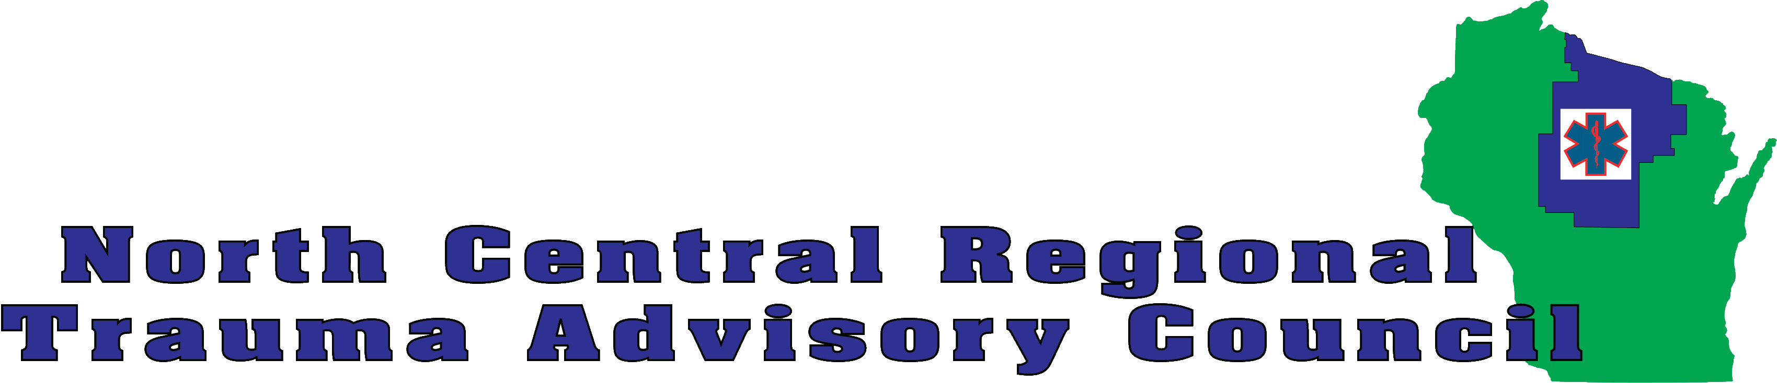

Attendee Registration Form – NCRTAC Trauma Conference 2019
Attendee name (please complete a separate form for each attendee)
Organization name
Address
Phone
Email

NCRTAC Newsletter | Please sign me up for the NCRTAC electronic newsletter (1-2 emails per month)
Role (mark all that apply) | First Responder (EMR) EMT AEMT  Intermediate Paramedic RN  Physician Pharmacist Registrar  Law enforcement  Other:
Payment method | A check for $35.00 made out to The Non-Profit Helping Hand Foundation is enclosed.  A check request has been submitted to my organization and will be mailed soon. Please reserve a space for me.
** For credit card payment please go to: https://www.eventbrite.com/e/ncrtac-trauma-conference-2019-registration-55046723231
(Completion of this form is not required if online registration and payment is chosen)
Attendee Signature
REFUND Policy: Attendees can receive a refund if a cancellation request is received prior to April 26, 2019.
Break-out Session Selections (Select one choice for each session)
Session 1 | a) Spinal Motion Restriction  b) Spinal Cord Injury and Treatment  c) EMS Training Officer Program  d) The Opioid Crisis (Must attend session 1d & 2d)  e) Suction Science (Must attend session 1e & 2e)
Session 2 | a) Guns, Gels, Kings, Drills, & More  b) Initial Management of the Severely Injured Extremity  c) FirstNet  d) The Opioid Crisis (Must attend session 1d & 2d)  e) Suction Science (Must attend session 1e & 2e)
Session 3 | a) Toxic Concerns of Farm Open Pit Manure Ponds  b) Emergency Assessment of Neuro Nightmares  c) MABAS for EMS  d) EMS for RNs  e) Suction Science (Must attend session 3e & 4e)
Session 4 | a) Traumatic Arrest  b) The Pregnant Trauma Patient  c) Good Medicine in Bad Places  d) Burn Care  e) Suction Science (Must attend session 3e & 4e)

Return form and registration fee to:
Please make checks payable: The Non-Profit Helping Hand Foundation
Michael Fraley Or Michael.Fraley@NCRTAC-WI.org
NCRTAC
PO Box 23
Woodruff WI 54568-0023

