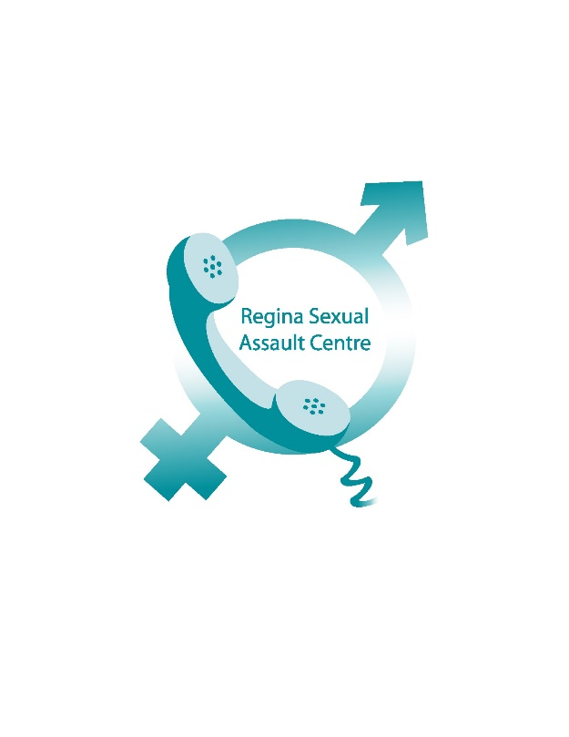
Sexual Assault Services of Saskatchewan received funding for, and is organizing, First Responder to Sexual Assault and Abuse Training, which is offered by the Association of Alberta Sexual Assault Services. This comprehensive five-day course provides attendees with the certification to provide training to first responders to sexual assault. These first responders include police, ambulance, prosecutors, doctors and nurses.
Due to the recent attention to a lack of coordinated and knowledge-based response to sexual assault, this training is very timely and we are excited to participate. We look forward to connecting with community agencies in order to provide this training to them and give sexual assault victims the best care and service we can.

The training is occurring from May 29 to June 2, 2017. If you require any information about what this training offers and who may be eligible to receive this training, please feel free to call our office at 306-522-2777.

