SPECIAL MEETING
JANUARY 4, 2021

A Special Meeting of the Town Board of the Town of Hampton, County of Washington and the State of New York was held at the Town Hall and via Zoom, 2629 State Route 22A, Hampton, New York on the 4th day of January 2021.

PRESENT: David K. O’Brien------------Supervisor
Tamme Taran----------------Councilwoman – via Zoom
Donald Sady-----------------Councilman
Andrea Sweeney------------Councilwoman - absent
Michael Pietryka----------- Councilman – via Zoom
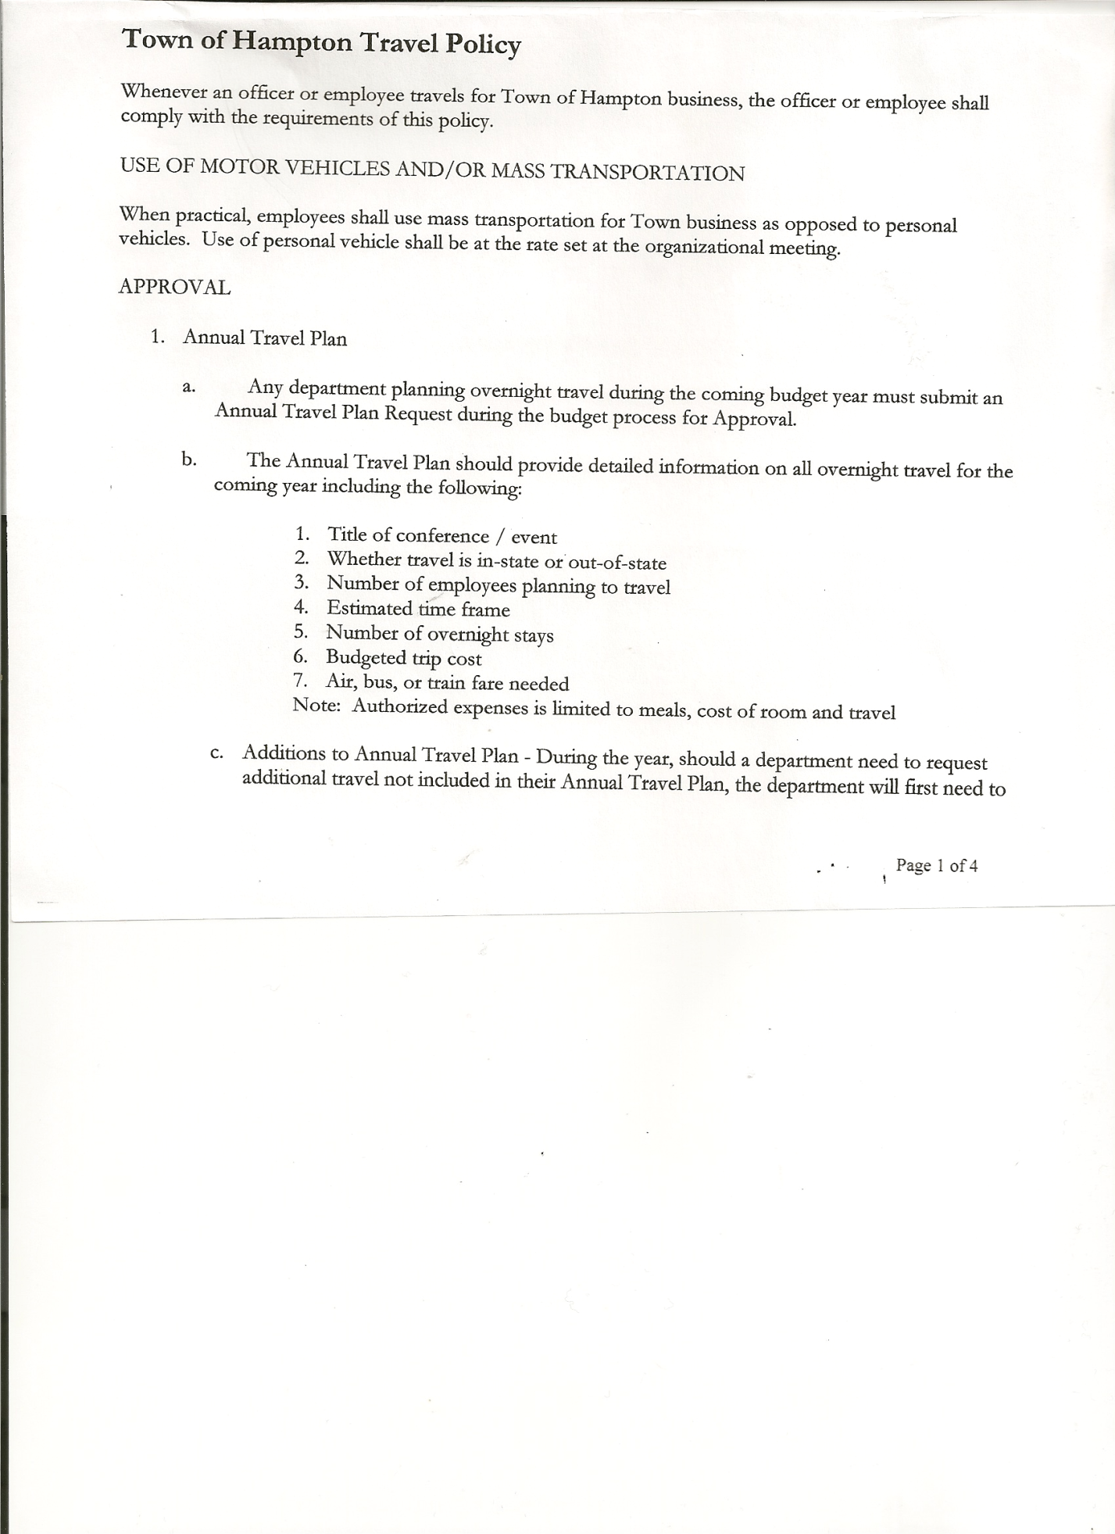
Rebecca Jones---------------Town Clerk – via Zoom
Camilla Shaw----------------Tax Collector/Deputy Town Clerk – via Zoom
Herbert Sady, Jr.-------------Highway Superintendent - absent

Planning Board Members: Bonnie Hawley and Matthew Pratt (via Zoom)

Also present: Artie Pratt (via Zoom)

The Special Meeting was called to order by Supervisor O’Brien at 7:02pm, followed by the Pledge of Allegiance. Location of Fire Exits were given. Quorum of board members present.

RESOLUTION NO. 1-2021
HAMPTON ORGANIZATIONAL CHARTER FOR 2021
On a motion of Councilman Sady, seconded by Councilwoman Taran, the following resolution was ADOPTED: Ayes 4 O’Brien, Sady, Taran, Pietryka
Nays 0
Absent 1 Sweeney
RESOLVED, that upon review the Hampton’s Organizational Charter for 2021 is adopted as proposed.

Oaths of Office are ready for Appointed Officials. The Town Clerk will notify appointees to stop at the Town Hall to sign their Oaths.
RESOLUTION NO. 2-2021
HAMPTON TOWN POLICIES
On a motion of Councilman Sady, seconded by Councilwoman Taran, the following resolution was ADOPTED: Ayes 4 O’Brien, Sady, Taran, Pietryka
Nays 0
Absent 1 Sweeney
RESOLVED, that upon review the following Policies:
- Travel Policy
- Investment Policy
- Cell Phone Policy
- Sexual Harassment Policy
- Workplace Violence Policy
- Procurement Policy
- Credit Card Policy
TOWN BOARD MEETING
JANUARY 4, 2021 PAGE 2

- On-line Banking Policy
- Ethics Policy
- Computer Usage Policy
- Record Storage Policy
- Employee Handbook
- Drug/Alcohol Testing Policy
- Town Hall Use
- Road Side Tree Policy
- Cyber Security Policy
Of the Town of Hampton are approved.

RESOLUTION NO. 3-2021
PROCUREMENT POLICY 2021
On a motion of Councilman Sady, seconded by Councilwoman Taran, the following resolution was ADOPTED: Ayes 4 O’Brien, Sady, Taran, Pietryka
Nays 0
Absent 1 Sweeney
RESOLVED, to accept the Procurement Policy for 2021 (copy is attached)

RESOLUTION NO. 4-2021
STANDARD WORKDAY and REPORTING RESOLUTION
On a motion of Councilman Sady, seconded by Councilwoman Taran, the following resolution was ADOPTED: Ayes 4 O’Brien, Sady, Taran, Pietryka
Nays 0
Abstain 1 Sweeney
RESOLVED, that the Standard Workday and Reporting Resolution for Elected and Appointed Officials (RS 2417-A) be approved. (copy is attached)

RESOLUTION NO. 5 -2021
AUTHORIZE TO PRE-PAY ITEMS
MOTION BY: COUNCILWOMAN TAMME TARAN
SECONDED BY: COUNCILMAN DONALD SADY

TITLE: RESOLUTION AUTHORIZING THE TOWN SUPERVISOR TO PAY BILLS
IN ORDER TO AVOID PENALTIES AND INTEREST

WHEREAS, the Town has determined that due to certain bills being due prior to the Town Board Audit of bills,

AND WHEREAS, the Town Board is desirous of avoiding late fees, penalties and interest and maintain its good credit standing,

TOWN BOARD MEETING
JANUARY 4, 2021 PAGE 3

NOW THEREFORE, BE IT RESOLVED:
That the Town Board of Hampton hereby authorizes the Supervisor to approve the payment of bills before audit if in the reasonable discretion of the Supervisor, it is necessary to do so to avoid any costs, penalties, interest or termination of service. The supervisor may pay
claims for public utilities, postage, freight and express charges, gas and diesel before they are audited. The term “public utilities” includes electric, gas, water, sewer and telephone services and the purchase of fuel oil. All claims must be presented for audit at the next regular board meeting audit. The claimant and the town officer incurring or approving these claims are jointly and severally liable for any amount disallowed upon audit.

BE IT FURTHER RESOLVED:
That the Town Board is not required by law to pre- audit payments of fixed salaries, compensation of officers or employees, principal and interest indebtedness, or amounts coming due on certain contracts

BE IT FURTHER RESOLVED that in the absence of the Supervisor, the Deputy Supervisor is authorized to review the bills and make the determination to authorize payment for the same reason.

BE IT FURTHER RESOLVED that the Town Clerk is hereby authorized and directed to add the following policy to the policy manual/employee handbook for the Town of Hampton.

DATED: January 4, 2021 Supervisor O’Brien AYE
Councilman Sady AYE
Councilwoman Taran AYE
Councilman Pietryka AYE
Councilwoman Sweeney ABSENT

RESOLUTION 6-2021
MEETING ADJOURNED
On a motion of Councilwoman Taran, seconded by Councilman Pietryka, the following resolution was ADOPTED: Ayes 4 O’Brien, Sady, Taran, Pietryka
Nays 0
Abstain 1 Sweeney
RESOLVED, that the meeting adjourned at 7:17pm.

Respectfully submitted,

Rebecca S. Jones, RMC
Town Clerk

