

**Summer 2014**

**End of Season**

Well it was always going to be a close match between myself and Matt Pinel which despite the state of the terrains we both played to a very high standard.

But Matt Pinel with his last boule tied at 12 – 12 in the first game fired my holding boule out for the title and then sealed this winning the second game 13 – 11.

Congratulations to Matt Pinel for his first ever Premier League title.

Ross Payne sealed third place with a draw over Andrew Bellamy who as a result finished 4th. Ross was the only undefeated player in the league, quite an achievement.

Keith Pinel lost heavily to Brian Harris but Chris Mutton lost to Chris Romeril (his first win!) and drew with Ian Foster to join previously relegated David Siouville and Chris Romeril.

Division 1 was won in style by Joey Le Clech only losing 4 points to Brendan Jones (including a 13 – 0) and was unbeaten all season.

Paul Le Moine finished runner up with more wins than Joey, but lost 4 matches in a remarkable season for Paul have got relegated from Division 1 last Winter will be playing in Division 2 Singles this Winter but in the Summer will be playing in the Premier League.

Third place saw one player surge from relegation to third place and promotion with three wins and a draw from his last four matches. Well Done Richard Potrzeba. All excellent additions to the Premier League next Summer Season.

Andrew Limbrick joined Celine Gimenez who will drop down to Division 2 next Summer.

Despite losing his first match of the season to Matt Buesnel, Jonny Hill won back to back Summer titles after winning Division 3 last Summer sealed the Division 2 title win a win over Lorna Limbrick with Matt finishing in second place. These 2 players finished well above third place and look strong contenders for the Division 1 title next Summer.

Third place was very close in the end as another player having a late surge was David Spencer winning 3 straight matches temporarily moved into third place before Stefan joined on 15 points with a draw against Cassie Stewart winning the second game 13 – 4. This 13 – 4 win proved decisive as Stefan piped David to third place with +18 to +17. Congrats to Stefan and commiserations to David.

Commiserations to Ann Ellis and Mike Dean both relegated to Division 3 next Summer. Unfortunately this is Ann’s third straight relegation, the only way is up now Ann.

Division 3 was decided on the last day as Nathan drew with Iain Shaw and Tom Smith which meant Craig Honey could have won the title but failed to play his last match against Karolina handing the title to Nathan, with Craig second and Tom third. Tom the only undefeated player in the league, well done.

*Back to back Premier League Doubles titles for*

*Ross Payne & Anthony Di Santo*

A remarkable two Summer seasons unbeaten as they continue to set new records for the club. Ross also holds the Winter Premier league doubles title with Jake Romeril, can he make it four in a row!!!

Second place to Callum & Andrew with Brian & David with a well-earned third place. Relegation fell on Karen & Colin Hidrio who were joined by Keith & Sue Pinel heading back to Division 1.

Division 1 was won by Alan Oliveira & Craig Kelly as they head back to the Premier League having been previously relegated. Second place was snatched at the last minute by Jonny Hill & Joey Le Clech after beating Eammon & Karen Hidrio on the last day of the season moved them above Matt Buesnel & Nathan Wheller on points difference who dropped to third place with Karen & Eammon dropping to fourth place and just missing out on promotion.

Division 2 was won by new pairing John McGaw & Dawn Buckley undefeated all season just beat Carol & William Kerr to the title with Ann Ellis & Ian Foster taking third.

Well done to everyone, hope you all enjoyed the season and if not playing in the Winter Leagues, then hope to see you all back next Summer but don’t forget you can still play in the melee’s and Christmas doubles competition (members & partners, (partners don’t have to be members).

If you have any comments on the season (hopefully all good!) or would like to make any suggestions or to see different competitions / events please feel free to contact me on [tjamesnorthern@yahoo.co.uk](mailto:tjamesnorthern@yahoo.co.uk)

Just 2 weeks to go to the Winter Season, hope you all can make the meal at the Inn 18th October 2014. Please email [callumstewart@hotmail.com](mailto:callumstewart@hotmail.com)

Kind Regards

Toby Northern

Chairman

Liberation Petanque Club

**Don’t forget outstanding matches can be played anytime, whether that be in your lunchtime or another evening or weekend as long as it is at our home terrains the Weighbridge.**

|  |  |
| --- | --- |
| http://nebula.wsimg.com/581c5785b63ee3a672a15bb793008009?AccessKeyId=521D75783279793C7EE2&disposition=0&alloworigin=1 | http://www.inapub.co.uk/DisplayPhoto.aspx?width=290&height=290&photoid=3615 |

[www.**elementsmediajersey**.co.uk](http://www.elementsmedia.co.uk/)

Kind Regards

Toby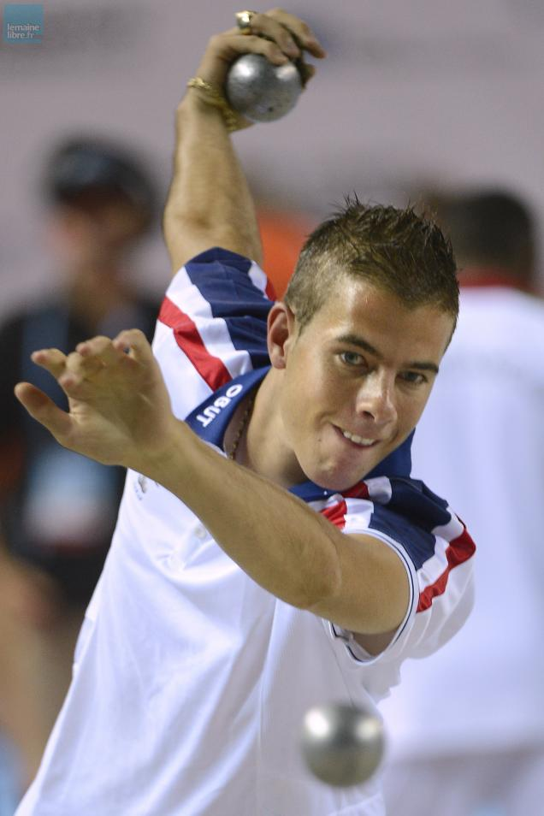 Northern

Chairman

Liberation Petanque Club