Grade 6 IMS Parent Orientation
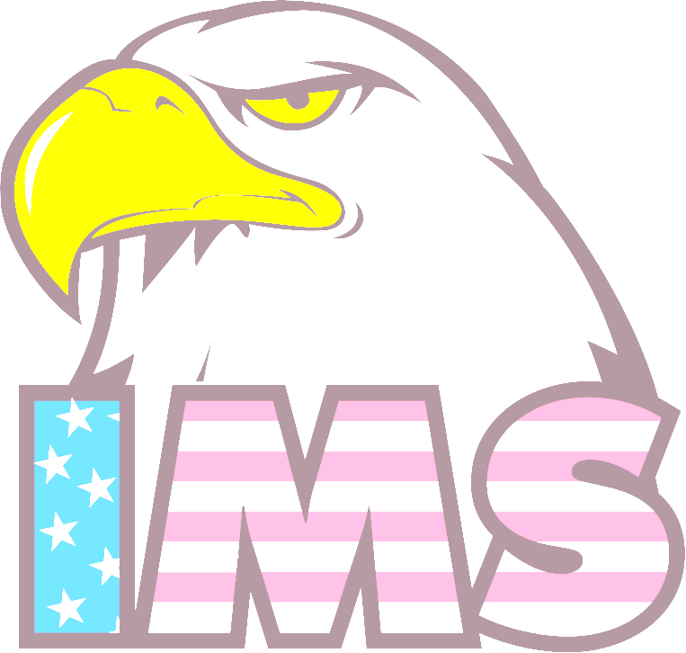
May 4, 2016

Agenda
- Welcome to IMS
Mrs. Koerner, Principal

- Overview and Registration
Ms. Brent & Mrs. Gulczewski, School Counselors

- Policies and Procedures
Mr. Duhy, Assistant Principal

- PTO
Bari Levitt, PTO President
Regina McClimond, Volunteer Coordinator

- School Safety
Officer Harbar, School Police
**If your child got accepted into one of our academies, please stay for more information.

